http://www.endotext.org/chapter/diabetes-treatment-strategies/treatment-for-type-2-diabetes/ ‎‎

Chapter 17.1 TREATMENT FOR TYPE 2 DIABETES
Patricia S. Juang, MD¹ and Robert R. Henry, MD¹
Center for Metabolic Research, VA San Diego Healthcare System & University of California, San Diego, CA, USA.
Hyperglycemia in type 2 diabetes is characterized by several pivotal abnormalities. First, resistance to insulin develops primarily in the skeletal muscle and adipose tissue leading to reduced insulin mediated glucose uptake, and in the liver to excessive glucose production. In addition, progressive impairment of insulin secretion develops in the pancreatic beta cell together with excessive secretion of glucagon from the alpha cell. Upon initial diagnosis of type 2 diabetes, all patients should undergo lifestyle modifications with changes in diet and exercise. When diet and exercise are no longer able to control hyperglycemia, pharmacological treatment should be initiated. There is a wide range of available pharmacologic therapy for treatment of type 2 diabetes. Choosing the right agent involves understanding the patient’s underlying pathophysiology. For example, in obese type 2 diabetic patients, insulin resistance and hyperinsulinemia are the classic abnormalities. Pharmacological treatment should focus on agents that decrease insulin resistance and suppress glucagon production. Oral anti-diabetic agents that stimulate insulin secretion may not be as effective when insulin deficiency is not the primary abnormality. In lean type 2 diabetic patients, impaired insulin secretion tends to be the primary defect while insulin resistance plays a more minor role. In this situation, insulin might be more effective than oral anti-diabetic agents.

SETTING GLYCEMIC TARGETS

One of the first steps in treatment of diabetic patients is to set glycemic targets. Professional societies such as the American Diabetes Association (ADA) and American Association of Clinical Endocrinologists (AACE) have guidelines on generalized targets for glycemic control (Table 1). The ADA set an A1C goal of <7% with fasting plasma glucose (FPG) goal of <130 mg/dL and peak post-prandial glucose goal (PPG) <180 mg/dL. The AACE set an A1C target of ≤6.5% with FPG goal <110 mg/dL and 2-hour PPG goal <140 mg/dL. However, glycemic targets should be set based on individual patients rather than general guidelines. When treating type 2 diabetic patients, physicians need to take into consideration a patient’s risk of hypoglycemia, risk of hyperglycemia-related complications, age, psychosocioeconomic situation, and other comorbidities when setting A1C goals (Figure 1)(1). For example, older patients with multiple comorbidities, including cardiovascular disease, who are at high risk for hypoglycemia should have an A1C goal of 8% or higher. Newly diagnosed, young patients who are highly motivated and who have not developed microvascular or macrovascular complications should have A1C goals closer to the 6-6.5% range as long as targets can be safely achieved without increased risk of hypoglycemia.

Table 1: Targets for Glycemic Control
Biochemical Index | ADA Goal(2) | AACE Goal(3)
A1C | < 7% | ≤ 6.5%
Fasting/pre-prandial glucose | < 130 mg/dL | < 110 mg/dL
Post-prandial glucose | < 180 mg/dL (peak) | < 140 mg/dL (2 hours)
Modified from Edelman, Steven and Henry, Robert. Diagnosis and Management of Type 2 Diabetes. 11th ed. United States: Professional Communications, Inc., 2011.

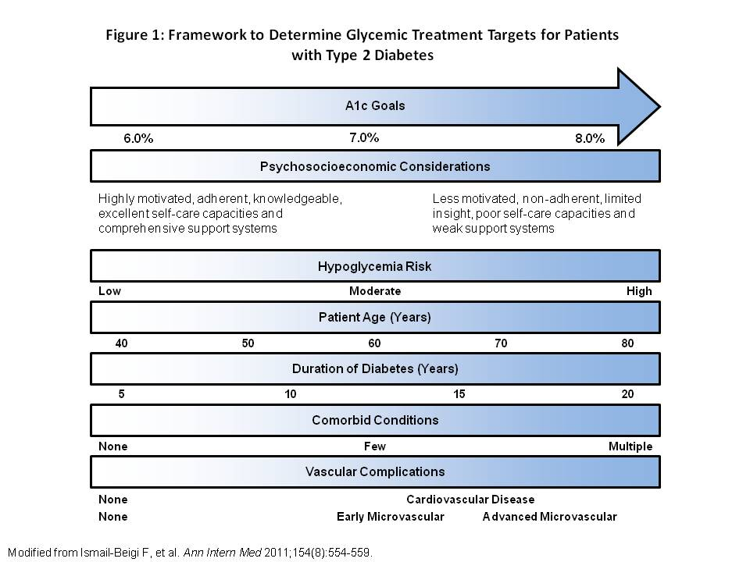
Figure 1: Framework to Determine Glycemic Treatment Targets for Patients with Type 2 Diabetes

To understand how these different A1C targets were derived, we take a look at four major long-term studies below which looked at the benefits of intensive versus conventional glucose control and their effects on microvascular and macrovascular complications.

United Kingdom Prospective Diabetes Study (UKPDS)
The UKPDS demonstrated benefits of intensive glucose control in 4209 newly diagnosed type 2 diabetic patients. Patients (median age 54) were randomized to receive intensive glucose control with sulfonylurea (SFU) or insulin (goal FPG <108 mg/dL) or conventional control with diet (goal FPG <127 mg/dL). Patients with body weight >120% of their ideal weight had the possibility of randomization to metformin (MET). After a median follow up of 10 years, A1C was 7.0% in the intensive group compared with 7.9% in the conventional group. There was a 25% risk reduction in microvascular endpoints (P = 0.0099) and a non-significant relative risk reduction of 16% in myocardial infarction (P = 0.052) in the intensive group(4). In post-trial follow-up of 3277 patients in the UKPDS, patients were monitored for an additional 5 years after completion of the initial trial. No attempts were made to maintain previously assigned therapies. Within 1 year of the original study end, between group differences in A1C levels disappeared. In the intensive control group, relative reductions in microvascular disease persisted at 10 years (24%, P = 0.007) while risk reductions of 15% for myocardial infarction (MI) (P = 0.01) and 13% for death from any cause (P = 0.007) emerged over time. These benefits were even greater in MET treated patients with risk reduction of 33% (P = 0.005) in MI and 27% (P = 0.002) in death from any cause. These results suggest aggressive glucose control early after diagnosis of diabetes may translate into long-term benefits on cardiovascular disease and mortality(5).

Action to Control Cardiovascular Risk in Diabetes (ACCORD) and Action in Diabetes and Vascular Disease (ADVANCE)
Despite the UKPDS showing long-term benefits on cardiovascular disease and mortality with aggressive glucose control early in the course of diabetes, ACCORD and ADVANCE trials concluded otherwise. ACCORD was a randomized study of 10,251 type 2 diabetic patients (mean age 62 years) with mean A1C 8.1%. Patients were randomized to intensive therapy with A1C goal <6% or standard therapy with A1C goal 7.0-7.9%. After 3.5 years, the study was discontinued because of higher all-cause and cardiovascular mortality in the intensive therapy group. At 4 years, there was a separation of the curves for the composite end point of non-fatal MI, non-fatal stroke or death from cardiovascular causes, favoring the intensive therapy group. Although the difference was not significant, it might have become significant had the trial been completed(6).

In the ADVANCE trial, 11,140 patients with type 2 diabetes were randomly assigned to standard glucose control or intensive glucose control with A1C goal <6.5%. After a median of 5 years, macrovascular event rate was not significantly different between the 2 groups, but microvascular complications, especially nephropathy, were significantly decreased in the intensive glucose group (9.4% vs. 10.9%; hazard ratio, 0.86; 95% CI, 0.77 to 0.97; P=0.01)(7). Difference in mortality of intensive group in the ACCORD vs ADVANACE trials are likely due to differences in population. ACCORD had more severe diabetic patients requiring insulin at baseline and insulin was initiated more aggressively. Hypoglycemia was higher in the intensive groups of ACCORD (10.5%) compared with ADVANCE (2.7%), which may have contributed to the increased total and cardiovascular deaths in the ACCORD intensive group.

Veteran Affairs Diabetes Trial (VADT)
The VADT also showed that intensive glucose control had no significant benefit in complications for cardiovascular disease in a very high risk type 2 diabetes population. 1791 veterans with type 2 diabetes were randomized to receive either intensive or standard glucose control. Goal in the intensive group was absolute reduction of 1.5% in A1C. The average number of years since diabetes diagnosis was 11.5. 40% of patients had a prior cardiovascular event, 72% had hypertension and most patients were obese. After median follow up of 5.6 years, A1C was 8.4% in the standard group and 6.9% in the intensive group. There was no significant difference in the rates of major cardiovascular events, death, or microvascular complications, except in the progression of albuminuria, which was reduced in the intensive group (P = 0.01)(8). These results indicate that there is no benefit from intensive glucose control in a patient population with long-standing diabetes, previous cardiovascular events, and multiple cardiovascular risk factors.

With results from above studies, the ADA and AACE A1C guidelines of <7% and ≤6.5%, respectively, are targets best used in newly diagnosed diabetic patients who can achieve tight control without hypoglycemia. Higher A1C goals are appropriate for patients with increased cardiovascular risk, increased risk of hypoglycemia and limited life expectancy.

TREATMENT GUIDELINES

After setting glycemic targets with patients, the next step is to decide on when and what pharmacologic treatment to start the patient on. Professional societies have also published guidelines on how to best approach pharmacological management in type 2 diabetic patients.

American Diabetes Association and the European Association for the Study of Diabetes
The American Diabetes Association (ADA) and the European Association for the Study of Diabetes (EASD) updated their consensus statement on management of hyperglycemia in type 2 diabetes in June 2012(9). These guidelines focus on individualized diabetes care with a patient-centered approach rather than the more rigid one goal fits all. The guidelines start with metformin (MET) as initial therapy for all patients who have no contraindications. MET is initiated at diagnosis in patients who failed to achieve, or is unlikely to achieve, glycemic target with lifestyle intervention alone. Patients with baseline A1C ≥9% are unlikely to achieve glycemic target with MET monotherapy. In such cases, it is justified to start a combination of 2 non-insulin agents or insulin. Insulin as initial therapy should be considered in patients who present with significant hyperglycemia (glucose >300-350 mg/dL or A1C ≥10-12%) and in patients with catabolic features. Once hyperglycemic symptoms are relieved and glucotoxicity resolved, insulin may be tapered and patient tried on a non-insulin agent alone or in combination with insulin.

If MET cannot be used as first line therapy, other oral agents such as sulfonylurea (SFU)/glinide, thiazolidinedione (TZD) or DPP-4 inhibitor can be used. When weight loss is an important part of a patient’s treatment plan, GLP-1 receptor agonists might be useful as initial therapy. Less commonly used diabetic drugs such as α-glucosidase inhibitors, colesevelam and bromocriptine might also be considered as first line in certain patients. After MET, there are limited data to help guide the next line of therapy.

If A1C goal is not reached in approximately 3 months with MET monotherapy, the next step is to add another oral agent, a GLP-1 receptor agonist or insulin (Figure 2). There is not enough data from long-term comparative-effectiveness trials to recommend one agent over another to be combined with MET. Typically, the addition of a second agent results in further A1C reduction of approximately 1%.

Advancing to three-drug combinations should be done when A1C is still not at goal on two-drug combinations. At this point, addition of insulin would give the strongest effect. However, addition of a non-insulin agent can also be tried with close monitoring of the patient (Figure 2). Again, there is not enough data to recommend one agent over another after failing two-drug therapy. In choosing a third agent, it is important when possible to use combination of agents with complementary mechanisms of action.

The sodium glucose transporter 2 (SGLT2) inhibitors have yet to be added into the ADA/EASD guidelines.

American Association of Clinical Endocrinologists/American College of Endocrinology
The American Association of Clinical Endocrinologists and the American College of Endocrinology also published a consensus panel on type 2 diabetes management(10) with its most recent update in April 2013. The algorithm emphasizes safety and efficacy, and therapeutic approach is stratified based on current A1C levels. A general A1C goal of 6.5% is set for all patients with the comment that goal must be customized for individual patients.

For patients with A1C <7.5%, a single agent may be enough to get A1C to goal. MET is listed as first line therapy followed by GLP-1 agonists, DPP-4 inhibitors, α-glucosidase inhibitors, SGLT-2 inhibitors, TZDs and SFU/glinides, in that order. GLP-1 agonists are preferred over DPP-4 inhibitors because of their greater effectiveness in reducing post-prandial glucose (PPG) and weight loss properties. If A1C is still not at goal after 3 months of treatment, dual therapy is recommended (Figure 2).

For patients with A1C 7.6 to 9.0%, dual therapy should be initiated. Choice of the first agent is similar to patients with A1C <7.5% as described above. A second agent should also be started as monotherapy is unlikely to achieve glycemic target in this population. Choice of second agent after MET include GLP-1 agonists, DPP-4 inhibitors, TZDs, SGLT-2 inhibitors, basal insulin, colesevelam, bromocriptine, α-glucosidase inhibitors or SFU/glinides, in that order. TZDs, SGLT-2 inhibitors and basal insulin are preferred over colesevelam, bromocriptine and α-glucosidase inhibitors because of their higher efficacy. If A1C is not at goal after 3 months, patients should proceed to triple therapy (Figure 2).

For patients with A1C > 9.0%, treatment depends on whether or not a patient has symptoms. If a patient is asymptomatic, dual or triple therapy should be initiated. Dual therapy is described above. For triple therapy, MET or other first-line agent along with a second line agent is started. Third line agents include GLP-1 agonist, TZDs, SGLT-2 inhibitors, basal insulin, DPP4-inhibitors, colesevelam, bromocriptine, α-glucosidase inhibitors or SFU/glinides, in that order. DDP4-inhibitors are much lower on this triple therapy list because they are not as efficacious in patients with higher A1C’s. For patients who are symptomatic, insulin with or without other oral agents should be initiated. If A1C is still not at goal after 3 months, insulin should be initiated or intensified.

In summary, the AACE/ACE algorithm differs from ADA/EASD in that it strongly favors the use of GLP-1 agonists and DPP-4 inhibitors because of their effectiveness and safety profiles. The newly updated guidelines have moved SFUs and glinides to the lowest priority for oral medications because of the risk of hypoglycemia, weight gain and failure to provide glycemic control after 1-2 years of use. In addition, the new AACE/ACE guidelines now include SGLT-2 inhibitors in the list of potential therapies.

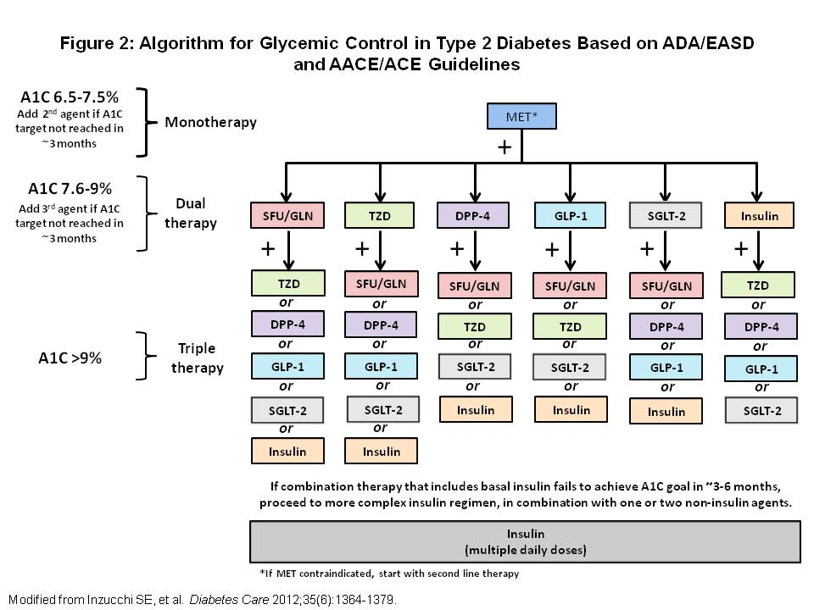
Figure 2: Algorithm for Glycemic Control in Type 2 Diabetes Based on ADA/EASD and AACE/ACE Guidelines
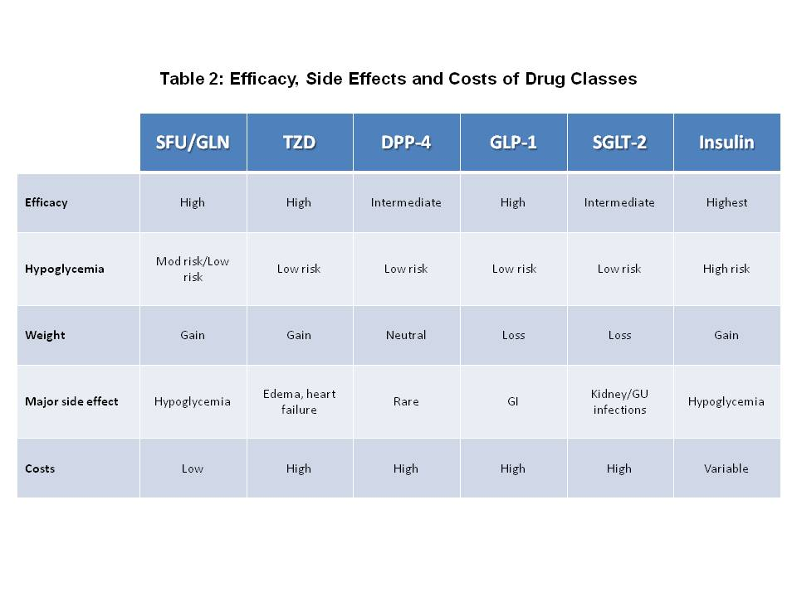
Table 2: Efficacy, Side Effects and Costs of Drug Classes

ORAL AGENTS USED IN THERAPY

Diabetes management has become increasingly more complex as the number of available oral agents has increased over the years. We now have 9 groups of oral anti-diabetic agents at our disposal (Table 2). It is important to understand pharmacokinetics, potency, metabolism and mechanism of action of each medication so that we can prescribe appropriate combination of drugs to achieve glycemic goals.

Table 3: Oral Anti-Diabetic Agents
Generic Name | Trade Name | Recommended Starting Dose (mg) | Daily Max Dose (mg) | Dose Frequency
α-Glucosidase Inhibitors
Acarbose | Precose | 25 tid w/ meals | 300 | bid-tid w/ meals
Miglitol | Glyset | 25 tid w/ meals | 150 | bid-tid w/ meals
Biguanide
Metformin | Glucophage  Fortamet  Glucophage XR  Glumetza | 500 qd w/ dinner  500-1000 qd  500 qd  1000 qd | 2550  2500  2000  2000 | bid-tid  qd  qd  qd
Bile Acid Sequestrant
Colesevelam | Welchol | 3750 | 3750 | qd-bid
Dopamine Receptor Agonist
Bromocriptine mesylate | Cycloset | 0.8 | 4.8 | qd within 2 hr after awakening
DPP-4 Inhibitor
Linagliptin | Tradjenta | 5 | 5 | Qd
Saxagliptin | Onglyza | 2.5-5 | 5 | Qd
Sitagliptin | Januvia | 100 | 100 | Qd
Alogliptin | Nesina | 25 | 25 | Qd
DPP-4 Inhibitor/Biguanide Combination Agent
Saxagliptin/metformin XR | Kombiglyze XR | 5/500 or 2.5/1000 | 5/2000 | qd w/ meals
Sitagliptin/metformin | Janumet | 50/500 | 100/2000 | bid w/ meals
Linagliptin/metformin | Jentadueto | 2.5/500 or 2.5/850 or 2.5/1000 | 5/2000 | bid
Alogliptin/metformin | Kazano | 12.5/500 or 12.5/1000 | 25/2000 | bid
Glinides
Nateglinide | Starlix | 120 tid w/ meals | 360 | bid-qid w/ meals
Repaglinide | Prandin | 0.5 bid-qid w/ meals | 16 | bid-qid w/ meals
Glinide/Biguanide Combination Agent
Repaglinide/metformin | Prandimet | 1/500 | 10/2500 | bid-qid w/ meals
SGLT2 Inhibitors

Canagliflozin | Invokana | 100 qd | 300 | qd
Dapagliflozin | Forxiga | 100 qd | 100 | Qk,d
Sulfonylureas
First Generation
Acetohexamide | Dymelor | 125 bid | 1500 | bid
Chlorpropamide | Diabinese | 250 qd | 500 | qd
Tolazamide | Tolinase | 100 qd | 1000 | bid
Tolbutamide | Orinase | 250 bid | 3000 | tid
Second Generation
Glimepiride | Amaryl | 1-2 qd | 8 | qd
Glipizide | Glucotrol | 5 qd | 40 | bid
Glipizide (extended release) | Glucotrol XL | 5 qd | 20 | Qd
Glyburide | DiaBeta, Micronase Glynase PresTab | 2.5-5 qd  1.5-3 qd | 20  12 | bid  bid
Sulfonylurea/Biguanide Combination Agents
Glipizide/metformin | Metaglip | 2.5/250 qd | 20/2000 | bid w/ meals
Glyburide/metformin | Glucovance | 1.25/250 qd | 10/2000 | bid w/ meals
Thiazolidinediones
Pioglitazone | Actos | 15-30 qd | 45 | qd
Rosiglitazone | Avandia | 4 qd or 2 bid | 8 | bid-qd
Thiazolidinedione/Biguanide Combination Agents
Pioglitazone/metformin | Actoplus Met | 15/500 or 15/850 w/ meal | 45/2550 | bid w/ meals
Pioglitazone/metformin XR | Actoplus Met XR | 15/1000 or 30/1000 w/ meal | 45/2000 | qd
Rosiglitazone*/metformin | Avandamet | 2/500 bid w/ meals | 8/2000 | bid w/ meals
Thiazolidinedione/Sulfonylurea Combination Agents
Pioglitazone/glimepiride | Duetact | 30/2 or 30/4 | 45/8 | qd
Rosiglitazone*/glimepiride | Avandaryl | 4/1 or 4/2 | 8/4 | qd
Thiazolidinedione/DPP-4 Inhibitor Combination Agent
Pioglitazone/alogliptin | Oseni | 15, 30 or 45/12.5 or 25 | 45/25 | qd
*Rosiglitazone is no longer approved for uset in Europe.

Modified from Edelman, Steven and Henry, Robert. Diagnosis and Management of Type 2 Diabetes. 11th ed. United States: Professional Communications, Inc., 2011.

Metformin

Metformin (MET) is the first line pharmacologic therapy along with lifestyle modifications for most patients initially diagnosed with type 2 diabetes. MET is a biguanide and works primarily by suppressing hepatic glucose output, possibly through antagonism of glucagon(11). It also has some effect on increasing glucose utilization by peripheral tissues and decreasing intestinal glucose absorption. MET as monotherapy has been shown to decrease A1C by -1.4% in a 29 week treatment period(12). In addition to its glucose lowering effects, MET has beneficial effect on lipids and weight. Favorable effects on lipid profile include lowering LDL, triglyceride, and total cholesterol(12). MET is considered weight neutral and can be associated with weight loss in some patients.

Side effects/Contraindications
MET’s major side effects are gastrointestinal (GI), mainly loose stools/diarrhea. Anorexia, nausea, and abdominal pain may also occur. GI side effects tend to be transient and dose related. Side effects can be minimized by starting at a low dose, titrating up to maximum dose, and taking MET with food.

A rare but life threatening complication of MET therapy is lactic acidosis. This is mainly seen in patients with renal dysfunction. Cr >1.4 in women and Cr >1.5 in men are contraindications to using MET. MET is also contraindicated in patients with significant hepatic dysfunction and alcohol abuse.

When patients go for studies requiring contrast dye, MET should be temporarily held for 48 hours after the procedure. Cr levels should be checked prior to reinitiating MET to ensure that renal function is intact. During hospitalizations, MET should also be temporarily stopped in anticipation of studies requiring contrast dye. Insulin should be used to control hyperglycemia as needed.

Prescribing
MET is initiated at 500 mg with dinner for one week then titrated up to 500 mg twice daily with breakfast and dinner. Once patients are able to tolerate twice daily dosing, dosage should be titrated up to maximum daily dose of 2000-2550 mg. Twice daily rather than three times daily dosing improves compliance. MET comes in combination pills with sulfonylureas, thiazolidinediones, DPP-4 inhibitors and glinides (Table 2).

Thiazolidinediones

Thiazolidinediones (TZDs) work mainly by increasing insulin sensitivity in skeletal muscle, liver and adipose tissue. They activate nuclear receptors called peroxisome proliferator-activated receptor gamma (PPARγ) which result in increased insulin sensitivity. Although many patients are still taking TZDs, this class of medication has fallen out of favor in recent years, particularly at higher doses. The two currently available TZDs in the U.S. are rosiglitazone and pioglitazone.
Rosiglitazone is now rarely used because of a 2007 meta-analysis demonstrating significantly increased risk of myocardial infarction (MI) and death from all cardiovascular disease(13). The drug now carries an FDA issued boxed warning regarding this risk. Patients who have diabetes well controlled on rosiglitazone should be informed of these risks, and physicians should discuss other possible therapy options with these patients prior to discontinuing rosiglitazone.

Pioglitazone is the more widely used TZD at this time and will be the focus of this section. As monotherapy, pioglitazone can reduce A1C by -1.4 to -1.6% with the maximum dose of 45 mg daily over a period of 26 weeks(14). In a head-to-head trial comparing pioglitazone and metformin (MET) in drug-naïve type 2 diabetic patients, pioglitazone was equally as effective as MET in a 32-week trial(15). In combination therapy, pioglitazone 30 mg significantly reduced A1C by -0.8% with MET and by -1.3% with sulfonylureas (SFUs)(16, 17). Pioglitazone 45 mg with MET significantly reduced A1C by -1.3%(16).
Pioglitazone use also has the beneficial effect of decreasing triglycerides and increasing HDL while having no change in LDL and total cholesterol(14).

Effect on Cardiovascular Risk Factors
The Prospective Pioglitazone Clinical Trial in Macrovascular Events (PROactive) was designed to determine whether pioglitazone reduces macrovascular morbidity and mortality in high risk patients with type 2 diabetes. PROactive was a randomized placebo controlled trial where 5238 type 2 diabetic patients with macrovascular disease were randomized to receive pioglitazone, titrated up to maximum dose of 45 mg daily. The primary endpoint was the composite of all-cause mortality, non-fatal myocardial infarction (MI) (including silent MI), stroke, acute coronary syndrome, endovascular or surgical intervention in the coronary or leg arteries and amputation above the ankle. The main secondary endpoint was the composite of all-cause mortality, non-fatal MI (excluding silent MI) and stroke. The average time to observation was 34.5 months.

PROactive demonstrated that pioglitazone non-significantly reduced the risk of the composite primary endpoint. The authors discussed this lack of significance in primary endpoint as a result of the initial design in protocol when it was thought that the need for amputation or coronary or leg revascularization would respond to therapy in a similar way to stroke and MI. This hypothesis did not prove correct because these endpoints were influenced by local surgical or medical practice. Thus, the study was likely underpowered to detect a significant difference in primary composite endpoint.
For the main secondary composite endpoint of all cause mortality, non-fatal MI and stroke, significantly fewer patients in the pioglitazone group (11.6%) than in the placebo group (13.3%) experienced at least one of these events (Figure 3)(18).

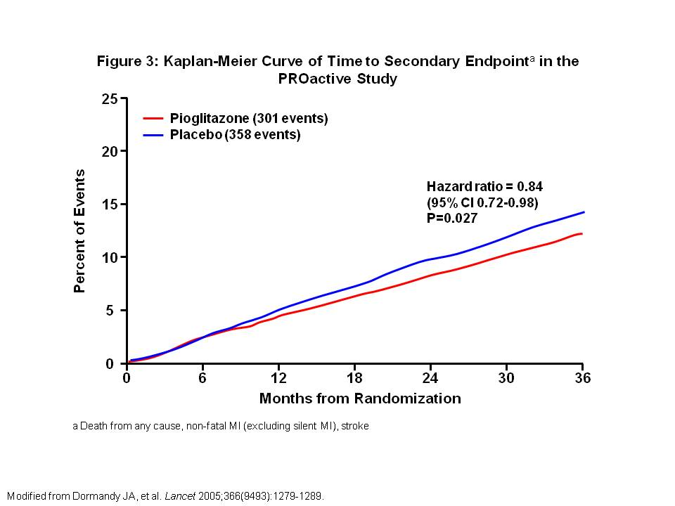
Figure 3: Kaplan-Meier Curve of Time to Secondary Endpointª in the PROactive Study

Further analyses were done from the PROactive study to evaluate effects of pioglitazone on pre-specified major adverse cardiovascular events (MACEs). MACEs are standard measures used to compare treatments in large cardiovascular outcome studies. The Cox proportional hazards model showed significant risk reduction of -16% with pioglitazone in the main secondary endpoint of all-cause mortality, non-fatal MI or non-fatal stroke. Significant risk reductions were also seen with pioglitazone compared to placebo for 6 of the MACE endpoints. For MACE1 composite endpoints of cardiovascular mortality, non-fatal MI, or non-fatal stroke there was a -18% risk reduction. For MACE2 composite endpoints of all-cause mortality, non-fatal MI, non-fatal stroke or acute coronary syndrome there was a -17% risk reduction(19).
In an independent analysis of 19 trials that enrolled 16,390 patients, pioglitazone treatment ranged from 4 months to 3.5 years. Death, MI, or stroke occurred in 450 of 7836 patients (4.4%) receiving pioglitazone versus 450 of 7836 patients (5.7%) receiving control therapy (HR 0.82; 95% CI 0.72-0.94; P=0.005)(20).

Side effects/Contraindications
Liver toxicity does not appear to be a significant clinical problem with currently available TZDs. However, prior to initiating TZD therapy, baseline liver enzymes should be checked. If abnormal, work up should be initiated to determine etiology of liver enzyme elevation. If alanine aminotransferase (ALT) is >2.5 times the upper limit of normal, TZDs should not be initiated. The exception is in nonalcoholic steatohepatitis (NASH) where TZD has been shown to improve biochemical and histological features of NASH(21). While on TZD therapy, liver enzymes should be monitored periodically. If at any time, liver enzymes become elevated, therapy should re-evaluated and continued with more frequent monitoring of liver enzymes. If ALT is >3 times the upper limit of normal, it should be repeated and if levels remain elevated, TZD therapy should be discontinued.

In 2007, the FDA issued a boxed warning regarding TZDs and their potential to cause or exacerbate CHF. In a meta-analysis of 19 trials that enrolled 16,390 patients, pioglitazone treatment significantly increased the risk of heart failure. Serious heart failure was reported in 2.3% of the pioglitazone treated group and 1.8% of the control group (HR 1.41; 95% CI 1.14-1.76; P=0.002), without an associated increase in mortality(20). TZD use is contraindicated in patients with NYHA Class III or IV heart failure, and not recommended in patients with symptomatic heart failure. For patients who develop signs and symptoms of heart failure while on therapy, TZD should be discontinued or dose reduced. Prior to initiating TZD therapy, physical exam should be performed to document presence or absence of ankle edema. Edema itself is not an absolute contraindication to starting TZDs, but should be monitored closely during therapy, and TZDs discontinued or dose reduced if edema significantly worsens. Risks factors for heart failure in patients treated with TZDs include history of heart failure, myocardial infarction, coronary artery disease, hypertension, left ventricular hypertrophy and significant aortic or mitral valve disease.

In 2011, the FDA updated the safety label for pioglitazone to highlight the risk of bladder cancer. The FDA recommends that pioglitazone should not be used in patients with active bladder cancer. In patients with prior history of bladder cancer, pioglitazone should be used with caution. To address concerns of long-term risk bladder cancer, the drug manufacturer (Takeda) is conducting a 10 year observational cohort study in 193,099 diabetic patients in the Kaiser Permanente Northern California (KPNC) diabetes registry--30,173 of those who are treated with pioglitazone. The primary outcome is an incident diagnosis of bladder cancer identified from the KPNC cancer registry. Treatment with pioglitazone is the primary exposure of interest. A planned five-year interim analysis was published with data collected from January 1997 to April 2008. Median duration of therapy with pioglitazone was 2 years. Results showed no significant increase in the risk of bladder cancer in patients ever exposed to pioglitazone compared to patients never exposed to pioglitazone (hazard ratio [HR] 1.2; 95% confidence interval [CI] 0.9-1.5). However, there was a significantly increased risk of bladder cancer with increasing dosage and duration of pioglitazone use (HR 1.4; 95% CI 1.03-2)(22). Patients currently taking pioglitazone should be aware of the bladder cancer risk and counseled to report any signs or symptoms of blood in the urine, urinary urgency, pain on urination, or back or abdominal pain, which may be due to bladder cancer.

Bone loss is another concern with TZD therapy. In March 2007, Takeda Pharmaceuticals reported increased fracture risk in women treated with pioglitazone based on an analysis of their clinical trial database. Fracture incidence among women was 1.9 per 100 person-years for pioglitazone and 1.1 per 100 person-years for those on placebo or another active drug. In addition, in a 4 year follow up from the Health, Aging, and Body Composition observational study, TZD use was associated with greater bone loss at the whole body of -0.67% per year (95% CI -1.03, -0.30% per year), lumbar spine of -1.23% per year (95% CI -2.06, -0.40% per year) and trochanter of -0.65% per year (95% CI -1.18, -0.12% per year) in women 70-79 years of age(23). The increased risk of fracture is apparent 1 year after TZD use among women(24). Given that older postmenopausal women at are greatest risk for fracture, and bone loss with TZDs is most consistent in this group, postmenopausal women using or starting TZD should be screened for low bone density with appropriate treatment initiated when necessary.

Prescribing
Pioglitazone can be started at 15 or 30 mg once daily and titrated up by 15 mg increments to maximum effective daily dose of 45 mg daily, if desired. It can be given as monotherapy or in combination with other oral diabetic medications and/or insulin. Pioglitazone’s effect can be seen as early as 2 weeks with maximum effects observed at 10-14 weeks(14). Liver enzymes should be monitored prior to initiating therapy and periodically while on therapy. Pioglitazone comes in combination pills with sulfonylureas, metformin and alogliptin (Table 2).

In a post hoc analysis of the PROactive study, insulin requirements and regimens were examined. A rapid and sustained decrease in insulin dose was observed with pioglitazone (Figure 4). Mean insulin dose by the end of the study was 42 U/d in pioglitazone group versus 55 U/d in placebo group (P=0.0001). Insulin regimen was also more simplified with greater A1C reductions in pioglitazone (-0.93%) versus placebo group (-0.45%, P<0.0001). At the end of the study, insulin had been discontinued in 9% of pioglitazone versus 2% of placebo patients (P<0.0001)(25).
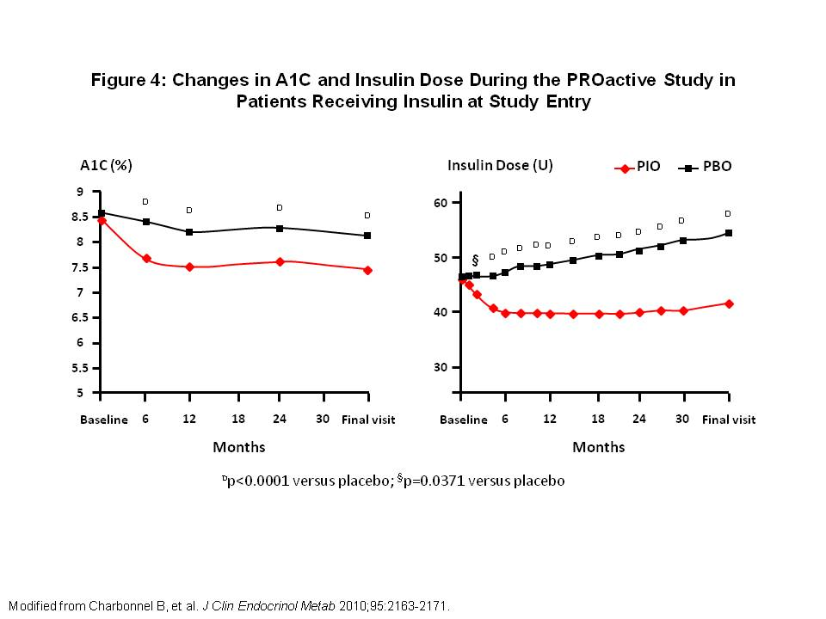
Figure 4: Changes in A1C and Insulin Dose During the PROactive Study in Patients Receiving Insulin at Study Entry
DPP-4 Inhibitors
The discovery of intestinal peptides has resulted in the development of diabetic medications with novel mechanisms of action. Intestinal peptides glucagon-like peptide 1 (GLP-1) and glucose-dependent insulinotropic polypeptide (GIP) have incretin effects, in which oral glucose stimulates greater insulin secretion than intravenous glucose. The incretin effect is mediated by intestinal peptides, in particular GLP-1. Incretin hormones are rapidly degraded by the enzyme DPP-4 through N-terminal cleavage. The development of DPP-4 inhibitors thus became a new strategy for diabetes management. There are three DPP-4 inhibitors available in the United States – sitagliptin, saxagliptin and linagliptin. All three are oral medications, as opposed to the incretin mimetics which are injectables.
Sitagliptin
Sitagliptin was the first DPP-4 inhibitor approved for use in type 2 diabetes. It is approved for use as a single agent as initial treatment of type 2 diabetes, as second agent in addition to metformin (MET), thiazolidinedione (TZD) or sulfonylurea (SFU), in combination with insulin therapy or as a third agent in addition to MET and a TZD when adequate glycemic control is not achieved.

Monotherapy Trials
The efficacy of sitagliptin as monotherapy has been demonstrated in randomized controlled clinical trials. In a Japanese study with 151 type 2 diabetic patients with average baseline A1C of 7.6%, patients underwent an 8 week diet and exercise run-in period and drug washout period for patients who had been on a single oral diabetic agent. After 8 weeks, patients were randomized to sitagliptin 100 mg daily or placebo for 12 weeks. At the end of 12 weeks, A1C decreased by -0.65% in the sitagliptin group versus increasing by 0.41% in the placebo group with between group difference of -1.05% (95% CI -1.27, -0.84; P<0.001) (Figure 5). 58.1% of patients in the sitagliptin group reached A1C target of <7% and 14.5% reached target in the placebo group (P<0.001). A meal tolerance test (MTT) performed at baseline and at 12 weeks demonstrated a 2 hour post-prandial glucose (PPG) decrease by -69.2 mg/dL in the sitagliptin group compared with an increase by 11.7 mg/dL in the placebo group (Figure 6)(26).

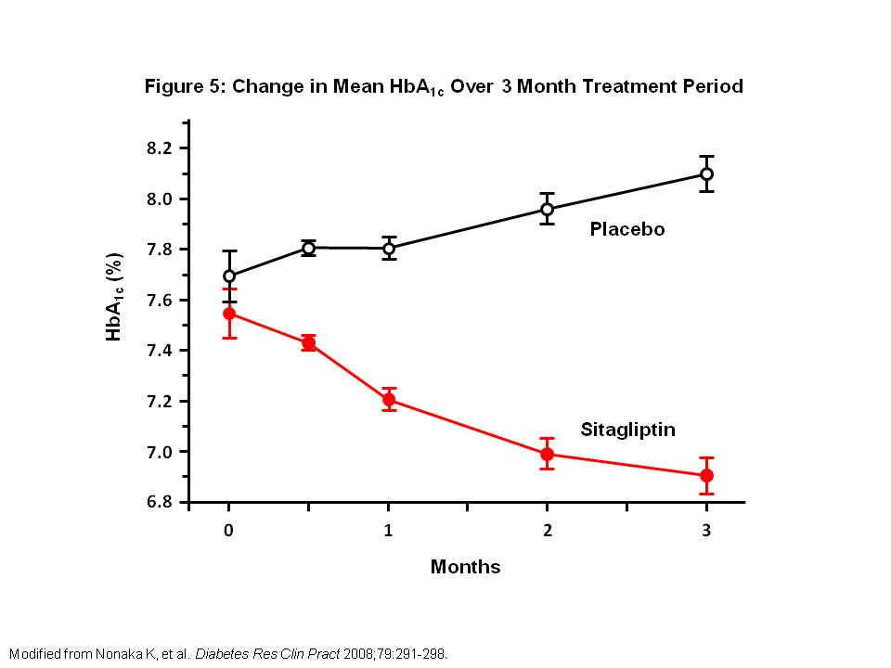
Figure 5: Change in Mean A1C Over 3 Month Treatment Period
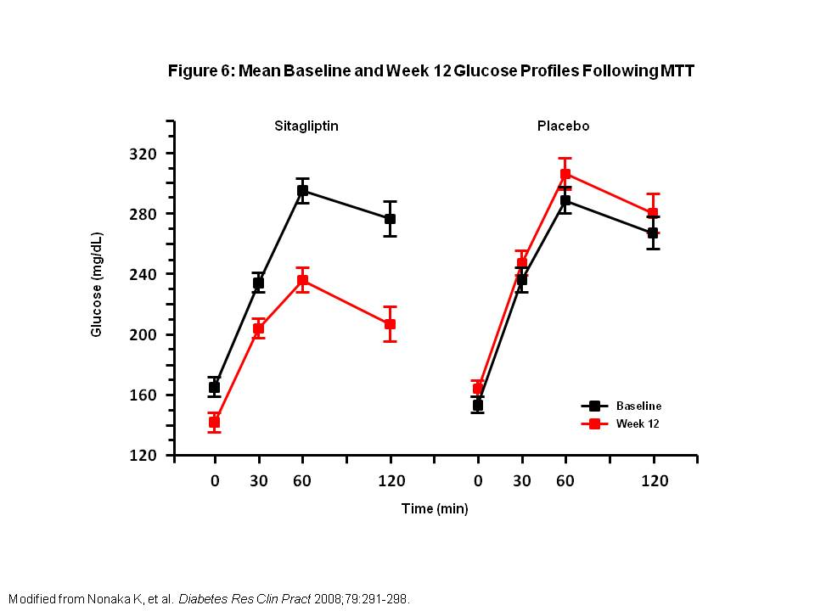
Figure 6: Mean Baseline and Week 12 Glucose Profiles Following MTT

In another randomized, double-blind, placebo controlled trial, 741 patients with baseline A1C of 8% were randomized to receive sitagliptin 100 mg or 200 mg or placebo for 24 weeks. Both sitagliptin 100 mg and 200 mg resulted in significant placebo-subtracted reductions in A1C (-0.79% and -0.94%, respectively, P<0.001). Patients with baseline A1C ≥9% had greater reductions in placebo-subtracted A1C with sitagliptin 100 mg and 200 mg (-1.52% and -1.50%, respectively) than patients with A1C <8% (-0.57% and -0.65%) or 8-8.9% (-0.80% and -1.13%, respectively). In a MTT, sitagliptin 100 mg and 200 mg significantly decreased 2 hour PPG (placebo-subtracted PPG -46.7 and -54.1 mg/dL, respectively). The two sitagliptin doses did not show any significant differences in A1C, fasting plasma glucose (FPG) or PPG. There was no significant change in body weight with sitagliptin 100 mg or 200 mg (-0.2 kg and -0.1 kg, respectively). Body weight change with placebo (-1.1 kg) was significantly greater than that with sitagliptin (P < 0.01)(27).

Combination or Add-On Therapy Trials
Sitagliptin with Metformin
In a 24 week, randomized, double-blind, placebo-controlled clinical trial, the efficacy of initial combination therapy with sitagliptin and MET in type 2 diabetic patients were evaluated. A total of 1091 patients with A1C 7.5-11% were randomized to one of six daily treatments: sitagliptin 100mg/MET 1000mg (S100/M1000), sitagliptin 100mg/MET 2000mg (S100/M2000), MET 1000mg (M1000), MET 2000mg (M2000) (all MET as divided doses administered twice daily), sitagliptin 100mg daily or placebo. Mean baseline A1C was 8.8%. The placebo-subtracted A1C change from baseline was -2.07% (S100/M2000), -1.57% (S100/M1000), -1.3% (M2000), -0.99% (M1000), and -0.83% (S100) (P<0.001 for comparisons versus placebo and for combination versus monotherapies). 66% of patients achieved A1C <7% and 44% achieved A1C <6.5% in the S100/M2000 group (P<0.001 vs S100 or M2000 monotherapies)(28).

Sitagliptin Added to Metformin
Sitagliptin’s efficacy was also evaluated as an addition to ongoing MET therapy in patients who had inadequate glycemic control with A1C 7-10% with MET alone. 701 patients with mean A1C of 8% who had been receiving ongoing MET therapy (≥1500 mg/day) were randomized to receive the addition of either placebo or sitagliptin 100 mg daily in a 1:2 ratio for 24 weeks. After 24 weeks, the addition of sitagliptin to MET led to significantly reduced A1C (-0.65%), FPG (-25.4 mg/dL), and 2 hour PPG (-50.6 mg/dL) compared to placebo. Significantly greater proportion of patients achieved A1C <7% with sitagliptin (47.0%) than with placebo (18.3%). Sitagliptin was not associated with increased risk of hypoglycemia or GI side effects compared with placebo(29).

Sitagliptin Compared to Glipizide Added to Metformin
The efficacy and safety of sitagliptin or glipizide in patients inadequately controlled on MET was assessed in a 2 year study. 1172 patients who were on a stable MET dose of ≥1500 mg daily for at least 8 weeks were randomized to receive either sitagliptin 100 mg daily or glipizide 5 mg daily (titrated up to 20 mg daily). Mean baseline A1C was 7.3% for both groups. After 2 years, 504 of the 1172 patients completed the treatment and were included in the analysis. The least squares mean change in A1C from baseline was -0.54% (95% CI -0.64, -0.45) in the sitagliptin group and -0.51% (95% CI -0.60, -0.42) in the glipizide group. From week 24 to week 104, A1C rise was smaller at 0.16% per year with sitagliptin (coefficient of durability 95% CI 0.10, 0.21) compared with 0.26% per year for glipizide (95% CI 0.21, 0.31). 73% of patients in the sitagliptin group reached A1C<7% compared with 69% in the glipizide group. Rates of hypoglycemia were lower with sitagliptin (5%) compared with glipizide (34%). Sitagliptin was also associated with weight loss (-1.6 kg) compared with weight gain (+0.7 kg) with glipizide(30).

Sitagliptin Added to Pioglitazone
The efficacy and safety of combination therapy with sitagliptin and pioglitazone compared with pioglitazone monotherapy was assessed in a 54 week trial. 520 patients were randomized to combination sitagliptin 100mg/day and pioglitazone 30mg/day or monotherapy pioglitazone 30mg/day. After 24 weeks, mean reduction in A1C and fasting plasma glucose were -2.5% and -62.1 mg/dl with combination versus -1.9% and -48.7 mg/dl with monotherapy. 317 patients then entered into the 30-week extension study where pioglitazone dose was increased to 45mg/day in both groups. At the end of the extension, mean reduction in A1C was -2.4% with combination therapy versus -1.9% with monotherapy (95% CI -0.5% [-0.8, -0.3] and mean reduction in fasting plasma glucose was -61.3 mg/dl versus -52.8, respectively (95% CI -8.5 mg/dl [-16.3, -0.7]. Increases in body weight were seen in both treatment groups, and safety and tolerability were similar in both groups(31).

Sitagliptin Added to Insulin
Sitagliptin’s efficacy and tolerability when added to insulin was evaluated in a 24 week study. 641 patients inadequately controlled on long-acting, intermediate-acting or premixed insulin with or without MET were randomized to receive addition of sitagliptin 100 mg daily or placebo. Baseline A1C ranged from 7.5 to 11%. Addition of sitagliptin significantly reduced A1C by -0.6% compared to placebo (0.0%) (P<0.001). Greater proportion of patients achieved A1C <7% in the sitagliptin group compared with placebo (13 vs 5%, respectively; P<0.001). Sitagliptin also significantly reduced fasting plasma glucose by 15.0 mg/dl and 2 hour PPG by 36.1 mg/dl relative to placebo (P<0.001). There was a higher incidence of hypoglycemia in the sitagliptin group (16%) compared with placebo (8%)(32).

Side effects/Contraindications
Side effects of sitagliptin include upper respiratory tract infection, nasopharyngitis and headache. Sitagliptin in combination with SFU resulted in more hypoglycemic episodes than placebo. In patients taking sitagliptin, there have been post-marketing reports of acute pancreatitis, including fatal and nonfatal hemorrhagic or necrotizing pancreatitis. If pancreatitis is suspected, sitagliptin should be discontinued. It is not known whether sitagliptin use increases the risk of pancreatitis in patients with history of pancreatitis.

Prescribing
Sitagliptin is initiated at 100 mg daily as monotherapy or combination therapy. It can be taken with or without food. Renal function should be checked prior to initiation of sitagliptin. Dose adjustment to 50 mg daily should be made for GFR 30 to 50 mL/min and to 25mg daily for GFR <30 mL/min. After starting sitagliptin, renal function should be checked periodically and dose adjustment made as needed. Sitagliptin is available in combination with MET (Table 2).

Saxagliptin
Saxagliptin is also approved for monotherapy or combination therapy for patients with type 2 diabetes. Saxagliptin is 10 times more potent than sitagliptin, and its metabolite, M2, is 2-fold less potent than saxagliptin. After an oral glucose load or meal, saxagliptin results in 2-3 fold increases in the level of active GLP-1 and GIP, decreased glucagon concentrations and increased glucose-dependent insulin secretion. These effects result in lower fasting plasma glucose (FPG) and post-prandial glucose (PPG).

Monotherapy Trials
In a 12 week randomized, placebo controlled clinical trial, 338 drug naïve type II diabetic patients with inadequate glycemic control (baseline A1C 6.8-9.7%) were randomized to receive saxagliptin 2.5, 5, 10, 20 or 40 mg once daily or placebo. Placebo-subtracted A1C reductions were 0.45-0.63%. Saxagliptin also had significant placebo-subtracted reductions in fasting serum glucose (14-25 mg/dl)(33).

In another 24 week trial, a main treatment cohort (MTC) of 401 treatment naïve patients with type 2 diabetes and inadequate glycemic control (baseline A1C 7-10%) were randomized to saxagliptin 2.5, 5, or 10 mg daily or placebo. In a separate open-label cohort (OLC), 66 patients (baseline A1C 10-12%) received saxagliptin 10 mg daily for 24 weeks. In the MTC, saxagliptin demonstrated significant decreases in adjusted mean A1C changes from baseline to week 24 for all 3 doses of saxagliptin (Figure 7). A greater proportion of patients in the saxagliptin group achieved A1C <7% (35% [P=NS], 38% [P=0.0443], 41% [P=0.0133]) for saxagliptin 2.5, 5, and 10 mg, respectively compared with placebo (24%). In the OLC, consistent with higher baseline A1C, reduction in A1C (-1.9%), FSG (-33 mg/dL), and PPG at 120 min (-66 mg/dL) were greater in magnitude compared with the MTC. By 24 weeks, A1C <7% was achieved in 14% of OLC patients(34).

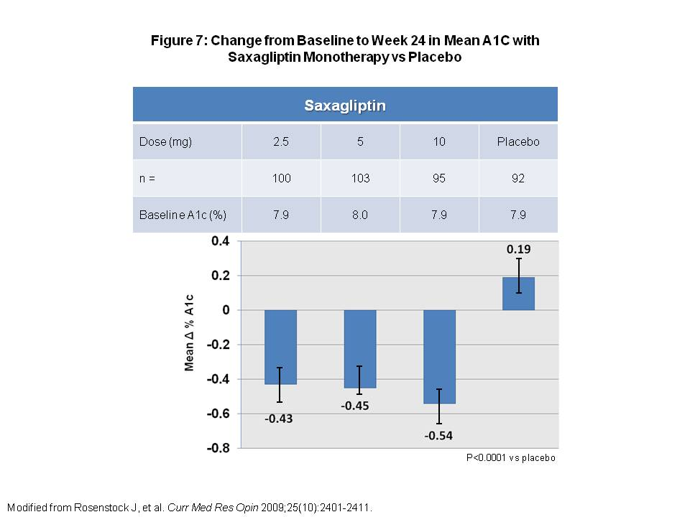
Figure 7: Change from Baseline to Week 24 in Mean A1C with Saxagliptin Monotherapy vs Placebo

Combination or Add-On Therapy Trials
Saxagliptin with Metformin
The efficacy of saxagliptin with MET as initial combination therapy was evaluated in a multicenter, randomized clinical trial with 1306 treatment naïve patients with type 2 diabetes and inadequate glycemic control (A1C 8-12%). Patients were randomized to saxagliptin 5 mg with MET, saxagliptin 10 mg with MET, saxagliptin 10 mg monotherapy or MET monotherapy. After 24 weeks, saxagliptin 5 mg with MET and saxagliptin 10 mg with MET demonstrated statistically significant decreases in A1C and FPG compared with saxagliptin 10 mg and MET monotherapies (Figure 8). A1C <7% was achieved in 60.3% and 59.7% for saxagliptin 5 mg with MET and saxagliptin 10 mg with MET, respectively (P<0.001 vs monotherapy)(35).
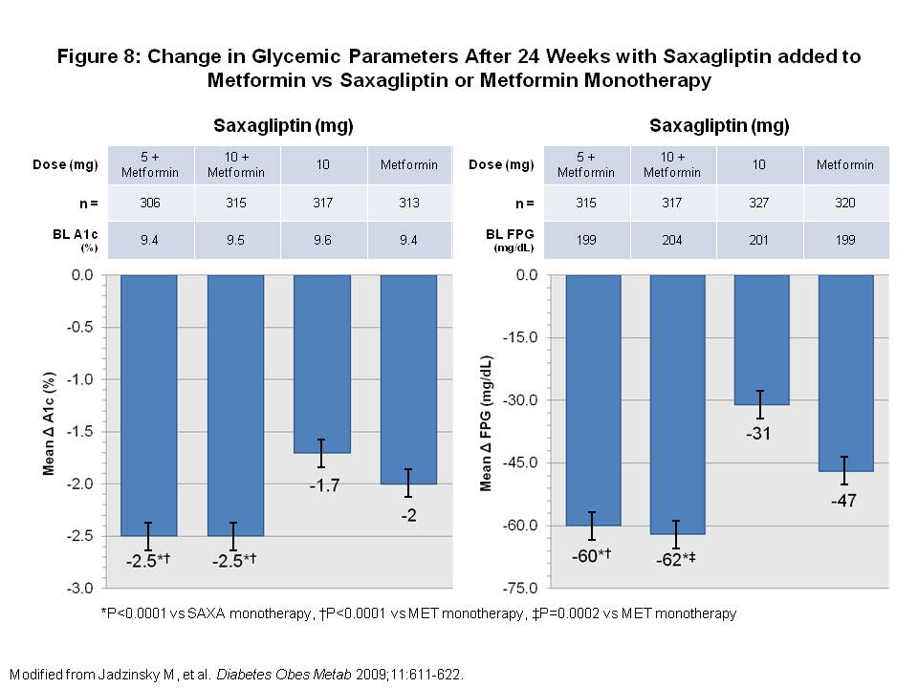
Figure 8: Change in Glycemic Parameters After 24 Weeks with Saxagliptin added to Metformin vs Saxagliptin or Metformin Monotherapy

Saxagliptin Added to Metformin
A 24 week trial assessed the efficacy of saxagliptin added on to type 2 diabetic patients with inadequate control on MET monotherapy (baseline A1C 7-10%). 743 patients were randomized to receive either saxagliptin (2.5, 5, or 10 mg daily) or placebo plus stable dose of MET (1,500-2,500 mg). Saxagliptin (2.5, 5, and 10 mg) plus MET demonstrated significantly reduced A1C from baseline to week 24 (-0.59, -0.69, -0.58% vs +0.13%; all P<0.0001). FPG and PPG were also significantly reduced compared with placebo, and more than twice as many patients on saxagliptin plus MET achieved A1C <7% compared with placebo. Hypoglycemic events and weight reductions were similar in the 2 groups(36).

Saxagliptin Added to Glyburide
To assess efficacy and safety of saxagliptin added to glyburide vs up titration of glyburide monotherapy, 768 patients with A1C 7.5-10% were randomized to saxagliptin 2.5 or 5 mg in combination with glyburide 7.5 mg or placebo with glyburide 10 mg for 24 weeks. In the glyburide-only arm, blinded up titration of glyburide was allowed up to maximum dose of 15 mg daily. By 24 weeks, 92% of glyburide-only patients were uptitrated to 15 mg daily. Saxagliptin 2.5 and 5 mg significantly decreased A1C and FPG compared with glyburide monotherapy (Figure 9). The mean change in 2-hour PPG from baseline was -31 mg/dl for saxagliptin 2.5 mg, -34 mg/dl for saxagliptin 5 mg and +8 mg/dl for up titrated glyburide (P<0.0001). There was no significant difference in the incidence of hypoglycemia between the groups. Body weight increased in all groups and was significantly greater in the saxagliptin 2.5 and 5 mg groups versus up titrated glyburide (+0.7kg [P=0.0381] and +0.8,g [P=0.0120], respectively vs. +0.3 kg)(37).

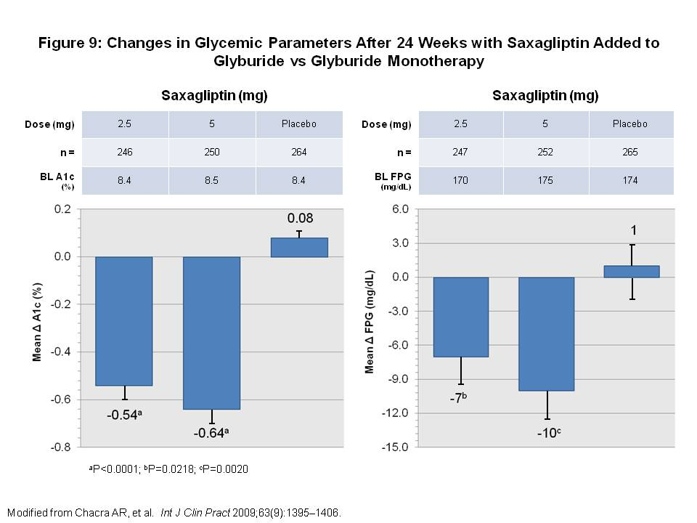
Figure 9: Changes in Glycemic Parameters After 24 Weeks with Saxagliptin Added to Glyburide vs Glyburide Monotherapy

Saxagliptin Added to Thiazolidinedione
To assess the efficacy of saxagliptin plus TZD in type 2 diabetic patients inadequately controlled on TZD monotherapy, 565 patients with A1C 7-10.5% on stable TZD monotherapy (pioglitazone 30 or 45 mg or rosiglitazone 4 or 8 mg) were randomized to saxagliptin (2.5 or 5 mg daily) or placebo plus stable TZD dose. After 24 weeks, saxagliptin 2.5 and 5 mg plus TZD significantly decreased A1C and FPG compared with placebo (Figure 10). The proportion of patients achieving A1C <7% was 42.2% (P=0.001) and 41.8% (P=0.0013) in the saxagliptin 2.5 and 5 mg groups, respectively, vs 25.6% in the placebo group. PPG area under the curve (AUC) was also significantly reduced in saxagliptin groups compared with placebo (P<0.0001). Hypoglycemic event rates were similar in all groups(38).

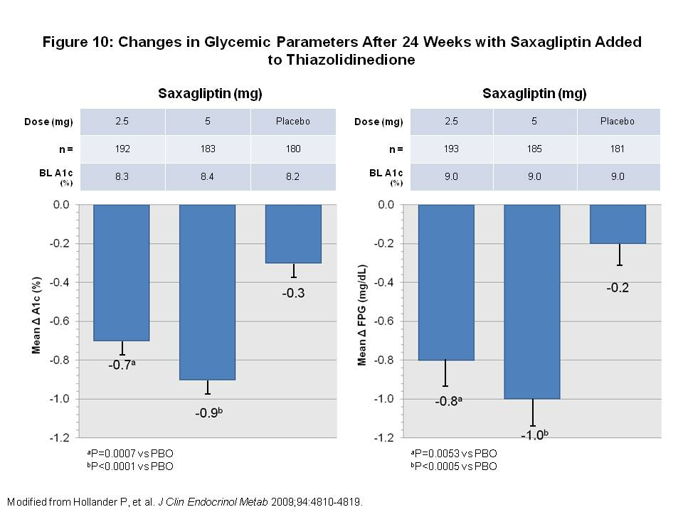
Figure 10: Changes in Glycemic Parameters After 24 Weeks with Saxagliptin Added to Thiazolidinedione

Side effects/Contraindications
Saxagliptin is well tolerated for the most part. Side effects include upper respiratory tract infection, urinary tract infection, nasopharyngitis and headache.
Prescribing
The recommended dose of saxagliptin is 2.5 mg or 5 mg daily. Renal function should be evaluated prior to starting therapy and while on therapy. For patients with moderate or severe renal impairment (CrCl ≤50mL/min) or with end stage renal disease requiring dialysis, the recommended dose is 2.5 mg daily. For patients taking strong cytochrome P450 3A4/5 inhibitors, the recommended dose is also 2.5 mg daily. Saxagliptin comes in combination pills with MET (Table 2).

Linagliptin
Linagliptin is another DPP-4 inhibitor. It is approved for use as monotherapy, in adjunct to diet and exercise in type 2 diabetic patients or in addition to MET, SFU or TZDs. Linagliptin is the first DPP-4 inhibitor approved for use at one dosage strength. No dose adjustment is needed for renal or hepatic impairment. Linagliptin is excreted unchanged mainly in the feces. With 5 mg daily dosing, a steady-state plasma concentration is reached by the third dose.

Monotherapy Trials
The safety and efficacy of linagliptin was demonstrated in a 24 week trial with 503 type 2 diabetic patients. Patients were randomized to receive either linagliptin 5 mg daily (n = 336) or placebo (n = 167). Before randomization, patients pre-treated with one oral anti-diabetic agent underwent a 6 week washout period, including a placebo run-in period the last 2 weeks. Patients previously untreated with an oral anti-diabetic agent underwent a 2 week placebo run-in period as well. Treatment with linagliptin significantly lowered A1C from baseline by -0.69% (P<0.0001) compared with placebo (Figure 11). In patients with baseline A1C≥9%, the adjusted A1C reduction was -1.01% (P<0.0001) compared with placebo. Patient treated with linagliptin were more likely to achieve A1C reduction of ≥ 0.5% at 24 weeks compared to placebo (47.1 vs 19.0%, respectively, P<0.0001). FPG improved by -1.3 mmol/l (P<0.0001) in the linagliptin group compared with placebo. Linagliptin also significantly reduced 2 hr PPG by -3.2 mmol/l (P<0.0001) compared with placebo. There was increased risk of hypoglycemia with linagliptin treatment compared with placebo(39).

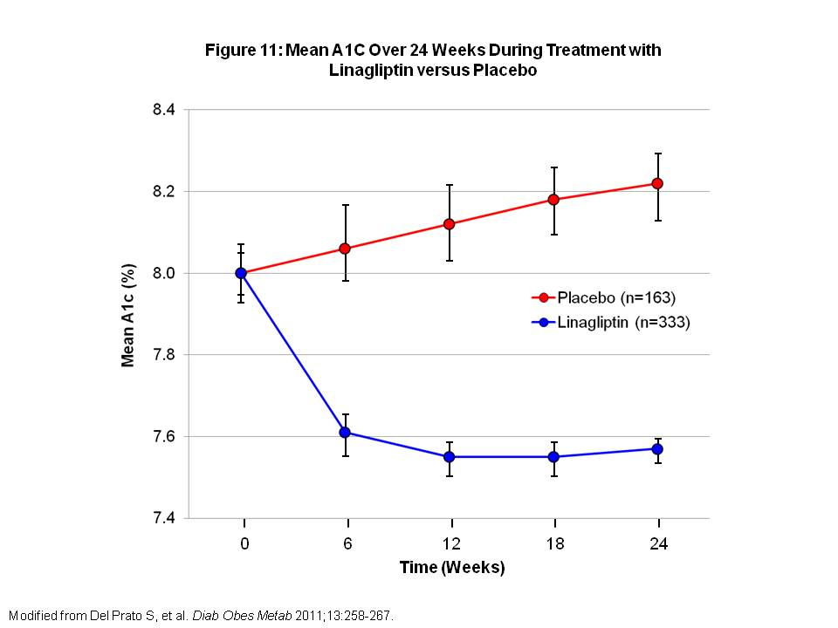
Figure 11: Mean A1C Over 24 Weeks During Treatment with Linagliptin versus Placebo

Combination or Add-On Therapy Trials
Linagliptin Added to Metformin
Linagliptin as add-on therapy in type 2 diabetic patients inadequately controlled on MET and maximum of one other oral anti-diabetic agent was evaluated in a 24 week trial. There were a total of 701 patients with baseline A1C 7-10%. Patients on another oral anti-diabetic agent other than MET were discontinued on the other agent and continued on MET for 6 weeks, including a 2 week placebo run-in period. Patients were then randomized to receive linagliptin 5 mg daily or placebo in addition to continuing stable dose of MET. Linagliptin showed significant A1C reduction of -0.49% compared with increase of 0.15% in the placebo group (P<0.0001). FPG and 2-hr PPG were also significantly reduced in the linagliptin group compared with placebo (-0.59 vs 0.58 mmol/l and -2.7 vs 1.0 mmol/l, respectively, P<0.0001 for both). Hypoglycemia occurred in 0.6% of patients in the linagliptin group and 2.8% in the placebo group. No significant weight changes were noted from baseline in either group(40).

Linagliptin Added to Metformin and a Sulfonylurea
The efficacy and safety of linagliptin was evaluated in type 2 diabetic patients inadequately controlled by MET and SFU combination treatment. 1058 patients were randomized to receive linagliptin 5 mg daily or placebo added to their MET and SFU treatment. After 24 weeks, linagliptin was superior to placebo for adjusted mean change in A1C from baseline to week 24 (-0.62%, 95% CI -0.73 to -0.50; P<0.0001). Adjusted mean change in FPG was greater with linagliptin compared with placebo (-0.7 mmol/l, 95% CI -1.0 to -0.4; P<0.0001). Hypoglycemia occurred more frequently in the linagliptin group (22.7%) compared to placebo (14.8%; odds ratio 1.64, 95% CI 1.14-2.38; P-0.0083). No significant weight changes were observed in either group(41).

Linagliptin and Pioglitazone as Initial Therapy
Linagliptin with pioglitazone as initial therapy was evaluated in a 24 week trial. Patient were randomized to receive combination of pioglitazone 30 mg daily plus linagliptin 5 mg daily (n=259) or pioglitazone with placebo (n=130). After 24 weeks of treatment, the adjusted mean change in A1C with linagliptin plus pioglitazone was -1.06% compared with -0.56% in the pioglitazone plus placebo group (Figure 12). Adjusted mean difference in A1C between the groups was -0.51% (95% CI -1.2, -0.4; P<0.0001). Greater proportion of patients taking linagliptin plus pioglitazone achieved A1C <7% compared with placebo (42.9 vs. 30.5%, respectively; P=0.0051) and reduction of A1C ≥ 0.5% (75 vs. 50.8%, respectively; P<0.0001)(42).

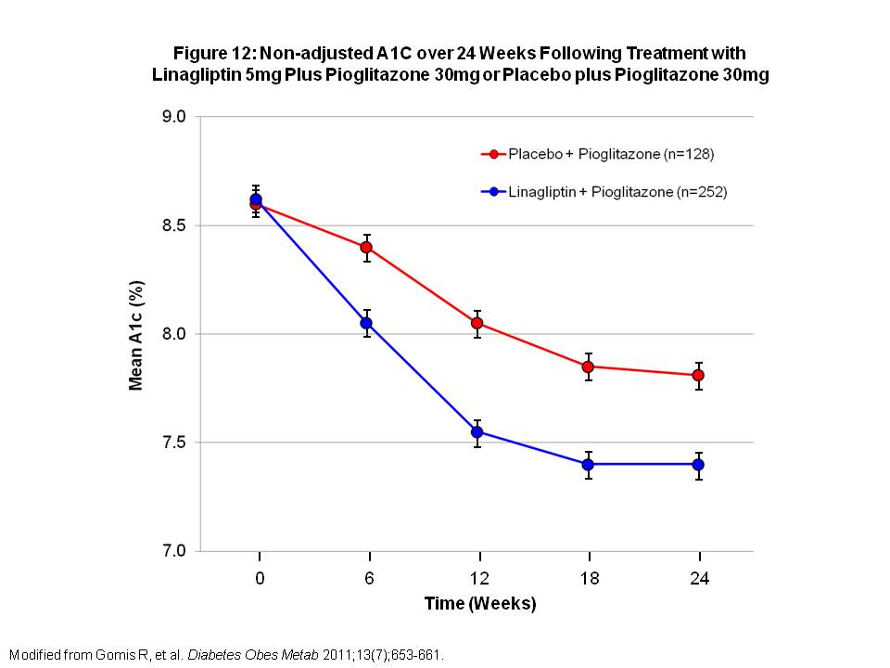
Figure 12: Non-adjusted A1C over 24 Weeks Following Treatment with Linagliptin 5mg Plus Pioglitazone 30mg or Placebo plus Pioglitazone 30mg

Linagliptin Compared with Glimepiride in Patients on Metformin
In a 2 year non-inferiority trial, patients with type 2 diabetes on MET alone or with one additional oral anti-diabetic agent were randomized to receive linagliptin 5 mg daily (n=777) or glimepiride 1-4 mg daily (n=775). Glimepiride was started at 1 mg daily and electively titrated up to maximum dose of 4 mg daily over 12 weeks to optimize glycemic control. Patients on another oral anti-diabetic agent underwent a 6 week run-in period with MET and washout of the other agent. After 2 years, reduction in adjusted mean A1C (baseline 7.7% in both groups) were similar in the linagliptin (-0.16%) and glimepiride groups (-0.36%). The difference between treatment groups was 0.20% which met non-inferiority criterion (97.5% CI 0.09-0.3; P=0.0004). Fewer patients had hypoglycemia in the linagliptin compared with glimepiride group (7% vs 36%, P<0.0001)(43).

Side effects/Contraindications
In general, linagliptin is well tolerated. Nasopharyngitis was the most common side effect reported for linagliptin in placebo-controlled trials.

Prescribing
Linagliptin is started at the recommended dose of 5 mg daily as monotherapy or combination therapy. It can be taken with or without food. No dose adjustment is needed for renal or hepatic impairment.

Alogliptin
Alogliptin is the newest DPP-4 inhibitor approved for use. It is approved for use as monotherapy or combination therapy with metformin (MET), sulfonylurea (SFU), thiazolidinedione (TZD) and insulin.

Monotherapy Trials
The efficacy and safety of alogliptin was evaluated in a 26 week randomized, double-blind, placebo-controlled trial. 329 type 2 diabetic patients with mean baseline A1C 7.9% were randomized to once daily alogliptin 12.5 mg, 25 mg or placebo. At the end of the study, mean A1C change was significantly greater for the alogliptin 12.5 mg (-0.56%) and 25 mg (-0.59%) groups compared with placebo (-0.02%; P < 0.001 for both comparisons). Fasting plasma glucoses were also significantly reduced with alogliptin 12.5 mg (-10.3 mg/dl) and 25 mg (-16.4 mg/dl) compared with placebo (+11.3 mg/dl; P < 0.001 for both comparisons). Overall incidences of adverse events and hypoglycemia were similar between all three groups(44).

Combination or Add-On Therapy Trials
Alogliptin Added to Metformin
The efficacy of alogliptin added to MET was studied in a randomized, double-blind trial in type 2 diabetic Japanese patients who were inadequately controlled on MET. 288 patients were randomized to either alogliptin 12.5 mg or 25 mg once daily plus MET or placebo plus MET. After 12 weeks, A1C reduction from baseline was significantly greater for alogliptin 12.5 mg plus MET (-0.55%) and 25 mg plus MET (-0.64%) compared with placebo plus MET (0.22%; P < 0.0001 for both comparisons). In an open-label extension trial for an additional 40 weeks, 276 patients continued on either alogliptin 12.5 mg or 25 mg plus MET. Over 52 weeks, there were no safety or tolerability concerns with alogliptin and MET combination therapy(45).

Alogliptin Added to Metformin and Pioglitazone
Adding on alogliptin versus uptitrating pioglitazone dose in type 2 diabetic patients who were inadequately controlled on MET and pioglitazone was compared in a double-blind, parallel group study. Patients at baseline were receiving MET (≥ 1500 mg or maximum tolerated dose) and pioglitazone 30 mg daily. They were randomized to receive alogliptin 25mg (n = 404) or additional pioglitazone 15 mg daily (for total of 45mg daily; n = 399) for 52 weeks. The alogliptin group had greater A1C change from baseline compared with pioglitazone group (-0.70 vs -0.29%; P < 0.001). A greater proportion of patients in the alogliptin group achieved A1C ≤ 7% compared with the pioglitazone group (33.2 vs 21.3%; P < 0.001). Hypoglycemia rates were 4.5% in the alogliptin group versus 1.5% in the pioglitazone group. The addition of alogliptin to MET and pioglitazone regimen resulted in superior glycemic control compared with uptitrating pioglitazone dose(46).

Alogliptin Added to Glyburide
The efficacy and safety of alogliptin in combination with glyburide was evaluated in type 2 diabetic patients inadequately controlled on SFU monotherapy. Patients first entered a 4 week run-in period where they were switched from their original SFU to an equivalent glyburide dose and placebo. After the run-in period, patients were randomized to alogliptin 12.5 mg (n = 203), 25 mg (n = 198) or placebo (n = 99) once daily. Mean A1C was around 8.1% in each group. By week 26, A1C reductions were -0.38% and -0.52% versus +0.01% (P < 0.001) in the alogliptin 12.5 mg and 25 mg versus placebo groups, respectively. More patients in the alogliptin 25mg group had A1C ≤ 7% by week 26 compared with placebo (34.8 vs 18.2%; P = 0.002). Hypoglycemia rates were not significantly different among the three groups. Addition of alogliptin to glyburide monotherapy resulted in significant A1C reductions (47).

Alogliptin Added to Insulin
In a 26 week double-blind trial, 390 type 2 diabetes patients were randomly assigned to receive alogliptin 12.5 mg, 25 mg or placebo once daily as add-on to stable insulin therapy with or without MET. Mean baseline A1C was 9.3%. By the end of the study, A1C reduction was significantly greater for alogliptin 12.5 mg (-0.63%) and 25 mg (-0.71%) compared with placebo (-0.13%; P < 0.001) (Figure 13). Hypoglycemia rates were similar for alogliptin 12.5 mg (27%), 25 mg (27%) and placebo (24%) groups. Mean weight increase were also similar for all three groups, around 0.6-0.7 kg. Alogliptin added on to insulin therapy with or without MET improved glycemic control without causing significant weight gain or increasing incidence of hypoglycemia(48).

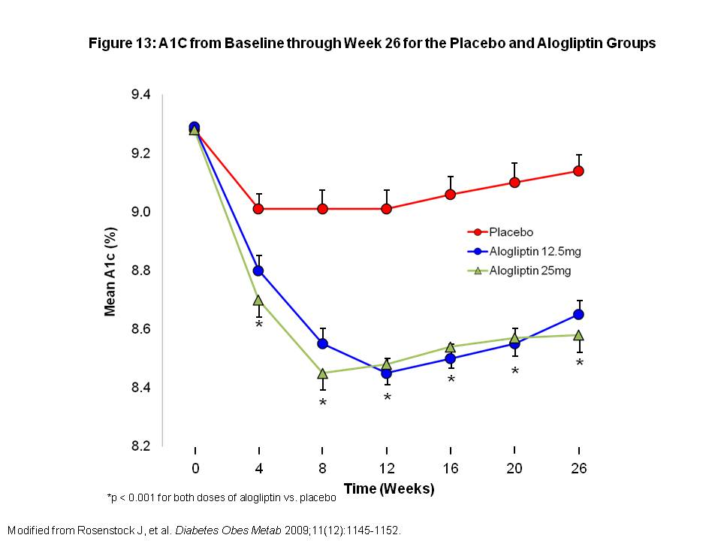
Figure 13: A1C from Baseline through Week 26 for the Placebo and Alogliptin Groups

Side effects/Contraindications
The most frequent adverse reactions for alogliptin are nasopharyngitis, headache and upper respiratory tract infection.

Prescribing
Alogliptin is started at a dose of 25 mg daily, taken with or without food. Dose adjustment to 12.5 mg daily is necessary for patients with moderate renal impairment (CrCl ≥ 60 mL/min) and to 6.25 mg daily for severe renal impairment (CrCl 15-30 mL/min) and end-stage renal disease (CrCl < 15mL/min). Renal function should be checked prior to initiation of alogliptin and periodically while on the medication.

SGLT2 Inhibitors
Sodium-glucose co-transporters (SGLTs) are responsible for glucose reabsorption in the kidney. 90% of glucose reabsorption is accounted for by SGLT2 located in the S1 segment of proximal tubules, while SGLT1 located in the S2/S3 segments of the proximal tubule accounts for 10% of glucose reabsorption. The discovery of SGLT inhibitors as a novel therapeutic agent for treatment of diabetes came from experiments in the 1800s with phlorizin (isolated from root bark of apple trees), which improved blood glucose in laboratory animals. Observations of patients with familial renal glycosuria, a rare genetic abnormality in SGLT, lent further support for development of SGLT inhibitors given that chronic dysfunction of SGLT does not appear to result in significant adverse renal effects. SGLT2 inhibitors’ mechanism of action is through elimination of glucose through the kidneys. Currently, there are two SGLT2 inhibitors available, dapagliflozin in Europe and canagliflozin in the United States.
Dapagliflozin
Dapagliflozin was the first SGLT2 inhibitor approved for use in Europe. However, the FDA did not approve the drug for use in the U.S. and instead, asked for more data regarding its benefits and risks. The FDA advisory committee recommended against approving the drug, citing concerns over potential breast and bladder cancer risks. It is approved for use in adjunct to diet and exercise and in combination with other oral anti-diabetic agents and insulin.

Monotherapy Trials
The efficacy and safety of dapagliflozin as monotherapy for type 2 diabetes was studied in a 12 week Japanese trial. A total of 279 patients were randomized to receive various doses of dapagliflozin (1, 2.5, 5 or 10 mg/day) or placebo once daily. Significant A1C reductions were seen with all dapagliflozin doses (-0.11 to -0.44%; P <0.0001 for all) compared with placebo (+0.37%). Fasting plasma glucoses were also significantly reduced with all dapagliflozin doses (-15.6 to -31.9 mg/dl; P <0.0001 for all) compared with placebo (+11.17 mg/dl). Signs and symptoms suggestive of urinary tract infections and genital infections occurred in 0-3.8% and 0-1.8%, of patients in the dapagliflozin treated groups compared with 1.9% and 0%, in the placebo group. Dapagliflozin monotherapy for 12 weeks significantly improved glycemic control compared with placebo with low risk of adverse events(49).

Combination or Add-On Therapy Trials
Dapagliflozin Added to Metformin
In a a phase 3 multicenter, double blind, placebo controlled trial, the effect of dapagliflozin added to metformin in patients inadequately controlled on metformin monotherapy was studied. 546 patients were randomized one of three dapagliflozin doses (2.5mg, 5mg or 10mg daily) or placebo. All patients were on metformin ≥1500mg daily with baseline A1C of around 8%. After 24 weeks, mean A1C reduction was -0.30% in the placebo group compared to -0.67% (P = 0.0002), -0.70% (P < 0.0001) and -0.84% (P < 0.0001) in the dapagliflozin 2.5, 5 and 10mg groups, respectively. Rates of hypoglycemia were similar in the dapagliflozin (2-4%) and placebo groups (3%). Rates of genital infections were higher in the dapagliflozin 2.5, 5 and 10 mg groups (8%, 13%, 9%, respectively) compared with placebo (5%). Weight reduction was significantly higher in the dapagliflozin 2.5, 5 and 10mg groups (-2.2, -3.0 and -2.9 kg, respectively, P <0.0001 for all) compared with placebo group (-0.9kg). (50).

Dapagliflozin Added to Glimepiride
The effect of dapagliflozin in combination with glimepiride was evaluated in a 24 week trial of 597 patients inadequately controlled on glimepiride. Subjects were randomly assigned to placebo or dapagliflozin 2.5, 5 or 10mg daily added to glimepiride 4 mg daily. At the end of the trial, A1C changes in all dapagliflozin groups were significantly greater compared with placebo (all P < 0.0001) (Figure 14). Change in body weight was -0.72 kg in the placebo group versus -1.18, -1.56, -2.26 kg in the dapagliflozin 2.5, 5, and 10mg groups, respectively. Hypoglycemia occurred in 4.8% of placebo group versus 7.1-7.9% in the dapagliflozin groups. Genital infection rate was 0.7% versus 3.9-6.6% and urinary tract infection was 6.2% versus 3.9-6.9% in the placebo versus dapagliflozin groups, respectively(51).

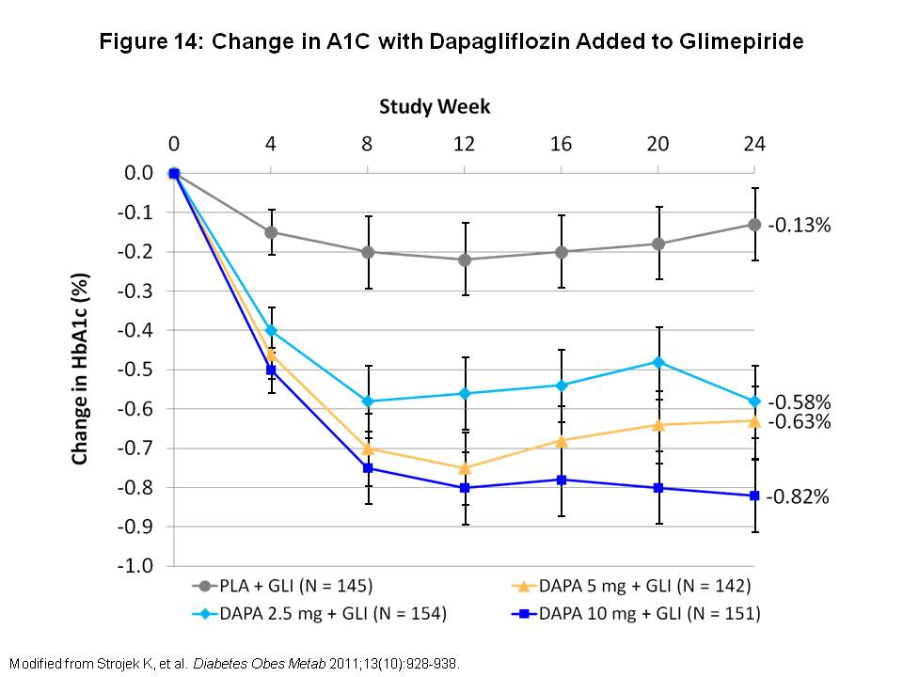
Figure 14: Change in A1C with Dapagliflozin Added to Glimepiride

Dapagliflozin Added to Pioglitazone
In a 48 week trial, efficacy of dapagliflozin in combination with pioglitazone was evaluated. Patients first entered a 10-week pioglitazone monotherapy dose-optimization period. They were then randomized to dapagliflozin 5mg (n=141), 10mg (n=140) or placebo (n=139) daily plus open-label pioglitazone. At the end of 24 weeks, mean A1C reduction from baseline was -0.42% for placebo compared with -0.82 and -0.97% for dapagliflozin 5 and 10 mg, respectively (P = 0.0007 and P < 0.001). By week 48, the pioglitazone alone group had greater weight gain (3 kg) compared with dapagliflozin plus pioglitazone (0.7-1.4 kg). Hypoglycemia was rare during the 48 weeks. Genital infections were more frequent in the dapagliflozin groups (8.6-9.2%) compared with placebo (2.9%). Rates of urinary tract infection were similar for dapagliflozin (5.0-8.5%) and placebo groups (7.9%). Edema occurred more frequently in pioglitazone alone group (6.5%) compared with dapagliflozin plus pioglitazone (2.1-4.3%)(52).

Dapagliflozin Added to Insulin
Long-term efficacy of dapagliflozin in type 2 diabetic patients on insulin was evaluated in a 24 week, randomized, multicenter trial, followed by a 24 week extension period. A total of 808 patients with inadequate glycemic control on at least 30 u of insulin daily with or without up to 2 oral anti-diabetic agents were randomized to dapagliflozin 2.5, 5, or 10mg or placebo daily. After 24 weeks, A1C decreased by 0.79 to 0.96% in the dapagliflozin groups compared with 0.39% in the placebo group. Daily insulin dose decreased by 0.63 to 1.95u in the dapagliflozin groups compared with an increase of 5.65 u in the placebo group. Body weight decreased by 0.92 to 1.61 kg in the dapagliflozin groups compared with weight gain of 0.43 kg in the placebo group. These effects were maintained at 48 weeks. Compared with placebo, dapagliflozin groups had higher rates of hypoglycemia (51.8 vs 56.6%), genital infections (2.5 vs 9.0%) and urinary tract infections (5.1 vs 9.7%)(53).

Side effects/Contraindications
The most common adverse effects associated with dapagliflozin are genital and urinary tract infections. Nasopharyngitis, headache, upper respiratory tract infections, back pain and diarrhea have also been reported. The FDA advisory committee had concerns about dapagliflozin-associated breast cancer, bladder cancer and liver dysfunction, which will require further long-term studies. Dapagliflozin alone has low risk of hypoglycemia, but used in combination with other agents such as sulfonylureas and insulin may increase the risk of hypoglycemia.

Prescribing
Dapagliflozin should be initiated at a dose of 10mg once daily. It can be taken at any time of day, regardless of food intake. For patients at risk for volume depletion due to other medical conditions or medication usage, a starting dose of 5 mg daily is recommended. Dapagliflozin is contraindicated in patients with GFR <45 ml/min.

Canagliflozin
Canagliflozin was the first SGLT2 inhibitor approved for use in the United States. Despite its approval, canagliflozin is still required to undergo postmarketing studies to assess cardiovascular outcomes, especially the increased risk of stroke. Unlike dapagliflozin, canagliflozin does not appear to have increased risk of malignancy. It is approved for use as an adjunct to diet and exercise and in combination with other oral agents and insulin.

Monotherapy trials
The efficacy and safety of canagliflozin monotherapy was evaluated in type 2 diabetic patients inadequately controlled with diet and exercise. In a 26-week randomized, placebo controlled trial, 584 subjects received canagliflozin 100mg, 300mg or placebo daily. At the end of the study, A1C reduction was significantly higher with canagliflozin 100mg and 300mg compared with placebo (-0.77 and -1.03 vs. 0.14%, respectively, p <0.001 for both). Differences in least significant mean changes in fasting plasma glucose were -2.0 and -2.4 mmol/l for canagliflozin 100 and 300mg compared with placebo, respectively (P <0.001 for both). Body weight reductions were -2.5 kg and -3.4 kg for canagliflozin 100 and 300 mg compared with -2.5 kg for placebo (P < 0.001 for both). Hypoglycemia rates were similar with canagliflozin 100, 300 mg and placebo (3.6, 3.0 and 2.6%, respectively). There was a modest increase in rates of urinary tract infection in the canagliflozin 100 and 300 mg groups (7.2 and 5.1%, respectively) compared with placebo (4.2%). Genital infections were higher in the canagliflozin 100 and 300mg groups for both males (2.5 and 5.6%, respectively) and females (8.8 and 7.4%, respectively) compared with placebo (males 0%, females 3.8%). Overall, canagliflozin improved glycemic control, reduced body weight and was well tolerated(54).

Combination or Add-On Therapy Trials
Canagliflozin Added to Metformin
Canagliflozin as add-on therapy to metformin was evaluated in a double-blind, placebo-controlled multicenter trial of 451 subjects inadequately controlled on metformin monotherapy. Patients were randomized to canagliflozin 50, 100, 200 or 300 mg daily or 300mg BID, sitagliptin 100mg daily or placebo for 12 weeks. A1C reductions for the canagliflozin groups were significantly higher (-0.79, -0.76, -0.70, -0.92, -0.95% for canagliflozin 50, 100, 200, 300 mg daily and 300 mg BID, respectively) compared with placebo (-0.22%) and similar compared to sitagliptin (-0.74%). In the canagliflozin groups, fasting plasma glucose was reduced by -16 to -27 mg/dL compared with +3.6 mg/dL for placebo and -12.6 mg/dL for sitagliptin. Body weight was reduced by -2.0 to -2.9 kg in the canagliflozin groups compared to -0.8 kg and -0.4 kg in the placebo and sitagliptin groups, respectively. Canagliflozin groups had higher rates of gential infections (3-8%) compared with placebo and sitagliptin (2%). Urinary tract infection rates were 3-9% of canagliflozin, 6% of placebo and 2% of sitagliptin groups. Hypoglycemia rates were low for all arms(55).

Canagliflozin Added to Insulin
Canagliflozin in combination wtih insulin was evaluated in a 28 week study of 29 patients inadequately controlled on insulin and up to one oral anti-diabetic agent. Subjects were randomized to canagliflozin 100 mg daily, 300 mg BID or placebo. A1C reductions were -0.73 and -0.92% with canagliflozin 100 mg daily and 300mg BID, respectively, compared with -0.19% with placebo (P < 0.05 for canagliflozin 300 mg BID). Body weight changes were -0.73kg and -1.19 kg with canagliflozin 100mg daily and 300mg BID, respectively, compared with +0.03 kg with placebo (P < 0.05 for canagliflozin 300 mg BID). Adverse events were similar across all groups(56).

Side effects/Contraindications
The most common side effects of canagliflozin are vaginal yeast and urinary tract infections. Hypotension can occur after starting canagliflozin as a result of intravascular volume contraction. This is especially likely in patients with impaired renal function, elderly patients and those on diuretics or medications that interfere with the renin-angiotensin-aldosterone system. Canagliflozin can increase serum creatinine and decrease GFR, especially in patients with hypovolemia. Renal function should be monitored frequently in those with GFR <60 ml/min. Risk of hypoglycemia on canagliflozin monotherapy is low, but risk is increase when used in combination with insulin or sulfonylurea/glinides. For unclear reasons, canagliflozin results in a dose-related increase in LDL.

Prescribing
The recommended starting dose for canagliflozin is 100mg daily to be taken before the first meal of the day. Maximum dose is 300mg daily in patients who have GFR >60 ml/min. In patients with GFR 45-60 ml/min, canagliflozin should be limited to 100mg daily, and it should not be used in patients with GFR < 45 ml/min. In patients with volume depletion, hypovolemia should be corrected prior to starting canagliflozin. For those taking UDP-glucuronosyl transferase enzyme inducers, such as rifampin, phenytoin, phenobarbital and ritonavir, consider increasing dose to 300mg daily if glycemic control is inadequate on 100mg daily.

α-Glucosidase Inhibitors

Acarbose and miglitol are the 2 α-glucosidase inhibitors available on the market. Alpha-glucosidase inhibitors are oral agents that work by slowing the digestion of complex carbohydrates into monosaccharides or glucose. This results in delayed carbohydrate absorption after meals, which decreases the post-prandial glucose (PPG). In general, α-glucosidase inhibitors are more effective the higher the carbohydrate content of the diet.

Acarbose
Acarbose can be used as monotherapy or in combination with other oral anti-diabetic drugs. It reduces mean PPG by about 50 mg/dL and fasting glucose by 10 to 20 mg/dL. Average A1C reductions are 0.5 to 1%.

Side effects/Contraindications
Main side effects of acarbose are GI related. The main side effect is flatulence followed by soft stools or diarrhea and abdominal pain. Side effects are dose related and tend to be worse during initial 8 weeks of therapy. Symptoms are due to the osmotic effect of undigested carbohydrate in the colon. Many patients are unable to tolerate acarbose because of GI side effects. However, because acarbose is not absorbed systemically, it may be considered safer than other oral anti-diabetic agents in the elderly and in patients with kidney disease.

Prescribing
Due to acarbose side effects, it is recommended that the drug be started at a dose of 25 mg daily and slowly titrated up to maintenance dose of 50 to 100 mg three times daily with meals.

Miglitol
Miglitol is the other available α-glucosidase inhibitor. It can be used as monotherapy or in combination with other oral anti-diabetic agents and insulin. Miglitol works mainly by lowering PPG. Average A1C reductions of 0.5 to 1% are seen, similar to acarbose.

Side effects/Contraindications
Miglitol’s side effects are similar to acarbose with flatulence as the main side effect.

Prescribing
The starting dose of miglitol is 25mg daily to be titrated up slowly to a maintenance dose of 25 to 50 mg three times daily with meals.

Sulfonylureas

Sulfonylureas (SFUs) work by stimulating insulin secretion from the pancreas. Increased insulin secretion results in reduced hepatic glucose output and increased peripheral glucose disposal. There are two groups of SFUs – first and second generation. First generation SFUs include acetohexamide, chlorpropamide, tolazamide and tolbutamide. Second generation SFUs include glipizide, glyburide and glimepiride. Both groups have similar efficacy, but second generation SFUs are more potent per milligram basis, have fewer side effects and interact less with other drugs. Here we discuss only second generation SFUs.

Second Generation Sulfonylureas
Glimepiride
Glimepiride is the only SFU approved by the FDA to be used in combination with insulin. Therapy should be started at the 1 to 2 mg once daily before breakfast. Dosage can be progressively increased every 1 to 2 weeks until therapeutic response is achieved. Maintenance dose is 1 to 4 mg once daily. Maximum recommended dose is 8 mg daily.

Glipizide
Glipizide is metabolized by the liver to mainly inactive products so it has a lower risk of hypoglycemia. Glipizide is often the preferred SFU if used in the elderly and those with significant renal impairment. Recommended starting dose is 5 mg once a day, which can be progressively titrated up to therapeutic dose. Maximum recommended dose is 40 mg daily. Dosing is 1 to 2 times daily for immediate-release glipizide. Glipizide also comes in extended release formulation (Glucotrol XL) which maintains therapeutic plasma levels for 24 hours and is prescribed as once a day dosing.

Glyburide
Glyburide is metabolized by the liver to mostly inactive products, but some of the by-products have hypoglycemic activity. Patients with liver or kidney dysfunction should be careful when taking glyburide. Recommended starting dose is 2.5 to 5 mg once a day, to be progressively titrated up to maximum therapeutic dose. Maximum recommended dose is 20 mg daily. Duration of action is 16 to 24 hours and dosing is recommended 1 to 2 times daily.

Side effects/Contraindications
SFUs tend to be well tolerated. Hypoglycemia is the most common side effect, especially with long-acting SFUs. Other side effects include weight gain, GI upset, skin reactions and abnormal liver function tests. These side effects occur less often in the second generation SFUs. Chlorpropamide, a first generation SFU, has a higher risk of severe hypoglycemia given its longer duration of action. Chlorpropamide also can result in hyponatremia, fluid retention and flushing reaction after alcohol ingestion.

Meglitinide

The meglitinides, repaglinide and nateglinide, are non-sulfonylurea (SFU) insulin secretagogues that are structurally different from the SFUs. They act by blocking ATP-dependent potassium channels in pancreatic beta cells, which depolarizes the cell and results in insulin secretion. Meglitinides promote insulin secretion only in the presence of glucose and have a very rapid onset and short duration of action, which should improve post-prandial control of hyperglycemia and reduce the risk of hypoglycemic events compared to SFUs.

Repaglinide
Repaglinide, a benzoic acid derivative, was first introduced in 1998. It is approved for use as monotherapy and in combination with metformin (MET) or thiazolidinediones (TZDs). Efficacy of repaglinide was evaluated in a randomized, double blind clinical trial. Type 2 diabetic patients (n=83) inadequately controlled on MET alone were randomized to one of three treatment groups: MET plus placebo, repaglinide plus placebo and MET plus repaglinide. MET dose remained unchanged while repaglinide was titrated from 0.5 mg/meal to 4 mg/meal in a 4 to 8 week period. After 3 months of maintenance therapy, A1C decreased from 8.6 to 8.3% in the MET group, 8.6 to 8.2% in the repaglinide group and 8.3 to 6.9% in the MET plus repaglinide group (P<0.001 vs baseline; P<0.05 vs each monotherapy group). By the end of the study, 59% of patients in the MET plus repaglinide groups achieved A1C ≤7% compared with 20% and 22% in the MET and repaglinide monotherapy groups, respectively. Mild hypoglycemia symptoms were seen in patients treated with repaglinide(57).

Prescribing
Starting dose for repaglinide is 0.5 mg/meal for patients who have not previously taken oral anti-diabetic agents or in patients with A1C <8%. For patients who previously have taken oral anti-diabetic agents or with A1C ≥8%, starting dose is 1 or 2 mg/meal. Repaglinide can be titrated up to 4 mg/meal for a daily maximum recommended dose of 16 mg/day. It should be taken 30 minutes to immediately before a meal. If patients skip a meal, repaglinide should not be taken for that meal. Repaglinide is available in combination tablet with MET (Table 2).

Side effects/Contraindications
Hypoglycemia is the most common side effect with repaglinide. Small weight gain is also seen when repaglinide is used as monotherapy. Repaglinide is metabolized by the liver with less than 10 percent of metabolites being renally excreted; therefore dose adjustment for renal impairment is not necessary.

Nateglinide
Nateglinide, a D-phenylalanine derivative, is approved for type 2 diabetes as initial monotherapy and in combination with MET. Efficacy of nateglinide was evaluated in a 24-week trial with 701 type 2 diabetic patients with A1C 6.8 to 11.0%. Patients underwent a 4 week run-in trial with nateglinide 120 mg before meals, MET 500 mg three times daily, combination therapy or placebo. At the end of 24 weeks, A1C was reduced by -0.5% and -0.8% in the nateglinide and MET groups, respectively, and increased by 0.5% in the placebo group (all P≤0.0001). The combination group was additive with A1C reduction of -1.4% (P≤0.01 vs monotherapy). With Sustacal challenge, there was greater reduction in mealtime glucose in the nateglinide group compared with MET or placebo (AUC_{0-130min} -2.1, -1.1, -0.6 mmol x h⁻¹ x 1⁻¹; P≤0.0001). An even greater effect was observed with combination therapy (AUC_{0-130min} -2.5 mmol x h⁻¹ x 1⁻¹; P≤0.0001).

Prescribing
Nateglinide is started at a dose of 120 mg/meal, taken before each meal, and dose titration is not required. If a patient is close to the A1C goal, nateglinide at a lowered dose of 60 mg/meal can be initiated. If a meal is skipped, patient should be instructed to not take nateglinide for that meal. No dose adjustment is required for renal or hepatic impairment.

Side effects/Contraindications
Hypoglycemia is the most common side effect and tends to be mild. Minimal weight gain of <1kg has also been observed. Nateglinide is metabolized by the liver and excreted by the kidney. Approximately 16% of the dose is excreted unchanged in the urine(58). Nateglinide is safe to use in elderly patients and requires no dose adjustments in renal or hepatic impairment.

Comparing Repaglinide and Nateglinide
Repaglinide and nateglinide monotherapy were compared in a multicenter 16-week clinical trial in 150 type 2 diabetic patients treated with diet and exercise. Baseline A1C ranged from 7 to 12%. Patients were randomized to receive repaglinide 0.5 mg/meal (up to maximum of 4 mg/meal) or nateglinide 60 mg/meal (up to maximum of 120 mg/meal). After 16 weeks, mean A1C reduction was significantly greater in the repaglinide group compared with nateglinide group (-1.57 vs -1.04%, P=0.002). Mean FPG reduction was also significantly greater in the repaglinide vs nateglinide group (-57 vs -18 mg/dL; P<0.001) (Figure 15). There were more episodes of minor hypoglycemia (defined as blood glucose <50 mg/dl) in the repaglinide vs nateglinide group, 7% vs 0%, respectively. Mean weight gain was 1.8 kg in the repaglinide group vs 0.7 kg in the nateglinide group(59).

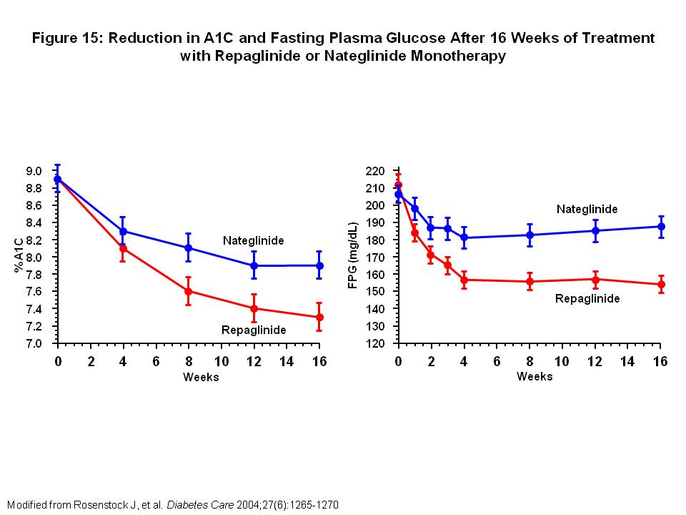
Figure 15: Reduction in A1C and Fasting Plasma Glucose After 16 Weeks of Treatment with Repaglinide or Nateglinide Monotherapy

Repaglinide and nateglinide in combination therapy with MET was compared in 192 patients with A1C 7-12% during previous treatment with a SFU, MET or low dose Glucovance (glyburide ≤2.5 mg, MET ≤500 mg). Patients underwent a 4 week run-in period with MET titrated up to 1000 mg bid then were randomized to repaglinide 1 mg/meal, maximum 4 mg/meal, or nateglinide 120 mg/meal, reduced to 60 mg/meal if needed. After 16 weeks, repaglinide with MET showed significantly greater A1C reduction and FPG compared with nateglinide with MET (-1.28 vs -0.67%; P<0.001; -39 vs -21 mg/dL; P=0.002). PPGs were not significantly different between the two groups(60).

In summary, comparison between repaglinide and nateglinide show that while both agents have similar effects on PPG, repaglinide, as monotherapy and in combination with MET, is significantly more effective in reducing A1C and FPG values.

Bile Acid Sequestrant

Colesevelam is a non-absorbed polymer that binds bile acids in the intestines and prevents their reabsorption. Colesevelam is approved for use in adjunct to diet and exercise in type 2 diabetes. The mechanism by which colesevelam works to improve glycemic control is unknown but available data suggests an effect to delay glucose absorption. It was initially developed to treat primary hyperlipidemia as monotherapy or in combination with an hydroxymethyl-glutaryl-coenzyme A (HMG CoA) reductase inhibitor.

In a 26 week randomized, double-blind, placebo controlled clinical trial, 316 subjects with inadequately controlled type 2 diabetes, A1C 7.5-9.5%, on metformin (MET) or MET with additional oral anti-diabetic drugs were randomized to colesevelam 3750 mg/day or placebo. Colesevelam significantly reduced mean placebo-corrected A1C (-0.54%; P<0.001). It also reduced LDL by 15.9% from baseline (P<0.001)(61).

Prescribing
The recommended dose of colesevelam is 3750 mg/day taken as 6 tablets (625 mg) once daily or 3 tablets twice a day with a meal or liquid. A sugar-free, oral suspension in a 3750 mg packet is also available to be mixed with water for patients who cannot tolerate taking 6 tablets a day.

Side effects/Contraindications
The main side effects of colesevelam are gastrointestinal. A total of 6.7% of colesevelam-treated patients and 3.2% of placebo-treated patients were discontinued from diabetes trials due to adverse reactions. This difference was mostly due to gastrointestinal side effects such as abdominal pain and constipation. Colesevelam can also increase triglycerides with a median increase of 5% compared to placebo in trials of patients with primary hyperlipidemia. Use of colesevelam is contraindicated in patients with history of bowel obstruction, triglyceride concentration >500 mg/dL, and in those with history of hypertriglyceridemia-induced pancreatitis.

Dopamine Receptor Agonist

Bromocriptine, an ergoline derivative, is a dopamine agonist that has been approved for use in adjunct to diet and exercise to improve glycemic control in type 2 diabetes. Bromocriptine’s mechanism of action is not clearly understood. However, it has been proposed that type 2 diabetic individuals have a low early morning dopaminergic tone and administering bromocriptine in the morning restores the circadian peak in central dopaminergic tone that normally occurs at this time in lean, healthy individuals. This could potentially result in preservation/induction of normal insulin sensitivity and glucose metabolism.
The safety and efficacy of bromocriptine was evaluated in four double-blind, placebo-controlled trials. In all trials, type 2 diabetic patients were randomized to either bromocriptine or placebo. Bromocriptine was started at an initial dose of 0.8 mg and increased by 0.8 mg weekly for 6 weeks to reach final dose of 4.8 mg/day, if tolerated. In the monotherapy trial, the bromocriptine group had a mean A1C change from baseline of -0.1% vs 0.3% in the placebo group. In one combination therapy trial with bromocriptine as add-on to sulfonylurea (SFU), mean A1C change from baseline were -0.1% and 0.4% in the bromocriptine and placebo groups, respectively. In a second combination therapy trial with add-on to SFU, mean A1C change from baseline were -0.4% and 0.3% in the bromocriptine and placebo groups, respectively. In the fourth 52-week trial, bromocriptine was added on to various oral anti-diabetic agents, mean A1C change from baseline was -0.4% in the bromocriptine group and 0% in the placebo group.

Prescribing
Initial starting dose for bromocriptine is 0.8 mg daily, to be titrated up weekly by 0.8 mg until maximum tolerated daily dose of 1.6 to 4.8 mg is reached. Bromocriptine should be taken within 2 hours of waking up in the morning and with food to decrease risk of gastrointestinal side effects.

Side effects/Contraindications
The most common side effects with bromocriptine are nausea, fatigue, dizziness, vomiting and headache. It can also cause orthostatic hypotension and syncope, especially upon therapy initiation and during dose escalation. Bromocriptine is contraindicated in patients with syncopal migraine as it can increase the likelihood of a hypotensive episode in these patients. It is also contraindicated in nursing woman as it can inhibit lactation.

The Cycloset (quick-release bromocriptine) safety trial was a 52-week, placebo controlled trial looking at the overall safety and cardiovascular safety of bromocriptine. A total of 3095 patients were randomized in a 2:1 ratio to bromocriptine or placebo in combination with their usual diabetes therapy. The frequency of serious adverse effects was comparable between the two groups, 8.6% in the bromocriptine group and 9.6% in the placebo group (HR 1.02 [96% one-sided CI 1.27]). Nausea was the most commonly reported adverse event in the bromocriptine group. Cardiovascular events were defined as a composite of myocardial infarction, stroke, coronary revascularization and hospitalization for angina or congestive heart failure. The bromocriptine group had fewer cardiovascular events compared to placebo (1.7% vs 3.2% respectively, HR 0.60 [95% two-sided CI 0.35-0.96]) resulting in a cardiovascular disease relative risk reduction of 40% in the bromocriptine group.

INSULIN THERAPY

Many type 2 diabetic patients will eventually require insulin therapy when diet, exercise and oral anti-diabetic agents are no longer adequate to achieve glycemic control. The length of time between diagnosis of diabetes and starting on insulin therapy is variable among patients because it is based on many different factors. One of the most important factors is the extent of beta cell exhaustion leading to relative endogenous insulinopenia. This then leads to the loss of compensatory hyperinsulinemia, which results in progressively worsening hyperglycemia. Weight gain, pregnancy, illness and certain medications can all contribute to worsening glycemic control in a previously well controlled patient on oral agents and as a result, tip the patient over to an insulin requiring regimen.

Table 4: Insulin Therapies and Their Time Course of Action
Insulin Preparation | Onset | Peak | Duration
Basal Insulins
Intermediate-Acting
Isophane (NPH) | 2-3 hrs | 6-8 hrs | 16-20 hrs
Long-Acting
Determir (Levemir) | 1-2 hrs | Relatively flat | Up to 24 hrs
Glargine (Lantus) | 1-2 hrs | Peakless | 24 hrs
Prandial Insulins
Short-Acting
Regular | 30 min | 2-3 hrs | 6-8 hrs
Fast-Acting
Aspart (Novolog) | Minutes | 1-3 hrs | 3-5 hrs
Lispro (Humalog)
Glulisine (Apidra)
Premixed Insulins
Humalog Mix 75/25, 50/50  (75% [50%] lispro suspension/25% [50%] lispro injection) | Minutes | 2 peaks: ~1hr, 6-8 hrs | 16-20 hrs
Humulin 70/30, 50/50  (70% [50%] human insulin suspension/30% [50%] human insulin injection) | 30 min | 2 peaks: 2-3 hrs , 6-8 hrs | 16-20 hrs
Novolog Mix 70/30  (70% aspart suspension/30% aspart injection) | 10-30 min | 2 peaks: 1hr, 4 hrs | Up to 24 hrs
Novolin 70/30  (70% NPH suspension/30% regular insulin injection) | 30 min | 2 peaks: 2 hrs, 12 hrs | Up to 24 hrs
Modified from Edelman, Steven and Henry, Robert. Diagnosis and Management of Type 2 Diabetes. 11th ed. United States: Professional Communications, Inc., 2011.

There are many different types of insulin available on the market currently, and choice of insulin should be individualized to match each patient’s lifestyle and needs. Table 4 gives a summary of the different insulin preparations and time course of action. There are no clear guidelines on how to start a patient on insulin therapy, but for most patients, basal insulin is the first form of insulin to be initiated.

In the Treating to Target in Type 2 Diabetes (4-T) study, 708 type 2 diabetic patients with suboptimal A1C (7 to 10%) on maximally tolerated doses of metformin (MET) and sulfonylurea (SFU) were randomly assigned to biphasic insulin aspart twice daily, prandial insulin aspart three times daily or basal insulin detemir once daily (twice daily if required). SFU was replaced by a second type of insulin if hyperglycemia became unacceptable after the first year of the study or subsequently if A1C >6.5%. After 3 years of treatment, A1C levels were similar in the biphasic (7.1%), prandial (6.8%) and basal (6.9%) insulin groups (P=0.28). However, fewer patients achieved A1C of ≤6.5% in the biphasic group (31.9%) than in the prandial (44.7%, P=0.006) or basal (43.2%, P=0.03) groups. Median rates of hypoglycemia per patient per year were lowest in the basal group (1.7), higher in the biphasic group (3.0), and highest in the prandial group (5.7) (P<0.001 for overall comparison). Mean weight gain was higher in the prandial group than in the biphasic or basal groups. Based on these results, the 4-T trial supports the initiation of insulin with basal insulin, which gives better glycemic control with less adverse effects(62, 63).

Combination Therapy
There are no clear guidelines on how to start a patient on insulin therapy. However, given that most patients starting insulin therapy have failed their oral anti-diabetic regimen, combination therapy is the most natural transition. Combination therapy refers to the use of oral anti-diabetic agents during the day and insulin at bedtime. Using either an intermediate or long-acting insulin at bedtime makes physiological sense because it treats fasting hyperglycemia that is seen in type 2 diabetes. Fasting blood glucose (FBG) is correlated with hepatic glucose production, which can be suppressed by bedtime insulin. The peak effect of intermediate-acting insulin at bedtime also correlates with the dawn phenomenon, usually occurring between 3 and 7 am. By bringing fasting glucoses to normal levels first, it gives oral agents a better chance of controlling postprandial hyperglycemia and maintaining euglycemia during the day.

Initial bedtime intermediate or long-acting insulin dosing can be based on average FBG, body weight or estimated low dose insulin (Table 5). To dose based on average FBG, divide the average FBG (mg/dL) by 18. To dose based on body weight, divide weight in kilograms by 10. Both these calculations give the initial dose of NPH, glargine or detemir to start at bedtime. A starting dose of 5-10 units of intermediate or long-acting insulin in lean patients and 10-15 units in obese patients is a conservative estimate. Initial starting dose should be titrated based on FBG readings every few days. A good way to titrate is to tell patients to increase insulin dose by 2-3 units every 3 days until FBG is between 80 to 140 mg/dL. If FBG falls below 80 mg/dL, patients should decrease insulin dose by 2-3 units until FBG is between 80 to 140 mg/dL (Table 6).

Table 5: Determining Dose of Insulin in Combination Therapy
To calculate initial doses of NPH, determir or glargine at bedtime:
- Based on average fasting glucose: Divide average fasting glucose (mg/dL) by 18
- Based on weight: Divide body weight (kg) by 10
- General estimate: 5-10 units for lean patients, 10-15 units in obese patients

Modified from Edelman, Steven and Henry, Robert. Diagnosis and Management of Type 2 Diabetes. 11th ed. United States: Professional Communications, Inc., 2011.

Table 6: Patient Instructions for Self-Adjustment of Evening Insulin
- You are starting insulin _______________ at a dose of _____ units administered at bedtime.
- If pre-breakfast blood sugar is >140 mg/dL for 3 days in a row, then increase evening insulin dose by 3 units.
- If pre-breakfast blood sugar is <80 mg/dL for 3 days in a row, then decrease evening insulin dose by 3 units.
- Remember to not increase insulin dose more frequently than every 3 days.
- If you have questions, please call me at ________________________________.
- Provider’s name: ___________________________________________________.

Modified from Edelman, Steven and Henry, Robert. Diagnosis and Management of Type 2 Diabetes. 11th ed. United States: Professional Communications, Inc., 2011.

Once FBG is in the target range, patients should then be asked to check pre-lunch, pre-dinner and bedtime glucoses to determine whether oral anti-diabetic agents are maintaining euglycemia during the day. A common situation is elevated post-dinner glucoses. If this is the case, bedtime intermediate or long-acting insulin can be switched to one of the premixed insulin therapies to cover for dinner. Premixed insulin contains rapidly acting insulin that will bring post-dinner glucoses down along with intermediate-acting insulin that will allow for overnight coverage. The problem with this regimen is that early morning hypoglycemia can occur because giving intermediate insulin at dinner results in an earlier peak of action.

After initiation of evening insulin, patients should be kept on their maximum doses of oral anti-diabetic agents. If daytime hypoglycemia starts to occur, oral anti-diabetic agents can be titrated down, especially SFUs. Once FBG is under control, combination therapy will be successful as long as oral anti-diabetic agents are able to maintain euglycemia during the day. However, once oral anti-diabetic agents are no longer able to control daytime glucoses, patients will either need to be switched to other classes of oral anti-diabetic agents or multiple injection regimens.

Multiple Daily Injections
After patients fail combination therapy (oral agents during the day and one basal insulin injection at night), they are most commonly advanced to multiple daily injections. One of the more common regimens in type 2 diabetes is a split-mixed regimen consisting of an intermediate-acting (NPH) and fast-acting insulin (aspart, lispro, regular insulin) injected pre-breakfast and pre-dinner. Obese patients may need insulin doses up to 1 unit per kilogram of body weight. The total daily dose can be divided equally between pre-breakfast and pre-dinner injections with 70% of total insulin requirement given as NPH and 30% as prandial insulin. The morning fast-acting insulin provides glycemic control between breakfast and lunch while NPH peaks around lunch and provides glycemic control between lunch and dinner. Dinnertime fast-acting insulin provides coverage from dinner until bedtime, and dinnertime NPH provides overnight coverage.

An alternative to the split-mixed regimen is the premixed insulin (Table 4). This regimen also consists of two injections per day, but with the convenience of having two types of insulin already mixed together. Patients can be started on premixed insulin at an initial total daily dose of 0.4 to 0.8 units per kilogram body weight split equally between pre-breakfast and pre-dinner injections. Thin type 2 diabetic patients are more prone to hypoglycemia and should be started on a lower total daily dose of premixed insulin, around 0.2 to 0.5 units per kilogram body weight. Although more convenient, premixed insulin does not allow for specific titrations of each insulin component in the mixture.

For patients who are not controlled on combination or split-mixed regimens, the next step in therapy is the more intensive insulin regimen with basal bolus insulin. Basal bolus regimen consists of a basal insulin for continuous coverage during the day and night with bolus insulin given with meals to cover for post-prandial glucose (PPG) peaks. This type of regimen more closely mimics physiological insulin delivery and is used in both type 1 and type 2 diabetic patients. Basal bolus insulin also allows for more flexibility when patients have poor appetite or erratic schedules that do not allow for regular meals. Using fast-acting insulin in this regimen allows patients to inject insulin immediately prior to a meal, and basal insulin can be given as glargine once a day or detemir or NPH once or twice daily based on patient needs. Although more flexible and physiologic, basal bolus insulin can require up to 4 separate injections a day, which may overwhelm patients and decrease the rate of compliance. Basal bolus insulin regimens should be reserved for patients who are motivated.

Choosing Between Different Insulin Types
There is no one regimen that fits all. Diabetes management should be an individualized decision between patient and physician depending on patient motivation, lifestyle, comorbidities, risk of hypoglycemia and treatment goals. Here we discuss three separate trials comparing glargine vs NPH, detemir vs NPH and twice daily premixed insulin vs basal insulin therapy. There are advantages and disadvantages to each type of insulin and insulin selection should reflect individual needs of the patient.

In combination therapy, initiating nighttime basal insulin can be done with NPH, lantus or detemir. In the Treat-to-Target Trial, glargine was compared to NPH. This was a 24 week trial, involving 756 type 2 diabetic patients on one or two oral anti-diabetic agents with inadequate A1C control (7.5-10%). Patients were randomized to receive either glargine or NPH, starting with 10 U at bedtime and dosage was titrated weekly according to daily self-monitored capillary fasting blood glucose measurements using meters. A forced titration schedule was used to target goal FPG ≤100 mg/dL. After 24 weeks, both glargine and NPH groups had similar mean FPG (117 vs 120 mg/dl, respectively) and A1C (6.96 vs 6.97%, respectively). However, 25% more patients in the glargine group achieved A1C ≤7% without documented nocturnal hypoglycemia (≤72 mg/dl) (33.2 vs 26.7%, P<0.05). Weight gain was similar in both groups, 3.0 ± 0.2 kg with glargine and 2.8 ± 0.2 kg with NPH(64).

Detemir was compared with NPH as add-on therapy to oral anti-diabetic agents. In a 24 week trial, type 2 diabetic individuals inadequately controlled on oral agents were randomized to either detemir or NPH twice daily. Insulin was started at 10 U per injection and titrated based on self-measured plasma glucose levels (average records from 3 consecutive days) to goal pre-breakfast and pre-dinner glucose of ≤ 108 mg/dL. At 24 weeks, A1C decreased similarly for both detemir and NPH groups (8.6 to 6.8% and 8.5 to 6.6%, respectively). However, the proportion of patients achieving A1C ≤7% without hypoglycemia was higher with detemir than NPH (26 vs 16%, P = 0.008). Mean weight gain was 1.2 kg with detemir and 2.8 kg with NPH (P <0.001)(65).

Twice daily pre-mixed lispro (75% insulin lispro protamine suspension, 25% insulin lispro) was compared with basal glargine in a 32 week crossover study of 97 type 2 diabetic patients. Patients were required to be using NPH once or twice daily, alone or in combination with an oral anti-diabetic agent, or a once-daily human insulin mixture with an oral agent for at least 1 months prior to the study. At endpoint, A1C was lower with the pre-mixed lispro plus MET compared with glargine plus MET (7.54±0.87% vs 8.14±1.03%, P<0.001). Two hour PPG was lower (P<0.001) during treatment with pre-mixed lispro plus MET, and FPG were lower with glargine plus MET (P=0.007). Patient treated with pre-mixed lispro plus MET had lower rate of nocturnal hypoglycemia (0.14±0.49 vs 0.34±0.85 episodes/patient/30 days; P=0.002), although overall hypoglycemia rate was not different between treatments (0.61±1.14 vs 0.44±1.07 episodes/patient/30 days; P=0.477).

Side effects/Contraindications
The most common side effects of insulin use are weight gain and hypoglycemia. Hyperinsulinemia as a result of exogenous insulin can lead to significant increase in weight of 3 to 9%. This is a serious concern because obesity is an insulin-resistant state that then contributes to increasing insulin requirements and more weight gain. This cycle can be minimized by using the lowest dose of insulin possible to achieve glycemic goal. Patients should also be counseled on decreasing caloric intake and increasing exercise when starting on insulin. Studies comparing insulin detemir with NPH have reported less weight gain with detemir (up to 1.2 kg) compared with NPH (up to 2.8 kg)(65, 66).

Hypoglycemia is more common with intensive insulin regimens, especially when used in thin and elderly type 2 diabetic patients. Severe hypoglycemia is rare in type 2 diabetic patients and is usually related to taking the incorrect dose or type of insulin, taking prandial insulin and forgetting to eat, unplanned physical activity, excessive alcohol intake or over-insulinization. All patients on insulin should be monitoring fingerstick glucoses regularly, especially when experiencing symptoms of hypoglycemia so that physicians have enough data to adjust insulin regimens appropriately.

Insulin Pens
Insulin pens combine an insulin vial and syringe into one portable device about the size of a thick marker. Many patients find insulin pens to be much more convenient because pens do not need to be refrigerated and they can easily be carried in shirt pockets or purses. They are also a good option for patients with poor eyesight who have trouble drawing up the correct dose of insulin using a needle and syringe.

Insulin pens are used with pen needles that need to be ordered separately, and a new pen needle should be used with each injection. Pen needles come in different lengths (between 4 to 12 mm) and gauges. In general, heavier patients require longer needles and thin patients require shorter needles. A lower gauge (thicker) needle is more painful, but if a patient requires high doses of insulin, a thicker needle may be better.

Table 7: Different Types of Insulin Pens
Pen type | Company | Use | Insulin used | Delivery
Humalog Kwikpen | Eli Lilly | Disposable | Humalog  Humalog Mix 75/25  Humalog Mix 50/50 | 1 unit increments, up to 60 units at once
Humapen Luxura HD | Eli Lilly | Reusable | Humalog | 0.5 unit increments, up to 30 units at once
Original Prefilled Pen | Eli Lilly | Disposable | Humulin N  Humulin 70/30 | 1 unit increments, up to 60 units at once
FlexPen | Novo Nordisk | Disposable | Levemir  NovoLog  NovoLog Mix 70/30 | 1 unit increments, up to 60 units at once
NovoPen 3 | Novo Nordisk | Reusable | NovoLog | 1 unit increments, 2 to 70 units at a time
NovoPen Junior | Novo Nordisk | Reusable | NovoLog | 0.5 unit increments, up to 35 units at once
Autopen Classic | Owen Munford | Reusable | Humalog | 1 unit increment version dispenses up to 21 units at once; 2 unit increment version dispenses up to 42 units at once
Solostar | Sanofi-Aventis | Disposable | Apidra  Lantus | 1 unit increments, up to 80 units at a time
Modified from Gebel, Erika. 2012 Consumer Guide: Insulin Pens. Diabetes Forecast. January 2012.

Table 7 shows the different types of insulin pens available and the types of insulin that are used with each pen. There are reusable and disposable pens. A reusable pen requires the patient to load a cartridge of insulin into the pen prior to use. Cartridges hold 150 to 300 units of insulin. The cartridges are thrown away after they are empty, but the pen can be used for several years. A disposable pen is pre-filled with insulin and thrown away when empty. Disposable pens hold 300 units of insulin, and are more convenient because patients do not need to load cartridges, but they cost more than the reusable pens and cartridges.

Patch Insulin Pumps

Patch insulin pumps are one of the newest breakthroughs in diabetes management. They are similar to traditional insulin pumps, but are disposable and no tubing is required as the patch pump is attached directly to the body. The pumps are controlled either by a wireless remote or by buttons on the pump itself. Some patch pumps deliver both basal and bolus insulin while others deliver only boluses.

Omnipod
The Omnipod is a two-part system that allows for insulin delivery and glucose monitoring. The insulin delivery device is 1.6 x 2.4 x 0.7 inches, 1.2 ounces and is worn under clothing like an infusion set. It has a reservoir of 200 units. Basal increments go up by 0.5 u/hr and bolus increments go up by 0.05, 0.1, 0.5 and 1 unit. Delivery of insulin is controlled wirelessly by the Personal Diabetes Manager (PDM). The PDM is a wireless, handheld device that can be pre-programmed with insulin instructions and also to customize insulin delivery. The PDM also works as a glucometer using FreeStyle blood glucose test strips.

Valeritas V-Go
The V-Go is a once daily, disposable basal-bolus insulin delivery device. It delivers a pre-set basal rate and a customizable bolus dosing. Pre-set basal rates are available as 20, 30 or 40 units in 24 hours (0.83 u/hr, 12.5 u/hr or 1.67 u/hr, respectively). Customizable bolus dosing is available in 2 unit increments, up to 36 units in a 24 hour period. The V-Go requires no batteries, infusion sets or programming. It is 2.4 x 1.3 x 0.5 inches, 1 ounce and is worn under clothing.

Calibra Medical’s Finesse
The Finesse is a slim bolus insulin delivery device, measuring 2 x 1 x 0.25 inches. It operates by squeezing two buttons on the device to deliver insulin. Each click can deliver 1 or 2 units depending on the model. Its reservoir holds 200 units of insulin and can be worn for 2-3 days. The Finesse requires no electronics and so is simple to learn to use. Because this is a bolus only device, users will still need their usual basal injection. The Finesse is not yet available.

SOLO Micropump
The SOLO micropump is a basal-bolus insulin delivery system that is made of two main parts (micropump and remote) that work wirelessly together. The micropump is made up of two parts that snap together, and is worn on the body to deliver insulin. It has a total size of 2.4 x 1.5 x 0.5 inches. The first part of the micropump consists of a 90-day reusable pump base that has the pump insulin settings. The base holds the electronics, pump motor, bolus buttons and a buzzer. The second part of the micropump is a disposable reservoir that holds 200 units of insulin and needs to be replaced every 2 or 3 days. It also holds a battery to power the pump base. The micropump attaches to a cradle and must be detached for showers and water activities as the micropump is not waterproof. The second part of the delivery system is the remote, which is 4.2 x 2.2 x 1.0 inches. The remote can be used to input settings to the pump and to give boluses. It also has features like the bolus calculator and has the ability to see a 90 day history of blood glucose trends, daily insulin doses and delivery details. This pump is not yet available.

GLP AGONISTS

The incretin effect, where oral glucose has greater effect on insulin secretion than intravenous glucose, is due to the insulinotropic action of gut hormones, in particular, glucose-dependent insulinotropic polypeptide (GIP) and glucagon like peptide 1 (GLP-1). These GLP agonists affect glucose by enhancing glucose-dependent insulin secretion, slowing gastric emptying, regulating postprandial glucagon secretion and suppressing appetite. GLP-1 is produced by L-cells of the small intestine. Normally, GLP-1 is released within 10-15 minutes of a meal, peaks around 2 hours and returns to baseline values after several hours. GLP-1 release is correlated with insulin and amylin secretion. However, in some patients with diabetes or impaired glucose tolerance, GLP-1 secretion after a meal may be reduced(67). In addition, there appears to be some resistance to GLP-1 at the receptor level.

Exogenous administration of GLP-1 has been shown to normalize fasting plasma glucose (FPG) and post-prandial glucose (PPG) levels in type 2 diabetic patients. The insulinotropic effects of GLP-1 are glucose dependent so that these agents do not cause hypoglycemia when administered alone. GLP-1 is rapidly degraded by the enzyme DPP-4 with elimination by the kidneys. The development of GLP-1 analogues with increased resistance to DPP-4 degradation has allowed us to use the therapeutic potential of GLP-1 for glycemic control. The GLP-1 agonist, exenatide, was the first incretin mimetic to be approved by the FDA. Liraglutide, a GLP-1 analogue was approved for use more recently.

Exenatide (Byetta)
Exendin-4 is a naturally occurring incretin mimetic found in the saliva of the Gila monster (Heloderma suspectum). It shares 53% amino acid sequence with mammalian GLP-1, but it is resistant to DPP-4 degradation, which contributes to a much longer half-life. Exenatide is synthetic exendin-4 and has all the insulinotropic effects of GLP-1. It is indicated as monotherapy or in combination therapy with metformin (MET), sulfonylureas (SFUs), thiazolidinediones (TZDs) and insulin glargine for patients with type 2 diabetes.

Monotherapy
Exenatide as monotherapy was evaluated in 232 patients in a 24 week trial. Type 2 diabetic patients not controlled on diet and exercise were randomized to receive exenatide 5 mcg, 10 mcg or placebo administered subcutaneously twice daily. At the end of 24 weeks, the least-squares mean A1C reductions from baseline were significantly greater with exenatide 5 and 10 mcg than with placebo (Figure 16). FPG reductions (mg/dL) were significantly greater in the exenatide 5 and 10 mcg groups than with placebo (-17.5 [4.0] and -18.7 [4.0] vs -5.2 [4.0]; P = 0.029 and P = 0.016, respectively). Reductions in daily mean PPG excursions (mg/dL) from baseline to end point were significantly greater with exenatide 5 and 10 mcg than placebo (-21.3 [2.7] and -24.7 [2.7] vs -8.3 [2.5]; both, P < 0.001). Weight reductions (kg) were significantly greater with exenatide 5 and 10 mcg than with placebo (-2.8 [0.3] and -3.1 [0.3] vs -1.4 [0.3]; P = 0.004 and P < 0.001, respectively)(68).

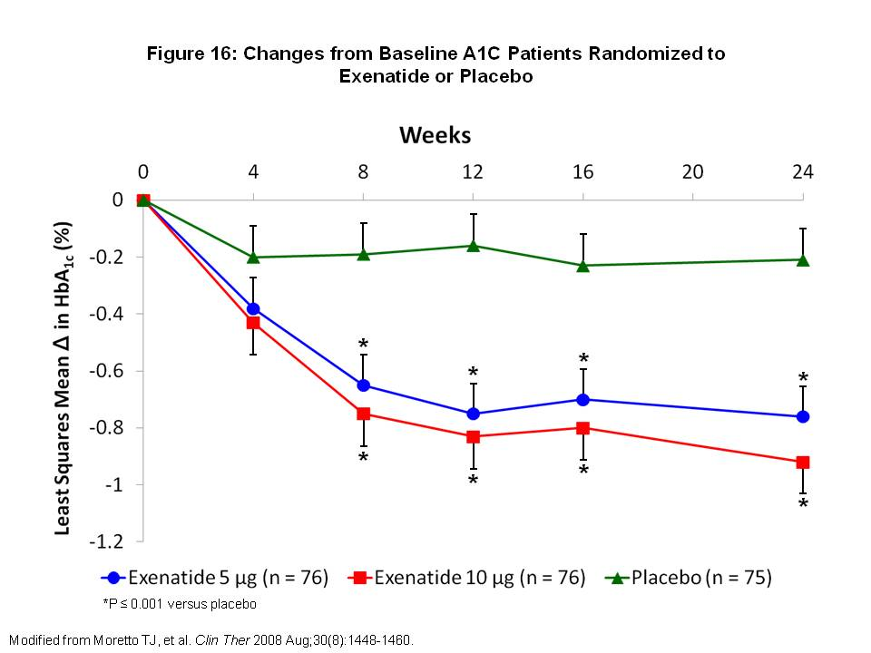
Figure 16: Changes from Baseline A1C Patients Randomized to Exenatide or Placebo

Combination therapy
Exenatide as combination therapy was evaluated in three 30-week, double blind, placebo-controlled trials(69-71). A total of 1446 patients with type 2 diabetes uncontrolled on MET alone, SFU alone or MET and SFU combination were randomized to receive exenatide 5 mcg bid, exenatide 10 mcg bid or placebo in addition to their current oral anti-diabetic agent. All patients randomized to exenatide started with exenatide 5 mcg twice daily for 4 weeks. After 4 weeks, patients either continued on exenatide 5 mcg bid or had their dose increased to 10 mcg bid. The primary endpoint was mean change from baseline A1C at 30 weeks. Results of the 30-week trials are summarized in Table 8.

On the highest dose of exenatide 10 mcg twice daily, A1C reductions approached 1% when used in combination with MET alone, SFU alone or MET and SFU combination. Approximately 40% of patients achieved A1C ≤ 7%. There was also significant weight loss of approximately 2 kg with exenatide 10 mcg twice daily. In general exenatide was well tolerated. The most common side effect was nausea, occurring more frequently early in the study. Exenatide in combination with SFU also had an increased risk of hypoglycemia, which was not observed with MET or the placebo group.

Table 8: Summary of Results of 30-week Trials of Exenatide in Combination with Metformin, Sulfonylurea or Both(69-71)
 | Placebo |  |  | Exenatide 5 mcg bid |  |  | Exenatide 10 mcg bid
In combination with: | MET | SFU | MET+  SFU | MET | SFU | MET +  SFU | MET | SFU | MET +  SFU
ITT population (n) | 113 | 123 | 247 | 110 | 125 | 245 | 113 | 129 | 241
Mean baseline A1C (%) | 8.2 | 8.7 | 8.5 | 8.3 | 8.5 | 8.5 | 8.2 | 8.6 | 8.5
Change at week 30 (%) | +0.1 | +0.1 | +0.2 | -0.4ª | -0.5ª | -0.6^{b} | -0.8^{b} | -0.9^{b} | -0.8^{b}
Proportion achieving A1C ≤ 7% (%) | 13 | 9 | 9 | 32ª | 33ª | 27^{b} | 46ª | 41^{b} | 34^{b}
Mean baseline body weight (kg) | 99.9 | 99.1 | 99.1 | 100.0 | 94.9 | 96.9 | 100.9 | 95.2 | 98.4
Change at week 30 (kg) | -0.3 | -0.6 | -0.9 | -1.6 | -0.9 | -1.6ª | -2.8^{b} | -1.6ª | -1.6ª
ª P ≤ 0.05 vs placebo
^{b} P ≤ 0.0001 vs placebo
Modified from Edelman, Steven and Henry, Robert. Diagnosis and Management of Type 2 Diabetes. 11th ed. United States: Professional Communications, Inc., 2011.

Compared to Insulin Glargine
In a 26-week trial of 551 type 2 diabetic patients inadequately controlled on combination MET and SFU, patients were randomized to receive exenatide 10 mcg twice daily or insulin glargine nightly, titrated to goal fasting glucose of <100 mg/dL. Baseline A1C was 8.2% and 8.3% in the exenatide and glargine groups, respectively. After 26 weeks, both exenatide and glargine groups had similarly reduced A1C of -1.11%. Exenatide reduced PPG excursions more than glargine while FPG was reduced more by glargine than exenatide. Weight change from baseline was -2.3 kg with exenatide and +1.8 kg with glargine. Hypoglycemia rates were similar in both groups, but nocturnal hypoglycemia was more common with glargine than exenatide (2.4 vs 0.9 event/patient-year, respectively). GI symptoms were more common in the exenatide group than in the glargine group, including nausea (57.1 vs 8.6%), vomiting (17.4 vs 3.7%) and diarrhea (8.5% vs 3.0%). Nausea was the most common adverse event with exenatide and resulted in a 6% discontinuation rate(72).

Use with Insulin Glargine
Exenatide use with basal insulin was evaluated in 261 type 2 diabetic patients uncontrolled on insulin glargine alone or in combination with MET or pioglitazone, or both. Patients were randomized to receive exenatide 10 mcg twice daily or placebo for 30 weeks. A1C decreased by 1.74% with exenatide and 1.04% with placebo (difference -0.69%; 95% CI -0.93 to -0.46%; P < 0.001). Weight decreased by 1.8 kg with exenatide and increased by 1.0 kg with placebo (difference -2.7 kg; 95% CI -3.7 to -1.7; P < 0.001). Average increase in insulin dosage with exenatide and placebo were 13 U/d and 20 U/d, respectively. Rate of minor hypoglycemia was similar between the two groups. GI side effects were significantly higher with exenatide than with placebo(73).

Long-term studies
Long term effects of exenatide on glycemic control and weight were studied in an interim analysis of 314 patients who received exenatide in the 30-week placebo-controlled trials and subsequently in the 52-week open-label uncontrolled extension studies for 82 weeks of exenatide in total. Patients continued their SFU and/or MET regimens throughout. Reductions in A1C from baseline to week 30 were sustained to week 82 (Figure 17). 48% of the patients achieved A1C ≤ 7% at week 82. Exenatide reduced body weight from baseline to week 30 with progressive reduction at week 82 (Figure 18) with similar results in the intent-to-treat group. The 82-week completer cohort also showed significant improvement in some cardiovascular risk factors(74).

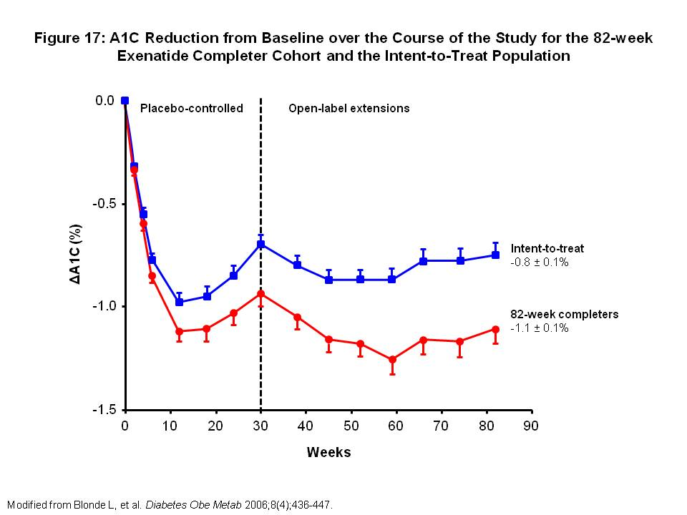
Figure 17: A1C Reduction from Baseline over the Course of the Study for the 82-week Exenatide Completer Cohort and the Intent-to-Treat Population
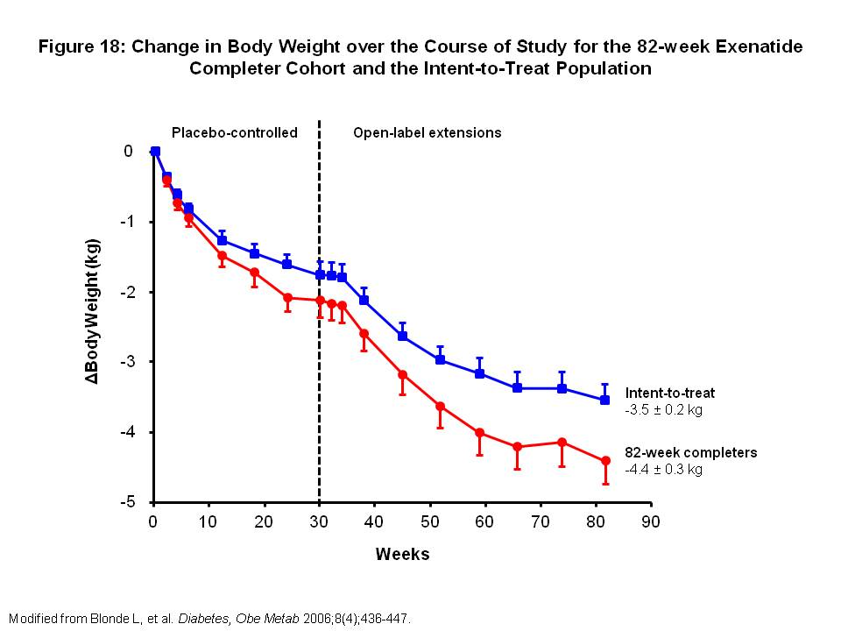
Figure 18: Change in Body Weight over the Course of Study for the 82-week Exenatide Completer Cohort and the Intent-to-Treat Population

In another interim 82-week analysis, 150 type 2 diabetic patients chose to continue exenatide treatment in an uncontrolled open-label extension of a 30-week double-blind, placebo-controlled trial. 92 patients completed the 82 weeks of exenatide therapy. All patients continued MET throughout the study. Exenatide resulted in A1C reduction from baseline of -1.0% with sustained reduction after 82 weeks of -1.3%. A1C ≤ 7% was achieved in 46% of patients after 30 weeks and 59% of patients after 82 weeks. Weight reduction from baseline at 30 weeks was -3 kg with a progressive reduction in weight of -5.3 kg after 82 weeks. Exenatide treatment resulted in significant improvements in cardiovascular risk factors after 82 weeks(75).

Exenatide Long-Acting Release (Bydureon)
Exenatide long-acting release (LAR) is a once weekly formulation of exenatide. It has 53% homology with native GLP-1. An amino acid substitution of glycine renders it resistant to DPP-4 degradation. Formulation into biodegradable polymeric microspheres entraps exenatide, leading to gradual drug delivery at controlled rates.

In the DURATION-1 trial, exenatide once weekly was compared with exenatide twice daily in type 2 diabetic patients uncontrolled on oral anti-diabetic agents. 295 patients were randomized to exenatide 2 mg once weekly or exenatide 10 mcg twice daily. At 30 weeks of treatment, exenatide once weekly had significantly greater reduction in A1C than exenatide twice daily (-1.9 vs -1.5%, P = 0.0023). Significantly greater proportion of patients achieved A1C ≤7% in the exenatide weekly group compared with exenatide twice daily (77% vs 61%, P = 0.0039). Both groups had similar reductions in body weight (-3.7 vs -3.6 kg in exenatide weekly vs twice daily). Treatment-related nausea was reported in significantly fewer patients treated with weekly than twice a day exenatide(76). At 30 weeks, patients had the option of switching from exenatide twice daily to weekly. 87% of patients enrolled and the study was extended to 52 weeks. At the end of 52 weeks, patients continuing on exenatide once weekly maintained A1C improvements, and patients switching from twice daily to weekly exenatide achieved further A1C reduction. Both groups had the same A1C reduction of -2.0% and mean A1C 6.6% at week 52 (Figure 19)(77).

DURATION-2 was a 26 week randomized trial comparing exenatide once weekly with pioglitazone and sitagliptin as add-on therapy to metformin in type 2 diabetic patients. Mean A1C reductions were -1.5% vs -1.2% (P = 0.0165 compared with exenatide) vs -0.9% (P < 0.0001 compared with exenatide) for exenatide once weekly, pioglitazone and sitagliptin groups, respectively. DURATION-3 compared exenatide once weekly to insulin glargine. After 26 weeks, A1C reductions were -1.5% in the exenatide group vs -1.3% in the glargine group (P = 0.017). Mean fasting glucose was lower in the glargine group, while post-prandial glucoses were lower in the exenatide group. There was a significant difference in body weight between the two groups, -2.6kg in the exenatide group vs +1.4kg in the glargine group. DURATION-4 looked at exenatide once weekly compared with metformin, pioglitazone or sitagliptin monotherapy. Exenatide once weekly reduced A1C by -1.5%, which was found to be noninferior to metformin (-1.5%) and pioglitazone (-1.6%), and superior to sitagliptin (-1.1%). DURATION-5 re-examined exenatide once weekly compared with exenatide twice daily. After 24 weeks, A1C reduction was greater in the once weekly compared with twice daily group (-1.6 vs 0.9%, respectively, P < 0.0001). Weight loss was greater in the once weekly group (-2.3 kg) compared with twice daily group (-1.4 kg), P < 0.05. Nausea was significantly less in the exenatide once weekly (14%) vs exenatide twice daily (35%) group.

DURATION-6 was a head-to-head comparison between exenatide once weekly and liraglutide once daily in patients with type 2 diabetes. This was a 26 week trial with 911 patients, mean A1C 8.5% on either no oral anti-diabetic drugs, monotherapy, or combination therapy at baseline. Mean A1C reduction was greater in the liraglutide group (-1.48%) compared with the exenatide group (-1.28%), treatment difference of 0.21% (95% CI 0.08-0.33), which did not meet non-inferiority criteria. The liraglutide group lost more weight (-3.57 kg) compared with the exenatide group (-2.68 kg). Nausea, diarrhea and vomiting occurred less frequently in the exenatide once weekly group.

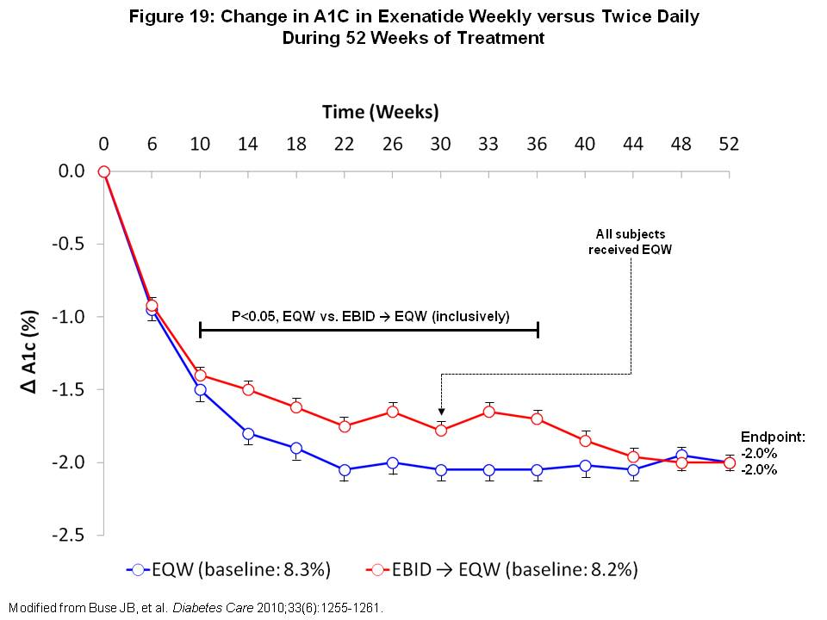
Figure 19: Change in A1C in Exenatide Weekly versus Twice Daily During 52 Weeks of Treatment

Prescribing
Exenatide is available in pre-filled pens. It is initiated at 5 mcg twice daily before, or within 60 minutes of a meal. Meals should be at least 6 hours apart. After 1 month of therapy, exenatide can be titrated up to 10 mcg twice daily. It is administered subcutaneously in the thigh, abdomen or upper arm and comes in prefilled syringes that hold a month’s supply of either 5 or 10 mcg doses. Exenatide is not recommended for use in patients with CrCl <30 ml/min.

Exenatide LAR is initiated at 2 mg once every 7 days. It is stored in powder form and needs to be reconstituted with a diluent prior to injection. This extra step may be considered cumbersome for some patients. The dose can be administered at any time of day, with or without meals. If a dose is missed and the next dose is due at least 3 days later, the missed dosed should be administered as soon as noticed. After that, patients can resume their usual dosing schedule of once weekly. If a dose is missed and the next scheduled dose is due 1 to 2 days later, patients should not administer missed dose and just resume exenatide LAR with the next regularly scheduled dose.

Side effects/Contraindications
Side effects of exenatide are mostly gastrointestinal. Nausea is common, but can be reduced with dose titration and tends to wane with duration of therapy. Weight loss can be seen with exenatide and is not solely due to nausea. Pancreatitis has been reported with exenatide use. If a patient develops pancreatitis, exenatide should immediately be discontinued and not restarted.

There have also been reported cases of acute renal failure or renal insufficiency in patients using exenatide. Some cases occurred in patients with pre-existing kidney disease or in patients at risk for developing kidney problems. Exenatide should not be used in patients with CrCl <30ml/min. In patients with CrCl 30 to 50 ml/min, serum creatinine should be periodically monitored after dose increase from 5 to 10 mcg.

Liraglutide (Victoza)

Liraglutide is a GLP-1 analog that has been modified to self-associate into a heptameric structure, which delays subcutaneous absorption, allowing for prolonged half-life and once a day dosing. This modification also gives liraglutide resistance against inactivation by DPP-4. Liraglutide reduces both fasting plasma glucose (FPG) and post-prandial glucose (PPG) by increasing insulin secretion, decreasing postprandial glucagon secretion, delaying gastric emptying and improving beta-cell function. Liraglutide is indicated for use as monotherapy or in combination with oral agents such as metformin (MET), sulfonylureas (SFUs), thiazolidinediones (TZDs) and with insulins glargine and detemir.

Safety and efficacy of liraglutide were assessed in the Liraglutide Effect and Action in Diabetes (LEAD) phase 3 program, which consists of 6 large, multicenter, randomized trials. All LEAD trials were 26 weeks in length, except for LEAD-3 which was 52 weeks. Some of the LEAD trials are discussed below.

Monotherapy
Liraglutide as monotherapy was evaluated in a 2 year study in comparison with glimepiride monotherapy in 746 type 2 diabetic patients uncontrolled with diet and exercise (LEAD-3 trial). Patients were randomized to receive once daily liraglutide 1.2 mg, liraglutide 1.8 mg or glimepiride 8mg. Patients who complete the 1-year randomized, double-blind period could continue open-label treatment for an additional year. In 2-year completers, A1C reductions were -0.6% with glimepiride vs -0.9% with liraglutide 1.2 mg (difference: -0.37, 95% CI: -0.71 to -0.02; P = 0.0376) and -1.1% with liraglutide 1.8 mg (difference: -0.55, 95% CI: -0.88 to -0.21; P = 0.0016). Mean body weight decreased over the first 12 weeks of therapy and decreases were maintained over 2 years in both liraglutide groups while the glimepiride group gained weight (Figure 20). Rates of hypoglycemia were significantly lower with liraglutide 1.2 and 1.8 mg compared with glimepiride (P < 0.0001)(78).

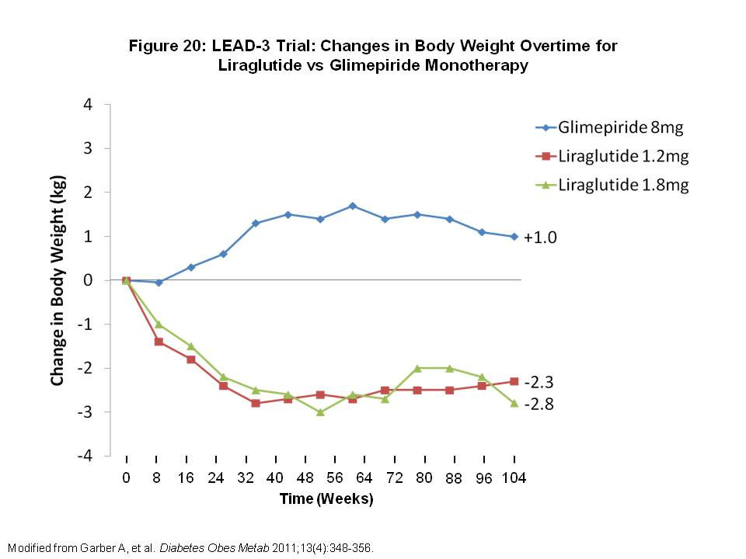
Figure 20: LEAD-3 Trial: Changes in Body Weight Overtime for Liraglutide vs Glimepiride Monotherapy

Combination therapy
In the LEAD-2 trial, efficacy and safety of liraglutide was compared to glimepiride and MET combination therapy and MET monotherapy over 2 years. 1091 uncontrolled type 2 diabetic patients were randomized to liraglutide (0.6, 1.2 or 1.8 mg once daily), placebo, or glimepiride for 26 weeks. All patients were on MET. After completion of the 26-week double blind phase, patients could enter into an 18-month open-label extension. A1C significantly decreased with liraglutide (0.4% with 0.6 mg, 0.6% with 1.2 and 1.8 mg) vs 0.3% increase with MET monotherapy (P < 0.0001). Liraglutide was non-inferior to glimepiride, with similar A1C reductions. All 3 liraglutide groups had significantly greater weight loss compared with glimepiride (Figure 21). Liraglutide 1.2 and 1.8 mg groups experienced significant weight loss compared to MET monotherapy (Figure 21). Minor hypoglycemia occurred significantly less in the liraglutide groups compared with the glimepiride group (<5% vs 24%; P < 0.0001). GI side effects were more common in the liraglutide groups than with glimepiride or MET monotherapy, but occurrence decreased with time(79).

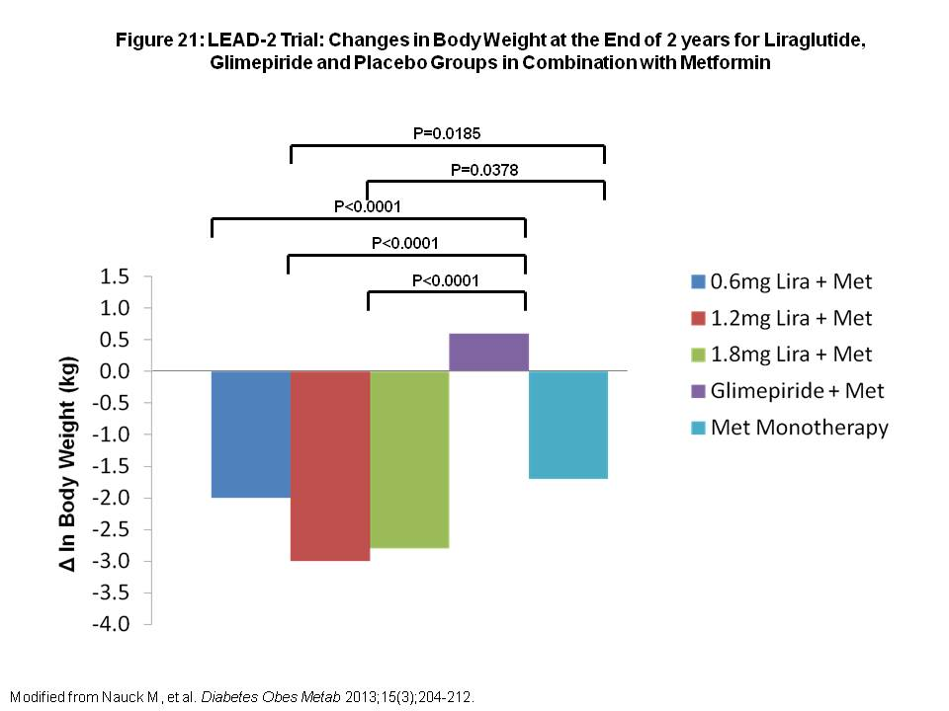
Figure 21: LEAD-2 Trial: Changes in Body Weight at the End of 2 years for Liraglutide, Glimepiride and Placebo Groups in Combination with Metformin

Compared with Insulin
Liraglutide versus insulin glargine and placebo in combination with MET and glimepiride was evaluated in 581 patients with type 2 diabetes (LEAD-5 trial). After 26 weeks, liraglutide 1.8 mg daily significantly reduced A1C compared with glargine (-1.33 vs -1.09%, respectively, -0.24% difference, 95% CI 0.08, 0.39; P = 0.0015) and placebo (-1.09% difference, 95% CI 0.90, 1.28; P < 0.0001). Greater weight loss was seen with liraglutide vs placebo (treatment difference -1.39 kg, 95% CI 2.10, 0.69; p = 0.0001), and vs glargine (treatment difference -3.43 kg, 95% CI 4.00, 2.86; p < 0.0001). Compared to insulin, liraglutide did have slightly higher number of adverse events, mainly gastrointestinal in origin including nausea at 14%(80).

Compared with Exenatide
Liraglutide was compared head-to-head with exenatide in the LEAD-6 trial. Inadequately controlled type 2 diabetic patients on maximally tolerated doses of MET, SFU or both were randomized to receive liraglutide 1.8 mg daily (n=233) or exenatide 10 mcg twice daily (n=231) in addition to their oral anti-diabetic drug. Liraglutide reduced A1C significantly more than exenatide (-1.12 vs -0.79%; difference of -0.33; 95% CI -0.47 to -0.18; P < 0.0001). More patients in the liraglutide group achieved A1C <7% (54 vs 43%, respectively; odds ratio 2.02; 95% CI 1.31 to 3.11; P = 0.0015). Liraglutide and exenatide groups both had similar weight loss (-3.24 vs -2.87 kg, respectively). Nausea was less persistent and hypoglycemia less frequent with liraglutide. Compared with exenatide, liraglutide was better tolerated and provided better glycemic control(81).

Prescribing
Liraglutide is available in prefilled pens. It is started at an initial dose of 0.6 mg once daily for one week to reduced GI side effects. After 1 week, dose should be increased to 1.2 mg once daily. If the glycemic control is not achieved, dose can be increased to 1.8 mg once daily. Liraglutide can be injected in the abdomen, thigh or upper arm at any time of day. It does not have to be timed with meals. To reduce the risk of hypoglycemia, dose reduction should be considered with concomitant use of an insulin secretagogue, particularly SFUs or meglitinides.

Side effects/Contraindications
The most common side effects with liraglutide are GI symptoms such as nausea, vomiting and diarrhea, which are dose related. Nausea tends to occur early in the treatment and resolves with continuation of therapy. Pancreatitis has been reported in patients receiving liraglutide in clinical trials and post approval. At this time, there is not enough evidence to know if there is a causal relationship, but for patients who have a history of severe pancreatitis, liraglutide use should be carefully considered.

Liraglutide use has been associated with thyroid C-cell tumors in rats. This adverse effect may not be pertinent to humans. However, at this time, liraglutide use is contraindicated in patients with a personal or family history of medullary thyroid cancer or multiple endocrine neoplasia 2A or 2B.

Pramlintide (Symlin)

Pramlintide is a synthetic amylin analogue. Amylin is a small peptide hormone that is co-secreted with insulin by beta cells of the pancreas after a meal. In patients with type 2 diabetes, amylin secretion is abnormal. Amylin works to control blood glucose by slowing gastric emptying, suppressing glucagon secretion and suppressing appetite. By using pramlintide to treat diabetic patients, it allows for glucose control in a more physiologic way. Pramlintide is approved for use in type 2 diabetic patients who are not controlled on optimal insulin therapy with or without sulfonylurea (SFU) and/or metformin (MET) use.

Pramlintide as an adjunct to insulin therapy was evaluated in a 52-week study of 656 patients with type 2 diabetes treated with insulin (alone or in combination with SFU and/or MET). Patients were randomized to additional pre-prandial subcutaneous injections of pramlintide 60 mcg TID, 90 mcg BID or 120 mcg BID or placebo. Pramlintide 120 mcg BID resulted in sustained reduction from baseline A1C of -0.68 at week 26 and -0.62% at week 52, which was significantly greater compared with placebo (P < 0.05). The proportion of patients achieving A1C <8% was 46% with pramlintide 120 mcg BID vs 28% with placebo (P < 0.05). The pramlintide treated group also had significantly greater weight loss at week 52 compared with placebo (-1.4 vs +0.7 kg, P < 0.05) without an increase in the rate of severe hypoglycemia(82).

Prescribing
Pramlintide is available in pre-filled 60 mcg or 120 mcg pens. Starting dose of pramlintide is 60 mcg immediately prior to major meals. If patient tolerates the 60 mcg dose after 3 or more days without significant nausea, dose is increased to 120 mcg prior to meals. When starting pramlintide, prandial insulin dose should be decreased by 50% to decrease the risk of insulin-induced hypoglycemia.

Side effects/Contraindications
The most common adverse events seen with pramlintide are GI, including nausea (30%) and vomiting (7%). GI symptoms, especially nausea, occurred early in the initiation of therapy, were dose dependent and resolved with time. Hypoglycemia can be seen with pramlintide, usually occurring within the first 3 hours after injection. Pramlintide use alone without insulin does not cause hypoglycemia.

Acknowledgements

We thank Ryan R. Henry of PresentMD for graphic assistance. This work was supported by the Department of Veterans Affairs and San Diego Healthcare System.

Bibliography

1. Ismail-Beigi F, Moghissi E, Tiktin M, Hirsch IB, Inzucchi SE, Genuth S. Individualizing glycemic targets in type 2 diabetes mellitus: implications of recent clinical trials. Ann Intern Med2011 Apr 19;154(8):554-9.
2. Inzucchi SE, Bergenstal RM, Buse JB, Diamant M, Ferrannini E, Nauck M, Peters AL, Tsapas A, Wender R, Matthews DR. Management of hyperglycaemia in type 2 diabetes: a patient-centered approach. Position statement of the American Diabetes Association (ADA) and the European Association for the Study of Diabetes (EASD). Diabetologia2012 Jun;55(6):1577-96.
3. Rodbard HW, Blonde L, Braithwaite SS, Brett EM, Cobin RH, Handelsman Y, Hellman R, Jellinger PS, Jovanovic LG, Levy P, Mechanick JI, Zangeneh F. American Association of Clinical Endocrinologists medical guidelines for clinical practice for the management of diabetes mellitus. Endocr Pract2007 May-Jun;13 Suppl 1:1-68.
4. Intensive blood-glucose control with sulphonylureas or insulin compared with conventional treatment and risk of complications in patients with type 2 diabetes (UKPDS 33). UK Prospective Diabetes Study (UKPDS) Group. Lancet1998 Sep 12;352(9131):837-53.
5. Holman RR, Paul SK, Bethel MA, Matthews DR, Neil HA. 10-year follow-up of intensive glucose control in type 2 diabetes. N Engl J Med2008 Oct 9;359(15):1577-89.
6. Gerstein HC, Miller ME, Byington RP, Goff DC, Jr., Bigger JT, Buse JB, Cushman WC, Genuth S, Ismail-Beigi F, Grimm RH, Jr., Probstfield JL, Simons-Morton DG, Friedewald WT. Effects of intensive glucose lowering in type 2 diabetes. N Engl J Med2008 Jun 12;358(24):2545-59.
7. Patel A, MacMahon S, Chalmers J, Neal B, Billot L, Woodward M, Marre M, Cooper M, Glasziou P, Grobbee D, Hamet P, Harrap S, Heller S, Liu L, Mancia G, Mogensen CE, Pan C, Poulter N, Rodgers A, Williams B, Bompoint S, de Galan BE, Joshi R, Travert F. Intensive blood glucose control and vascular outcomes in patients with type 2 diabetes. N Engl J Med2008 Jun 12;358(24):2560-72.
8. Duckworth W, Abraira C, Moritz T, Reda D, Emanuele N, Reaven PD, Zieve FJ, Marks J, Davis SN, Hayward R, Warren SR, Goldman S, McCarren M, Vitek ME, Henderson WG, Huang GD. Glucose control and vascular complications in veterans with type 2 diabetes. N Engl J Med2009 Jan 8;360(2):129-39.
9. Inzucchi SE, Bergenstal RM, Buse JB, Diamant M, Ferrannini E, Nauck M, Peters AL, Tsapas A, Wender R, Matthews DR. Management of hyperglycemia in type 2 diabetes: a patient-centered approach: position statement of the American Diabetes Association (ADA) and the European Association for the Study of Diabetes (EASD). Diabetes Care2012 Jun;35(6):1364-79.
10. Rodbard HW, Jellinger PS, Davidson JA, Einhorn D, Garber AJ, Grunberger G, Handelsman Y, Horton ES, Lebovitz H, Levy P, Moghissi ES, Schwartz SS. Statement by an American Association of Clinical Endocrinologists/American College of Endocrinology consensus panel on type 2 diabetes mellitus: an algorithm for glycemic control. Endocr Pract2009 Sep-Oct;15(6):540-59.
11. Miller RA, Chu Q, Xie J, Foretz M, Viollet B, Birnbaum MJ. Biguanides suppress hepatic glucagon signalling by decreasing production of cyclic AMP. Nature2013 Feb 14;494(7436):256-60.
12. DeFronzo RA, Goodman AM. Efficacy of metformin in patients with non-insulin-dependent diabetes mellitus. The Multicenter Metformin Study Group. N Engl J Med1995 Aug 31;333(9):541-9.
13. Nissen SE, Wolski K. Effect of rosiglitazone on the risk of myocardial infarction and death from cardiovascular causes. N Engl J Med2007 Jun 14;356(24):2457-71.
14. Aronoff S, Rosenblatt S, Braithwaite S, Egan JW, Mathisen AL, Schneider RL. Pioglitazone hydrochloride monotherapy improves glycemic control in the treatment of patients with type 2 diabetes: a 6-month randomized placebo-controlled dose-response study. The Pioglitazone 001 Study Group. Diabetes Care2000 Nov;23(11):1605-11.
15. Pavo I, Jermendy G, Varkonyi TT, Kerenyi Z, Gyimesi A, Shoustov S, Shestakova M, Herz M, Johns D, Schluchter BJ, Festa A, Tan MH. Effect of pioglitazone compared with metformin on glycemic control and indicators of insulin sensitivity in recently diagnosed patients with type 2 diabetes. J Clin Endocrinol Metab2003 Apr;88(4):1637-45.
16. Einhorn D, Rendell M, Rosenzweig J, Egan JW, Mathisen AL, Schneider RL. Pioglitazone hydrochloride in combination with metformin in the treatment of type 2 diabetes mellitus: a randomized, placebo-controlled study. The Pioglitazone 027 Study Group. Clin Ther2000 Dec;22(12):1395-409.
17. Kipnes MS, Krosnick A, Rendell MS, Egan JW, Mathisen AL, Schneider RL. Pioglitazone hydrochloride in combination with sulfonylurea therapy improves glycemic control in patients with type 2 diabetes mellitus: a randomized, placebo-controlled study. Am J Med2001 Jul;111(1):10-7.
18. Dormandy JA, Charbonnel B, Eckland DJ, Erdmann E, Massi-Benedetti M, Moules IK, Skene AM, Tan MH, Lefebvre PJ, Murray GD, Standl E, Wilcox RG, Wilhelmsen L, Betteridge J, Birkeland K, Golay A, Heine RJ, Koranyi L, Laakso M, Mokan M, Norkus A, Pirags V, Podar T, Scheen A, Scherbaum W, Schernthaner G, Schmitz O, Skrha J, Smith U, Taton J. Secondary prevention of macrovascular events in patients with type 2 diabetes in the PROactive Study (PROspective pioglitAzone Clinical Trial In macroVascular Events): a randomised controlled trial. Lancet2005 Oct 8;366(9493):1279-89.
19. Wilcox R, Kupfer S, Erdmann E. Effects of pioglitazone on major adverse cardiovascular events in high-risk patients with type 2 diabetes: results from PROspective pioglitAzone Clinical Trial In macro Vascular Events (PROactive 10). Am Heart J2008 Apr;155(4):712-7.
20. Lincoff AM, Wolski K, Nicholls SJ, Nissen SE. Pioglitazone and risk of cardiovascular events in patients with type 2 diabetes mellitus: a meta-analysis of randomized trials. JAMA2007 Sep 12;298(10):1180-8.
21. Promrat K, Lutchman G, Uwaifo GI, Freedman RJ, Soza A, Heller T, Doo E, Ghany M, Premkumar A, Park Y, Liang TJ, Yanovski JA, Kleiner DE, Hoofnagle JH. A pilot study of pioglitazone treatment for nonalcoholic steatohepatitis. Hepatology2004 Jan;39(1):188-96.
22. Lewis JD, Ferrara A, Peng T, Hedderson M, Bilker WB, Quesenberry CP, Jr., Vaughn DJ, Nessel L, Selby J, Strom BL. Risk of bladder cancer among diabetic patients treated with pioglitazone: interim report of a longitudinal cohort study. Diabetes Care2011 Apr;34(4):916-22.
23. Schwartz AV, Sellmeyer DE, Vittinghoff E, Palermo L, Lecka-Czernik B, Feingold KR, Strotmeyer ES, Resnick HE, Carbone L, Beamer BA, Park SW, Lane NE, Harris TB, Cummings SR. Thiazolidinedione use and bone loss in older diabetic adults. J Clin Endocrinol Metab2006 Sep;91(9):3349-54.
24. Habib ZA, Havstad SL, Wells K, Divine G, Pladevall M, Williams LK. Thiazolidinedione use and the longitudinal risk of fractures in patients with type 2 diabetes mellitus. J Clin Endocrinol Metab2010 Feb;95(2):592-600.
25. Charbonnel B, DeFronzo R, Davidson J, Schmitz O, Birkeland K, Pirags V, Scheen A. Pioglitazone use in combination with insulin in the prospective pioglitazone clinical trial in macrovascular events study (PROactive19). J Clin Endocrinol Metab2010 May;95(5):2163-71.
26. Nonaka K, Kakikawa T, Sato A, Okuyama K, Fujimoto G, Kato N, Suzuki H, Hirayama Y, Ahmed T, Davies MJ, Stein PP. Efficacy and safety of sitagliptin monotherapy in Japanese patients with type 2 diabetes. Diabetes Res Clin Pract2008 Feb;79(2):291-8.
27. Aschner P, Kipnes MS, Lunceford JK, Sanchez M, Mickel C, Williams-Herman DE. Effect of the dipeptidyl peptidase-4 inhibitor sitagliptin as monotherapy on glycemic control in patients with type 2 diabetes. Diabetes Care2006 Dec;29(12):2632-7.
28. Goldstein BJ, Feinglos MN, Lunceford JK, Johnson J, Williams-Herman DE. Effect of initial combination therapy with sitagliptin, a dipeptidyl peptidase-4 inhibitor, and metformin on glycemic control in patients with type 2 diabetes. Diabetes Care2007 Aug;30(8):1979-87.
29. Charbonnel B, Karasik A, Liu J, Wu M, Meininger G. Efficacy and safety of the dipeptidyl peptidase-4 inhibitor sitagliptin added to ongoing metformin therapy in patients with type 2 diabetes inadequately controlled with metformin alone. Diabetes Care2006 Dec;29(12):2638-43.
30. Seck T, Nauck M, Sheng D, Sunga S, Davies MJ, Stein PP, Kaufman KD, Amatruda JM. Safety and efficacy of treatment with sitagliptin or glipizide in patients with type 2 diabetes inadequately controlled on metformin: a 2-year study. Int J Clin Pract2010 Apr;64(5):562-76.
31. Yoon KH, Steinberg H, Teng R, Golm GT, Lee M, O'Neill EA, Kaufman KD, Goldstein BJ. Efficacy and safety of initial combination therapy with sitagliptin and pioglitazone in patients with type 2 diabetes: a 54-week study. Diabetes Obes Metab2012 Aug;14(8):745-52.
32. Vilsboll T, Rosenstock J, Yki-Jarvinen H, Cefalu WT, Chen Y, Luo E, Musser B, Andryuk PJ, Ling Y, Kaufman KD, Amatruda JM, Engel SS, Katz L. Efficacy and safety of sitagliptin when added to insulin therapy in patients with type 2 diabetes. Diabetes Obes Metab2010 Feb;12(2):167-77.
33. Rosenstock J, Sankoh S, List JF. Glucose-lowering activity of the dipeptidyl peptidase-4 inhibitor saxagliptin in drug-naive patients with type 2 diabetes. Diabetes Obes Metab2008 May;10(5):376-86.
34. Rosenstock J, Aguilar-Salinas C, Klein E, Nepal S, List J, Chen R. Effect of saxagliptin monotherapy in treatment-naive patients with type 2 diabetes. Curr Med Res Opin2009 Oct;25(10):2401-11.
35. Jadzinsky M, Pfutzner A, Paz-Pacheco E, Xu Z, Allen E, Chen R. Saxagliptin given in combination with metformin as initial therapy improves glycaemic control in patients with type 2 diabetes compared with either monotherapy: a randomized controlled trial. Diabetes Obes Metab2009 Jun;11(6):611-22.
36. DeFronzo RA, Hissa MN, Garber AJ, Luiz Gross J, Yuyan Duan R, Ravichandran S, Chen RS. The efficacy and safety of saxagliptin when added to metformin therapy in patients with inadequately controlled type 2 diabetes with metformin alone. Diabetes Care2009 Sep;32(9):1649-55.
37. Chacra AR, Tan GH, Apanovitch A, Ravichandran S, List J, Chen R. Saxagliptin added to a submaximal dose of sulphonylurea improves glycaemic control compared with uptitration of sulphonylurea in patients with type 2 diabetes: a randomised controlled trial. Int J Clin Pract2009 Sep;63(9):1395-406.
38. Hollander P, Li J, Allen E, Chen R. Saxagliptin added to a thiazolidinedione improves glycemic control in patients with type 2 diabetes and inadequate control on thiazolidinedione alone. J Clin Endocrinol Metab2009 Dec;94(12):4810-9.
39. Del Prato S, Barnett AH, Huisman H, Neubacher D, Woerle HJ, Dugi KA. Effect of linagliptin monotherapy on glycaemic control and markers of beta-cell function in patients with inadequately controlled type 2 diabetes: a randomized controlled trial. Diabetes Obes Metab2011 Mar;13(3):258-67.
40. Taskinen MR, Rosenstock J, Tamminen I, Kubiak R, Patel S, Dugi KA, Woerle HJ. Safety and efficacy of linagliptin as add-on therapy to metformin in patients with type 2 diabetes: a randomized, double-blind, placebo-controlled study. Diabetes Obes Metab2011 Jan;13(1):65-74.
41. Owens DR, Swallow R, Dugi KA, Woerle HJ. Efficacy and safety of linagliptin in persons with type 2 diabetes inadequately controlled by a combination of metformin and sulphonylurea: a 24-week randomized study. Diabet Med2011 Nov;28(11):1352-61.
42. Gomis R, Espadero RM, Jones R, Woerle HJ, Dugi KA. Efficacy and safety of initial combination therapy with linagliptin and pioglitazone in patients with inadequately controlled type 2 diabetes: a randomized, double-blind, placebo-controlled study. Diabetes Obes Metab2011 Jul;13(7):653-61.
43. Gallwitz B, Rosenstock J, Rauch T, Bhattacharya S, Patel S, von Eynatten M, Dugi KA, Woerle HJ. 2-year efficacy and safety of linagliptin compared with glimepiride in patients with type 2 diabetes inadequately controlled on metformin: a randomised, double-blind, non-inferiority trial. Lancet2012 Jun 27.
44. DeFronzo RA, Fleck PR, Wilson CA, Mekki Q. Efficacy and safety of the dipeptidyl peptidase-4 inhibitor alogliptin in patients with type 2 diabetes and inadequate glycemic control: a randomized, double-blind, placebo-controlled study. Diabetes Care2008 Dec;31(12):2315-7.
45. Seino Y, Miyata Y, Hiroi S, Hirayama M, Kaku K. Efficacy and safety of alogliptin added to metformin in Japanese patients with type 2 diabetes: a randomized, double-blind, placebo-controlled trial with an open-label, long-term extension study. Diabetes Obes Metab2012 Oct;14(10):927-36.
46. Bosi E, Ellis GC, Wilson CA, Fleck PR. Alogliptin as a third oral antidiabetic drug in patients with type 2 diabetes and inadequate glycaemic control on metformin and pioglitazone: a 52-week, randomized, double-blind, active-controlled, parallel-group study. Diabetes Obes Metab2011 Dec;13(12):1088-96.
47. Pratley RE, Kipnes MS, Fleck PR, Wilson C, Mekki Q. Efficacy and safety of the dipeptidyl peptidase-4 inhibitor alogliptin in patients with type 2 diabetes inadequately controlled by glyburide monotherapy. Diabetes Obes Metab2009 Feb;11(2):167-76.
48. Rosenstock J, Rendell MS, Gross JL, Fleck PR, Wilson CA, Mekki Q. Alogliptin added to insulin therapy in patients with type 2 diabetes reduces HbA(1C) without causing weight gain or increased hypoglycaemia. Diabetes Obes Metab2009 Dec;11(12):1145-52.
49. Kaku K, Inoue S, Matsuoka O, Kiyosue A, Azuma H, Hayashi N, Tokudome T, Langkilde AM, Parikh S. Efficacy and safety of dapagliflozin as a monotherapy for type 2 diabetes mellitus in Japanese patients with inadequate glycaemic control: a phase II multicentre, randomized, double-blind, placebo-controlled trial. Diabetes Obes Metab2013 May;15(5):432-40.
50. Bailey CJ, Gross JL, Pieters A, Bastien A, List JF. Effect of dapagliflozin in patients with type 2 diabetes who have inadequate glycaemic control with metformin: a randomised, double-blind, placebo-controlled trial. Lancet2010 Jun 26;375(9733):2223-33.
51. Strojek K, Yoon KH, Hruba V, Elze M, Langkilde AM, Parikh S. Effect of dapagliflozin in patients with type 2 diabetes who have inadequate glycaemic control with glimepiride: a randomized, 24-week, double-blind, placebo-controlled trial. Diabetes Obes Metab2011 Oct;13(10):928-38.
52. Rosenstock J, Vico M, Wei L, Salsali A, List JF. Effects of dapagliflozin, an SGLT2 inhibitor, on HbA(1c), body weight, and hypoglycemia risk in patients with type 2 diabetes inadequately controlled on pioglitazone monotherapy. Diabetes Care2012 Jul;35(7):1473-8.
53. Wilding JP, Woo V, Soler NG, Pahor A, Sugg J, Rohwedder K, Parikh S. Long-term efficacy of dapagliflozin in patients with type 2 diabetes mellitus receiving high doses of insulin: a randomized trial. Ann Intern Med2012 Mar 20;156(6):405-15.
54. Stenlof K, Cefalu WT, Kim KA, Alba M, Usiskin K, Tong C, Canovatchel W, Meininger G. Efficacy and safety of canagliflozin monotherapy in subjects with type 2 diabetes mellitus inadequately controlled with diet and exercise. Diabetes Obes Metab2013 Apr;15(4):372-82.
55. Rosenstock J, Aggarwal N, Polidori D, Zhao Y, Arbit D, Usiskin K, Capuano G, Canovatchel W. Dose-ranging effects of canagliflozin, a sodium-glucose cotransporter 2 inhibitor, as add-on to metformin in subjects with type 2 diabetes. Diabetes Care2012 Jun;35(6):1232-8.
56. Devineni D, Morrow L, Hompesch M, Skee D, Vandebosch A, Murphy J, Ways K, Schwartz S. Canagliflozin improves glycaemic control over 28 days in subjects with type 2 diabetes not optimally controlled on insulin. Diabetes Obes Metab2012 Jun;14(6):539-45.
57. Moses R. Repaglinide in combination therapy with metformin in Type 2 diabetes. Exp Clin Endocrinol Diabetes1999;107 Suppl 4:S136-9.
58. Weaver ML, Orwig BA, Rodriguez LC, Graham ED, Chin JA, Shapiro MJ, McLeod JF, Mangold JB. Pharmacokinetics and metabolism of nateglinide in humans. Drug Metab Dispos2001 Apr;29(4 Pt 1):415-21.
59. Rosenstock J, Hassman DR, Madder RD, Brazinsky SA, Farrell J, Khutoryansky N, Hale PM. Repaglinide versus nateglinide monotherapy: a randomized, multicenter study. Diabetes Care2004 Jun;27(6):1265-70.
60. Raskin P, Klaff L, McGill J, South SA, Hollander P, Khutoryansky N, Hale PM. Efficacy and safety of combination therapy: repaglinide plus metformin versus nateglinide plus metformin. Diabetes Care2003 Jul;26(7):2063-8.
61. Bays HE, Goldberg RB, Truitt KE, Jones MR. Colesevelam hydrochloride therapy in patients with type 2 diabetes mellitus treated with metformin: glucose and lipid effects. Arch Intern Med2008 Oct 13;168(18):1975-83.
62. Holman RR, Thorne KI, Farmer AJ, Davies MJ, Keenan JF, Paul S, Levy JC. Addition of biphasic, prandial, or basal insulin to oral therapy in type 2 diabetes. N Engl J Med2007 Oct 25;357(17):1716-30.
63. Holman RR, Farmer AJ, Davies MJ, Levy JC, Darbyshire JL, Keenan JF, Paul SK. Three-year efficacy of complex insulin regimens in type 2 diabetes. N Engl J Med2009 Oct 29;361(18):1736-47.
64. Riddle MC, Rosenstock J, Gerich J. The treat-to-target trial: randomized addition of glargine or human NPH insulin to oral therapy of type 2 diabetic patients. Diabetes Care2003 Nov;26(11):3080-6.
65. Hermansen K, Davies M, Derezinski T, Martinez Ravn G, Clauson P, Home P. A 26-week, randomized, parallel, treat-to-target trial comparing insulin detemir with NPH insulin as add-on therapy to oral glucose-lowering drugs in insulin-naive people with type 2 diabetes. Diabetes Care2006 Jun;29(6):1269-74.
66. Haak T, Tiengo A, Draeger E, Suntum M, Waldhausl W. Lower within-subject variability of fasting blood glucose and reduced weight gain with insulin detemir compared to NPH insulin in patients with type 2 diabetes. Diabetes Obes Metab2005 Jan;7(1):56-64.
67. Nauck MA, Vardarli I, Deacon CF, Holst JJ, Meier JJ. Secretion of glucagon-like peptide-1 (GLP-1) in type 2 diabetes: what is up, what is down? Diabetologia2011 Jan;54(1):10-8.
68. Moretto TJ, Milton DR, Ridge TD, Macconell LA, Okerson T, Wolka AM, Brodows RG. Efficacy and tolerability of exenatide monotherapy over 24 weeks in antidiabetic drug-naive patients with type 2 diabetes: a randomized, double-blind, placebo-controlled, parallel-group study. Clin Ther2008 Aug;30(8):1448-60.
69. Kendall DM, Riddle MC, Rosenstock J, Zhuang D, Kim DD, Fineman MS, Baron AD. Effects of exenatide (exendin-4) on glycemic control over 30 weeks in patients with type 2 diabetes treated with metformin and a sulfonylurea. Diabetes Care2005 May;28(5):1083-91.
70. Buse JB, Henry RR, Han J, Kim DD, Fineman MS, Baron AD. Effects of exenatide (exendin-4) on glycemic control over 30 weeks in sulfonylurea-treated patients with type 2 diabetes. Diabetes Care2004 Nov;27(11):2628-35.
71. DeFronzo RA, Ratner RE, Han J, Kim DD, Fineman MS, Baron AD. Effects of exenatide (exendin-4) on glycemic control and weight over 30 weeks in metformin-treated patients with type 2 diabetes. Diabetes Care2005 May;28(5):1092-100.
72. Heine RJ, Van Gaal LF, Johns D, Mihm MJ, Widel MH, Brodows RG. Exenatide versus insulin glargine in patients with suboptimally controlled type 2 diabetes: a randomized trial. Ann Intern Med2005 Oct 18;143(8):559-69.
73. Buse JB, Bergenstal RM, Glass LC, Heilmann CR, Lewis MS, Kwan AY, Hoogwerf BJ, Rosenstock J. Use of twice-daily exenatide in Basal insulin-treated patients with type 2 diabetes: a randomized, controlled trial. Ann Intern Med2011 Jan 18;154(2):103-12.
74. Blonde L, Klein EJ, Han J, Zhang B, Mac SM, Poon TH, Taylor KL, Trautmann ME, Kim DD, Kendall DM. Interim analysis of the effects of exenatide treatment on A1C, weight and cardiovascular risk factors over 82 weeks in 314 overweight patients with type 2 diabetes. Diabetes Obes Metab2006 Jul;8(4):436-47.
75. Ratner RE, Maggs D, Nielsen LL, Stonehouse AH, Poon T, Zhang B, Bicsak TA, Brodows RG, Kim DD. Long-term effects of exenatide therapy over 82 weeks on glycaemic control and weight in over-weight metformin-treated patients with type 2 diabetes mellitus. Diabetes Obes Metab2006 Jul;8(4):419-28.
76. Drucker DJ, Buse JB, Taylor K, Kendall DM, Trautmann M, Zhuang D, Porter L. Exenatide once weekly versus twice daily for the treatment of type 2 diabetes: a randomised, open-label, non-inferiority study. Lancet2008 Oct 4;372(9645):1240-50.
77. Buse JB, Drucker DJ, Taylor KL, Kim T, Walsh B, Hu H, Wilhelm K, Trautmann M, Shen LZ, Porter LE. DURATION-1: exenatide once weekly produces sustained glycemic control and weight loss over 52 weeks. Diabetes Care2010 Jun;33(6):1255-61.
78. Garber A, Henry RR, Ratner R, Hale P, Chang CT, Bode B. Liraglutide, a once-daily human glucagon-like peptide 1 analogue, provides sustained improvements in glycaemic control and weight for 2 years as monotherapy compared with glimepiride in patients with type 2 diabetes. Diabetes Obes Metab2011 Apr;13(4):348-56.
79. Nauck M, Frid A, Hermansen K, Thomsen AB, During M, Shah N, Tankova T, Mitha I, Matthews DR. Long-term efficacy and safety comparison of liraglutide, glimepiride and placebo, all in combination with metformin in type 2 diabetes: 2-year results from the LEAD-2 study. Diabetes Obes Metab2013 Mar;15(3):204-12.
80. Russell-Jones D, Vaag A, Schmitz O, Sethi BK, Lalic N, Antic S, Zdravkovic M, Ravn GM, Simo R. Liraglutide vs insulin glargine and placebo in combination with metformin and sulfonylurea therapy in type 2 diabetes mellitus (LEAD-5 met+SU): a randomised controlled trial. Diabetologia2009 Oct;52(10):2046-55.
81. Buse JB, Rosenstock J, Sesti G, Schmidt WE, Montanya E, Brett JH, Zychma M, Blonde L. Liraglutide once a day versus exenatide twice a day for type 2 diabetes: a 26-week randomised, parallel-group, multinational, open-label trial (LEAD-6). Lancet2009 Jul 4;374(9683):39-47.
82. Hollander PA, Levy P, Fineman MS, Maggs DG, Shen LZ, Strobel SA, Weyer C, Kolterman OG. Pramlintide as an adjunct to insulin therapy improves long-term glycemic and weight control in patients with type 2 diabetes: a 1-year randomized controlled trial. Diabetes Care2003 Mar;26(3):784-90.

