USE OF THE HISTORIAL WEIGHT TRAJECTORY TO GUIDE AN OBESITY-FOCUSED PATIENT ENCOUNTER

Gitanjali Srivastava, MD, Associate Professor of Medicine, Pediatrics and Surgery. Vanderbilt University School of Medicine and Vanderbilt University Medical Center, Dept. of Medicine, Division of Endocrinology, Diabetes & Metabolism, 719 Thompson Lane, Suite 22200, Nashville, TN 37214. gitanjali.srivastava@vumc.org.
Robert F Kushner, MD, Professor of Medicine. Department of Medicine, Section of Endocrinology, Diabetes & Molecular Medicine. Northwestern Medicine Feinberg School of Medicine |Northwestern University. 645 North Michigan Avenue, Suite 530. Chicago, IL 60611. rkushner@northwestern.edu
Caroline M. Apovian, MD, Co-Director, Center for Weight Management and Wellness, Division of Endocrinology, Diabetes and Hypertension, Department of Medicine, Brigham and Women’s Hospital. Member of Faculty, Harvard Medical School. 221 Longwood Avenue, RFB 490, Boston, MA 02115. capovian@partners.org

Updated October 14, 2022

ABSTRACT

Obesity is a chronic, complex, and challenging disease to address by clinicians. Thus, it is crucial for practitioners to obtain a thorough weight history from patients to identify potential triggers that influence weight gain trajectories and their relationships to development of disease co-morbidity and mortality. Obtaining a weight history from a patient can be approached systematically, similar to key elements of a history of present illness, as we will discuss. Furthermore, patient-drawn life-events graph or readily available electronic health records graphs can elucidate in visual context pertinent contributing factors to the etiology of obesity. Often, biological, social, behavioral, and psychological causes of weight gain can be elicited through the use of weight histories. In this chapter, we will also explore life-events graph more in detail as they can provide remarkable value to the overall assessment and plan of care (whether lifestyle intervention alone or in combination with pharmacological, surgical, or combination thereof) in the patient with obesity.

INTRODUCTION

Obesity adversely affects all organ systems in the human body and causes and/or exacerbates numerous medical disorders such as cardiovascular disease, diabetes, kidney disease, and some forms of cancer. Today, the average adult weight has increased (1), disproportionately skewing rightward (2) in the body mass index (BMI) distribution curve (Figure 1) with a higher percentage of the population meeting criteria for Class 1 obesity or greater (>30 kg/m²) and more disease severity (Class 2 obesity or higher; BMI >35 kg/m²). In addition, the average waist circumference has increased across US adults since 1999 (3). Increases in abdominal girth (>35 inches for women; >40 inches for men), commonly called central or abdominal obesity, is a surrogate for visceral adiposity, which increases risk for the metabolic syndrome, type 2 diabetes, inflammation, and cardiovascular disease (4).

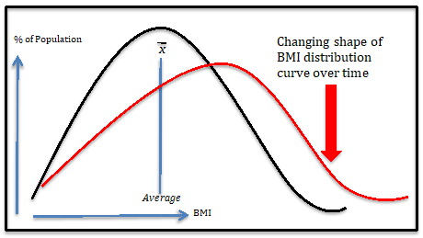
Figure 1. Changing shape of BMI distribution curve over time (2).

Obesity is defined as a pathologically elevated and defended body fat mass due to dysregulation of the pathways that determine energy balance. The complexity in these pathways, including biological, genetic, developmental, epigenetic, environmental, or behavioral factors, lead to substantial variability in the pathophysiological expression of both amount of unwanted weight gain experienced by an individual as well as the number and severity of co-morbid conditions (diabetes, hypertension, etc.) (5-9).

In addition to the variability in phenotypic presentation of weight gain and fat distribution in individuals with obesity (10), weight loss responses to lifestyle, pharmacological, and surgical treatment are also heterogeneous. Although most patients elicit an average response to a distinct type of treatment, some patients will have an above average response to the intervention, while responses in others may be sub-optimal, or they may not respond at all. Thus, a thorough weight history in combination with a clinically applied and integrated understanding of this disease, its root causes, and etiology can help guide successful treatment.

THE OVERWEIGHT AND OBESITY-FOCUSED ENCOUNTER

History, Physical, and Laboratory Testing of the Patient who is Overweight or Has Obesity

The evaluation and diagnosis of a patient with obesity includes the taking of a standard medical history with special attention to identification of potentially weight-promoting medications and obesity-related complications (11), a medical examination that characterizes the amount and distribution of weight as well as possible signs of secondary causes of unwanted weight gain, and review of relevant clinical laboratory tests. In addition, the history of present illness includes generation of a chronological weight graph (ideally using the electronic health record (EHR)) that incorporates a review of life events, lifestyle patterns and preferences, and previous successful and unsuccessful interventions.

The physical exam should note the distribution of weight (especially truncal and abdominal) and areas of conspicuous absence of fat characteristic of lipodystrophies (12), both of which herald increased cardiometabolic risk, as well as areas of disproportionate accumulation of excess fat, such as lipomas and lipedema (13); documentation of cardiac status looking specifically for evidence of heart failure; abdominal palpation for hepatomegaly; identification of inflammatory or degenerative joint issues that may limit activity; and skin/neurological examinations to look for evidence of hypercortisolism (wide striae, proximal muscle weakness), hypothyroidism, hirsutism/acne that might indicate polycystic ovarian syndrome, and acanthosis nigricans over extensor surfaces/neck/axilla. Laboratory evaluation at the initial visit should include a comprehensive metabolic panel, complete blood count, assessment of thyroid status, and cardiometabolic risk assessment including a lipid panel and A1c (Table 1).

Table 1. Key Elements of an Obesity-Focused Encounter
History of Present Illness (HPI) | Weight History and timing to life events, developmental milestones (including puberty, pregnancy, menopause), medication use, and injuries, surgeries, or illnesses.
Past Medical and Surgical History (PMH, PSH) | In addition to a general review, identification of obesity-associated comorbidities and procedures: gastroesophageal reflux, hypertension, HFpEF, asthma, OSA, OA, type 2 diabetes, CAD and PVD, menstrual irregularities/infertility/PCOS, bariatric surgery.
Social History (SH) | Lifestyle, health practices, nutrition, physical activity, sleep, smoking and recreational drug use, stressors, occupation, marital status.
Family History | Parental obesity, cultural patterns, family eating patterns.
Medications | Weight-gain promoting medications.
Physical Exam | BMI, waist circumference  Distribution of body fat, lipodystrophy, lipedema, hypercortisolism, acanthosis.
Laboratory and Diagnostic Testing | Risk assessment: comprehensive metabolic panel, complete blood count, 25-OH vitamin D, C-reactive protein, TSH, hemoglobin A1c, and lipid panel. When indicated, screening for co-morbid conditions such as obstructive sleep apnea, non-alcoholic steatohepatitis, and PCOS.
Assessment and Plan | Based on risks, complications, comorbid conditions and barriers to care.

Identification of obesity-related co-morbidities during the patient encounter and lab testing may necessitate referral for further evaluation, such as non-invasive imaging or liver biopsy to establish non-alcoholic steatohepatitis, a sleep study to diagnose obstructive sleep apnea, or X-rays to assess osteoarthritis in weight-bearing joints. Patients reporting low-level chest discomfort, dyspnea on exertion, or orthopnea should be considered for referral to a cardiologist for the possibility of cardiac ischemia or heart failure with preserved ejection fraction (HFpEF), an increasingly recognized disorder of severe obesity. Findings of weight-related medical conditions during the initial visit may prompt increased motivational drive toward behavioral and lifestyle changes as well as acceptance of recommendations to use anti-obesity medications or for referral for bariatric surgery.

CLINICAL IMPORTANCE OF A WEIGHT TRAJECTORY

During the weight-focused portion of the history of present illness, it is important to document changes in the health that led the patient to seek medical attention over time and establish a clear and chronological description of the sequential events, including weight gain or loss, leading up to the current visit (14-16) (Table 2).

Table 2. Key Elements of an Obesity-Focused History of Present Illness (16)
Onset | When did your weight gain start.  What did you weigh in early, late childhood, puberty, by decade as adult?
Nadir and Maximum Weight | What were your lifetime lowest and highest weights (excluding pregnancy)?  How did you achieve your lowest weight?
Precipitating Factors | What events in your life coincided with unwanted weight gain (puberty, pregnancy, menopause, starting or stopping smoking, starting a new medication such as insulin or steroids)?
Quality of Life | What is hardest to do at your current weight?  When did you feel your best?
Weight Loss Efforts | What did you try that helped you lose weight?  What interventions were successful for you?
Setting | In what context were you successful at your previous efforts? Why do you think those efforts worked?
Temporal Patterns | What is the nature of your weight loss and weight gain over time?  Do you ever weight cycle (yo-yo) or is it gradual or rapid over time?

Multiple studies have demonstrated that an early childhood upward weight trajectory can be predictive of future development of obesity, obesity-related comorbid conditions, disability, and mortality (17-21). A lifetime maximum BMI (compared to a single baseline BMI measurement) in the overweight or obesity categories, coupled with 16 or more years of weight history, is associated with an increased all-cause and cause-specific mortality including cardiovascular disease and coronary heart disease (22).

As will be discussed below, temporal patterns of weight gain that raise concerns in a weight history might include: (a) an early adiposity rebound during infancy or early childhood years (23,24), (b) adolescent weight gain that correlates with progression to severe adult obesity and related medical conditions (25), and (c) excessive weight gain during pregnancy or menopause. Other temporal associations with weight gain often not appreciated by patients and providers include those that accompany smoking cessation (26), resolution of hyperthyroidism (27), initiation of medications for depression, anxiety, and pain management (e.g., beta-blockers, amitriptyline, gabapentin, others) (11), and normal age-associated sarcopenia where skeletal muscle mass gradually declines and visceral fat preferentially increases (28).

Early Growth, Childhood, and Puberty

The timing of excessive body weight gain during one’s life is a predictor of future disease severity. Early and rapid weight gain during youth is predictive of co-morbidities later in life and these patients often experience a more steeply inclined weight trajectory into later stages of adulthood (19). During the ages of 2-6 years, children normally have lower adiposity and are usually at their nadir weight before “rebounding” back up during normal growth (Figure 2, blue line). When adiposity rebound occurs at less than one year of age as visualized on the BMI for-age and gender appropriate growth charts, typically expressed in percentile for age and sex, syndromic, congenital, and monogenic causes of obesity should be considered. Such a very early clinical weight gain history should trigger consideration for genetic testing of genes in the canonical melanocortin pathways (LEPR, PCSK1, POMC, MC4R), which range in incidence from very rare to being implicated in up to 1-6% of early-onset severe obesity (23,29,30). Genetic screening for obesity genes can also be triggered by rapid weight gain from early infancy, development of severe obesity (> 97th BMI percentile) at early ages (especially before the age of 10), persistent food-seeking behaviors indicative of poor appetite control, parental consanguinity, and tall stature/increased growth velocity (31). A weight trajectory following an early adiposity rebound (> 1 year age, ≤ 6 years of age, Figure 2, red dotted line) is a strong risk factor for obesity in adolescence and beyond (24,32) and should be can be an indication for early family-oriented lifestyle interventions.

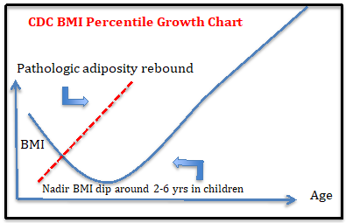
Figure 2. BMI Percentile Growth Chart.

Weight gain leading to obesity during the adolescent development period correlates highly with progression to severe adult obesity. Development of adolescent obesity can affect timing of puberty (early vs. delayed) when body composition and fat distribution are rapidly changing (33). During normal pubertal development and growth, males acquire greater fat-free and skeletal muscle mass, whereas females attain higher fat mass (34).

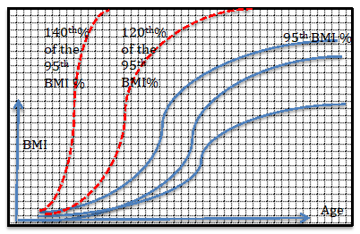
Figure 3. Schematic depiction of abnormal BMI percentile growth curves for adolescents with severe obesity. Greater than or equal to the 95th BMI percentile corresponds to cut-offs for pediatric obesity. Other important considerations that determine therapeutic criteria are if the adolescent’s trajectory falls at or above 120th% and 140th% the 95th BMI percentile for age/gender (see Table 3).

Most patients who experience unwanted, excess weight gain in childhood and adolescence develop obesity-related complications that, when severe, often require pharmacologic intervention and/or bariatric surgery. Early identification and treatment are recommended as for prevention (35). Currently there are six FDA-approved anti-obesity medications available for chronic weight management (orlistat, phentermine/topiramate, liraglutide 3.0 mg, semaglutide 2.4 mg, and setmelanotide). Phentermine/topiramate and orlistat are approved for >12 years respectively, phentermine alone is approved for age >16 years, and setmelanotide can be used as early as 6 years of age (35,36). Use of anti-obesity pharmacotherapy in adolescents with severe obesity (>95th BMI percentile plus the presence of obesity-related comorbidity or >120th of 95th BMI percentile) is now considered standard of care for pediatric obesity treatment (35). Furthermore, vertical sleeve gastrectomy and Roux-en-Y metabolic and bariatric surgery procedures are available options for adolescents with severe obesity (>120th of 95th BMI percentile plus obesity-related comorbidity or BMI >140th of 95th BMI percentile) (37).

Table 3. Available therapeutic options based on BMI percentile cut offs of weight trajectory in adolescent patients with severe obesity (38).
BMI percentile as per CDC growth chart | >95th BMI percentile | >120th of the 95th BMI percentile | >140th of the 95th BMI percentile
Intensive lifestyle intervention | √ | √ | √
Anti-obesity medication | With comorbidity  √ | √ | √
Adolescent bariatric metabolic surgery |  | With comorbidity  √ | √

Pregnancy, Breast Feeding, and Menopausal Transition

Pregnancy and menopause can be a time when women’s weights and body composition may become permanently altered under the influence of dramatic shifts in sex steroid levels. Excessive weight gain during pregnancy can result in epigenetic changes in the developing fetus leading to adult-onset chronic disease such as diabetes, cardiovascular disease, and obesity (39-45) . Furthermore, maternal obesity and excessive gestational weight gain have been linked to maternal-fetal complications such as increased risk of C-sections, preeclampsia, shoulder dystocia, and macrosomia in the infant (46-48). Data from large population-based epidemiological studies have shown that roughly 50% to 60% of women after pregnancy will return to their pre-pregnancy weight, but the other 50% will retain extra weight, with a third of all pregnant women shifting a BMI category (normal to overweight or obesity) (49).

The post-partum period following delivery of the newborn infant is also a vulnerable time for weight retention. Moreover, the relationship between breastfeeding practices and postpartum weight changes is largely unclear due to the difficulties examining breastfeeding and weight management in observational research and confounding variables (50,51). Breastfeeding overall has other notable health benefits to the infant, including reducing atop and improving , cognitive development, bone health, and maternal-infant attachment (52).

Weight gain during midlife is common, and about two-thirds of women ages 40 to 59 and nearly three-quarters of women older than 60 are overweight or have obesity (BMI greater than 25 kg/m²). On average, midlife women gain 1.5 pounds (0.7 kg) per year (53). Thus, it is not surprising that menopause is often depicted as a weight-gain trigger on a patient’s life-event graph, especially in older women who gain weight after a period of weight maintenance. Towards midlife, women undergo redistribution of body composition with increase in total body fat and enhanced inclination toward central abdominal visceral adiposity (54). Excess body weight during menopause is associated with elevated cardiovascular (55) and metabolic risk, including insulin resistance and Type 2 diabetes mellitus (56,57). Early or late-onset menopause (with final menstrual cycle age < 45 years or age > 55 years respectively) compared to age 46-55 years is associated with increased risk of Type 2 diabetes mellitus [HR 1.04, 95% CI 0.99, 1.09 and HR 1.08, 95% CI 1.01, 1.14, respectively] (58). Undergoing a hysterectomy or an oophorectomy increases diabetes risk further (RR 1.17, 95% CI 1.07-1.29) compared to peri-/post-menopausal women (59).

CASE LESSONS IN PATIENT-GENERATED WEIGHT GRAPHS

While in the clinic, having a patient generate their own drawing of weight graph accomplishes two-fold goals. First, it provides a template on which weight inflections in the patient’s life can be potentially identified with causative or contributory life events, medical conditions, and medications; and secondly, it provides a platform to guide the clinical discussion regarding appropriate goal setting and best approaches to help them achieve as close to a healthy weight range as possible.

Impact of Medications

The patient in Figure 4 experienced steroid-induced weight gain, a very common iatrogenic cause of obesity. Exploring reasons for why this patient was initiated on steroids and communication with other specialists regarding opportunities to switch to another non-steroid dependent medication, if available, might mitigate the weight gain and prove to be a successful weight management strategy. Similar discussions of alternative approaches may also be undertaken with other commonly prescribed medications that promote weight gain, including some birth control methods (e.g., Depo-Provera), histamines, beta-blockers, amitriptyline, gabapentin, pregabalin, sulfonylureas, thiazolidinediones, and insulin (60).

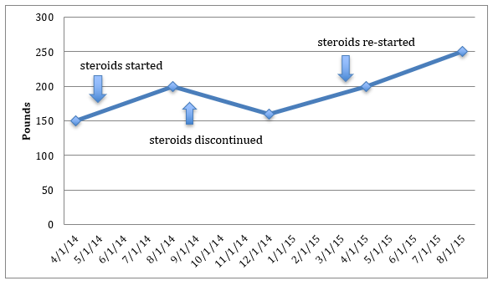
Figure 4. Life graph showing effects of repeated exposures to steroids on weight for chronic inflammatory arthritis.

Effects of Situational Life Changes That Impact Weight

In Figure 5, the patient’s weight was at its nadir during college years until graduation. Subsequently, marriage and job change were identified as life factors timed to weight gain. In addition, pregnancy and menopause were identified biological associations with upward weight trajectory over time. Psychological stressors appear to have further augmented weight gain over time. Resilience to major life stressors (marriage, divorce, loss of spouse, unemployment, death of a loved one, major illness or injury, moving/relocation) is, unfortunately, not as common as is thought and can precipitate psychosocial disorders such as anxiety, depression, and alcoholism (61,62).

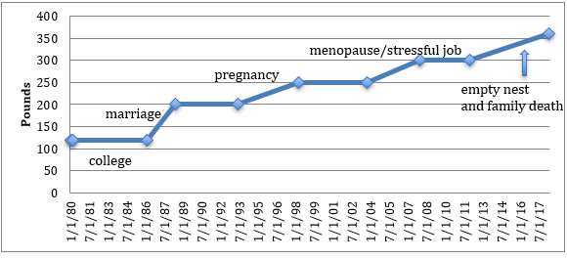
Figure 5. Life graph showing effects of several situational life changes that impact weight.

The patient In Figure 6 had a stable weight prior to a physically traumatic incident that led to immobility and sedentary behaviors. Identification of this specific event contributing to upward weight trajectory in the patient helped tailor the treatment strategy toward physical therapy, rehabilitation, and a customized exercise prescription to mitigate the weight gain.

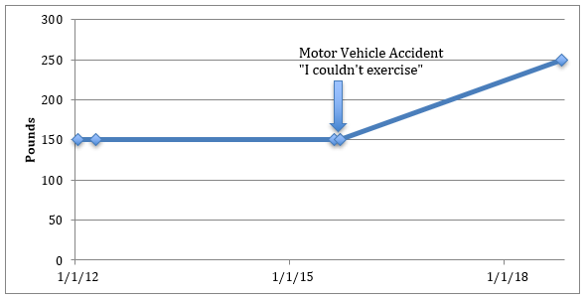
Figure 6. Life graph showing effect of a traumatic incident (a motor vehicle accident in this case) on weight.

Identification of Response to Weight Loss Interventions

The patient in Figure 7 gained over 40 pounds during exposure to various antipsychotic medications for the treatment of bipolar disorder. The downward shift in the weight graph occurred after initiation of metformin 500 mg once daily (to mitigate antipsychotic medication induced weight gain (63)) and phentermine. If certain medications are critical and cannot be substituted with an alternative, weight neutral medication, as is often the case in patients requiring anti-psychotic medications, anti-obesity medications (64), or bariatric surgery can often reverse the weight gain.

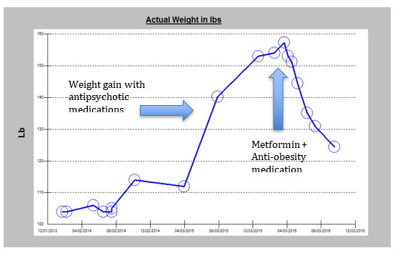
Figure 7. Life graph showing the effects of antipsychotic medications on weight and effective therapeutic intervention with metformin and anti-obesity medications.

Obesity has a multifactorial etiology leading to wide variability in its presentation. Understanding causation and association of weight gain promoting factors in a patient’s life can help elucidate appropriate treatment strategies. Furthermore, initial non-response to anti-obesity medication does not indicate that the medication is ineffective. Rather it may not be targeting the pathophysiological pathways involved in metabolic and body weight dysregulation in the individual patient and an alternative anti-obesity medication or combination should be trialed for synergistic or additive weight loss effects. In Figure 8, the first blue arrow shows the time of initial visit when the patient started to gain weight due to multifactorial etiology (strong family history of obesity, maladaptive stress related to work, unhealthy nutritional habits), followed by initiation of anti-obesity medicine therapy and intensive lifestyle intervention (phentermine; 2nd blue arrow). Subsequently, the patient developed side effects and phentermine monotherapy was discontinued (3rd blue arrow). Several other anti-obesity pharmacological options were trialed (4th blue arrow); however, the patient did not respond. Ultimately, the patient underwent bariatric surgery (Roux-en-Y gastric bypass (RYGB)) to achieve successful weight loss response.

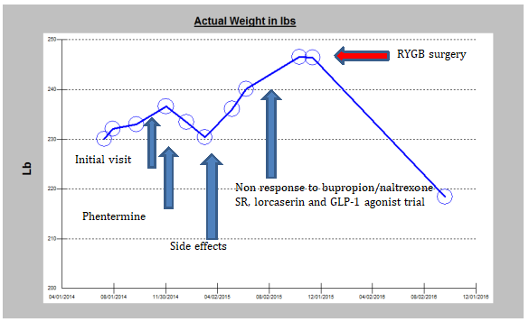
Figure 8. The life events graph depicts the response to treatment and strategies for further intervention.

Identification of Weight Regain after Successful Weight Loss: Importance of Prompt Intervention and Identification of Lifetime Maximum Weight

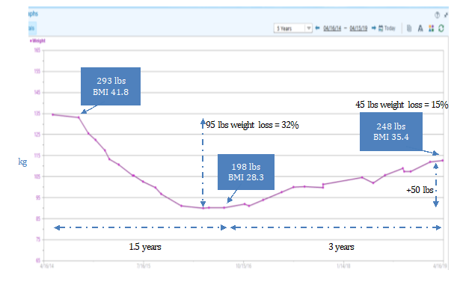
Figure 9. Life graph showing effect of weight loss program intervention over time with weight regain.

The life-events graph of a 55-year-old patient with a history of hypertension, obstructive sleep apnea, and severe obesity (BMI 41.8 kg/m²) in Figure 9 shows a 95 pounds over a 1.5-year period through self-monitoring using an electronic smart phone tracking application, 1800 kcal/day intake, and an increase in physical activity as tolerated. However, after 1.5 years of successful weight loss, despite continued intensive lifestyle changes, the patient experienced weight regain over the next 3 years. Weight regain after a period of caloric restriction is physiologic as long-term persistence of metabolic adaptation occurs and hunger and satiety signals resist weight loss (65). It important to initiate anti-obesity pharmacotherapy at this critical stage to help sustain the weight loss and prevent weight regain. In this patient, starting an anti-obesity medication after 1.5 years when weight gain had started to occur would be recommended. It is also important to identify the patient’s lifetime max as the starting point when gauging effectiveness of anti-obesity medications in this scenario. Simply using the pre-medication weight might lead to inappropriate stopping of this treatment if weight stabilization is achieved, since the absence of subsequent weight loss might be misinterpreted as medication “failure.” By determining the lifetime maximum weight, however, weight stabilization is a very successful ~20% to 30% total weight loss (50 to 100 lbs. weight loss compared to the lifetime maximum weight of 293 lbs., depending on when it was started).

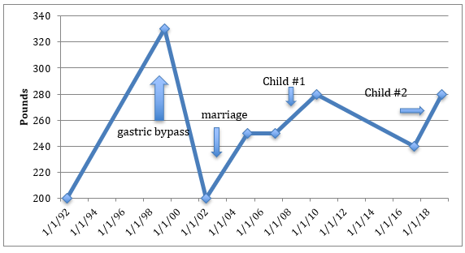
Figure 10. Life graph showing a patient status post gastric-bypass surgery with weight regain following situational life transitions (marriage, birth of children).

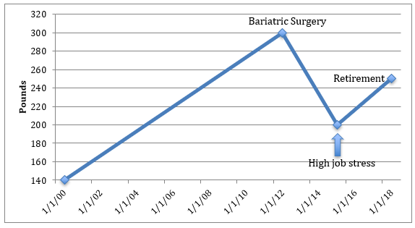
Figure 11. Life graph showing weight loss in a patient after bariatric surgery followed by weight regain after high job-related stress and retirement.

Figures 10 and 11 depict life-event graphs of two patients who underwent metabolic and bariatric surgery. Following successful weight loss, they both experienced weight regain. Weight regain in the postoperative bariatric patient is often difficult to treat and is usually of multifactorial etiology (as examples, recurrence of obesity-related comorbidities, non-compliance and adherence to treatment recommendations and routine bariatric care, physiologic return of hunger signals, introduction of life stressors). Early recognition, evaluation and medical management, provided anatomical causes have been ruled out, with multidisciplinary team support are crucial to removing obstacles to weight maintenance and patient’s continued commitment to lifestyle improvements. Further, it presents an opportunity to intervene early and initiate anti-obesity pharmacotherapy, ideally at the expected weight loss nadir, usually 1-3 years after surgery, to help optimize weight loss response and prevent weight regain (66).

Communicating with Patients About the Disease of Obesity

To effectively communicate obesity treatment recommendations to patients, medical professionals first need to translate obesity pathophysiology in language understood by patients, without bias or stigma. General questions, concerns, or sentiments often echoed by patients during their weight journey include:

- “Doc, are you calling me ‘fat?’”
- “I have tried every diet in the past. I lose weight only to regain it back.”
- “I know it’s my fault I am this weight.”
- “I have always been 300 pounds my entire life, no matter what.”
- “I don’t think I need surgery. I’ll just have to diet and exercise anyways.”
- “I don’t need medications to lose weight.”

Clinically, there are three important concepts to convey to patients about the disease state:

1. Obesity is a disease, like hypertension or diabetes.
2. Because it is a disease, we can treat it as such, either starting with lifestyle and then moving on to medical and surgical treatments for obesity, or initiating lifestyle plus these treatments in patients with severe obesity.
3. It is not the patient’s fault that they developed obesity. There are strong biological and genetic forces at play that determine body mass in addition to medical, behavioral, lifestyle, psychosocial, and environmental influences.

To clearly communicate with patients about the disease of obesity, a thorough understanding of energy metabolism is often necessary. Energy metabolism is complexly regulated in the arcuate nucleus of the hypothalamus to set a defended body weight (10,36,67). This body weight “set point” is oftentimes biologically and genetically determined with influences from the modern macro- and micro-environments. Chronic exposure to an obesogenic environment can increase body fat mass set point in susceptible individuals causing the body to defend a higher weight regardless of well-intended volitional efforts to lose weight. Thus, current treatment strategies include coupling intensive lifestyle therapy with anti-obesity medications and/or bariatric surgery, to allow significant and sustained reductions in the fat mass set point. Discontinuation of treatments that successfully lower the body mass set point will result in regain of body weight to the original, pathologically higher body mass set point. Therefore, patients need to understand that treatments for obesity are long-term, as is true for any medication prescribed for a chronic medical condition. Regain of weight after discontinuation of therapy is not evidence of failed treatment or lack of willpower; rather it is physiologically expected.

Medical professionals can incorporate this scientific understanding in a manner that evades bias and stigma and transforms the patient’s queries into a constructive dialogue. In response to the questions or concerns posed by the patients above, medical professionals can reply in the following manner:

- “Doc, are you calling me ‘fat’?” Response: “We only use the word ‘fat’ to describe mice and rodents, not humans. We are people. There are various parameters we check to make sure your body is healthy, not only from the outside, but also from the inside, similar to us checking your blood pressure and cholesterol. Your weight indicates that your body-mass-index is elevated. It means that it places you at high risk for, or already contributing to, other weight-related medical conditions. A high BMI is a result of a disease process inside your body, like diabetes. You have obesity, or adiposity-based chronic disease. The good news is that you have treatment options beyond just saying ‘eat less and exercise more’.”
- “I have tried every diet in the past. I lose weight only to regain it back.” Response: “Contrary to popular belief, we don’t consciously control our weight. It is regulated by a fat mass set point in our brains. If your fat mass set point is abnormally high (again, not your fault), your body will continue to defend that weight. This abnormal physiology is why weight regain is common. There are treatments that more effectively lower that fat mass set point, so you do not have to struggle. That way, when you are making healthy food choices and are active, your body starts to respond. If you’d like, we can discuss those treatment options and how they may benefit you.”
- “I know it’s my fault I am this weight.” Response: “First of all, I want you to understand that it’s not your fault you developed obesity. You did not choose to ‘have’ obesity. If you were here today to discuss your diabetes diagnosis, it would be a completely different conversation, correct? Just like you did not have a choice in selecting your parents, you did not have a choice in the development of your obesity. Again, contrary to popular belief, majority of our weight is not under our control. The good news is that we can treat it.”
- “I have always been 300 pounds my entire life, no matter what.” Response: “Have you wondered why that has been the reason? We now know that there is a weight set point in our brain that determines what our brains think of as “normal.”. It is biologically and genetically determined with influences from the outside environment, medications, and other factors. In patients with obesity, this weight set point is abnormally high—your brain thinks that weight is now “normal.” Thus, when you try to lose weight, you regain it back to this set point and, sometime, more. If improving your lifestyle isn’t working, we have treatments to lower this fat mass set point when it is high. Anti-obesity medications and bariatric surgery are great tools to allow your brain to be happy with a lower weight set point so that you do not have to fight against your body.”
- “I don’t think I need surgery. I’ll just have to diet and exercise anyways.” Response: “Let’s explore this further. Can you help me understand more your reasons as to why you think you do not need surgery? What are your concerns and fears? What is your understanding about bariatric surgery? Let’s see if we can address some of those today.”
- “I don’t need medications to lose weight.” Response: “Can you help me understand your reasons for not considering medications? What is your understanding of obesity medications and how they work? If we try to manage your weight without medications, I would like to reassess your progress in 12 weeks. If you are still struggling despite all your best efforts, please know that it is not your fault, and that your body is telling you that it needs something more intensive to treat the weight gain. You do have options still!”

CONCLUSIONS

An obesity-focused medical history is important for the care of the patient who is overweight or has obesity. In addition to identifying obesity-related complications by means of a thorough history, physical, and appropriate laboratory work up, using electronic health record weight graphs and identifying significant medical and life-events that influence body weight provide context and relevance for weight trajectories in the management of a patient with obesity. For example, these events can help guide the clinical discussion in regard to potentially modifiable influences on a patient’s weight, including identifying causative medical conditions or culprit medications that promote weight gain, associating weight gain with known life-transitions that increase a patient’s risk for becoming overweight or obese (e.g., puberty, pregnancy, menopause), help patients to re-commit to improved lifestyle choices, assess an individual’s responsiveness to recommended therapies, and help with timing for when initiating anti-obesity, therapies such as weight loss medications, weight loss surgery, or both, when indicated.

REFERENCES

1. Flegal KM, Carroll MD, Kit BK, Ogden CL. Prevalence of obesity and trends in the distribution of body mass index among US adults, 1999-2010. JAMA. 2012;307(5):491-497.
2. Penman AD, Johnson WD. The changing shape of the body mass index distribution curve in the population: implications for public health policy to reduce the prevalence of adult obesity. Prev Chronic Dis. 2006;3(3):A74.
3. Fryar CD, Kruszon-Moran D, Gu Q, Ogden CL. Mean Body Weight, Height, Waist Circumference, and Body Mass Index Among Adults: United States, 1999-2000 Through 2015-2016. Natl Health Stat Report. 2018(122):1-16.
4. Ritchie SA, Connell JM. The link between abdominal obesity, metabolic syndrome and cardiovascular disease. Nutr Metab Cardiovasc Dis. 2007;17(4):319-326.
5. Bessler M, Daud A, DiGiorgi MF, Schrope BA, Inabnet WB, Davis DG. Frequency distribution of weight loss percentage after gastric bypass and adjustable gastric banding. Surg Obes Relat Dis. 2008;4(4):486-491.
6. Gardner CD. Tailoring dietary approaches for weight loss. Int J Obes Suppl. 2012;2(Suppl 1):S11-S15.
7. Smith SR, Prosser WA, Donahue DJ, Morgan ME, Anderson CM, Shanahan WR, Group APDS. Lorcaserin (APD356), a selective 5-HT(2C) agonist, reduces body weight in obese men and women. Obesity (Silver Spring). 2009;17(3):494-503.
8. Hatoum IJ, Greenawalt DM, Cotsapas C, Reitman ML, Daly MJ, Kaplan LM. Heritability of the weight loss response to gastric bypass surgery. J Clin Endocrinol Metab. 2011;96(10):E1630-1633.
9. Buford TW, Roberts MD, Church TS. Toward exercise as personalized medicine. Sports Med. 2013;43(3):157-165.
10. Srivastava G, Apovian CM. Current pharmacotherapy for obesity. Nat Rev Endocrinol. 2018;14(1):12-24.
11. Verhaegen AA, Van Gaal LF. Drugs That Affect Body Weight, Body Fat Distribution, and Metabolism. In: Feingold KR, Anawalt, B., Boyce, A., Chrousos, G., Dungan, K., Grossman, A., Hershman, J. M., Kaltsas, G., Koch, C., Kopp, P., Korbonits, M., McLachlan, R., Morley, J. E., New, M., Perreault, L., Purnell, J., Rebar, R., Singer, F., Trence, D. L., Vinik, A., Wilson, D. P., ed. Endotext [Internet]. South Dartmouth (MA) MDText.com, Inc.; 2000-; 2019 Feb 11.
12. Akinci B, Sahinoz M, Oral E. Lipodystrophy Syndromes: Presentation and Treatment. In: Feingold KR, Anawalt, B., Boyce ,A., Chrousos, G., Dungan, K., Grossman, A., Hershman, J. M., Kaltsas, G., Koch, C., Kopp, P., Korbonits, M., McLachlan, R., Morley, J. E., New, M., Perreault, L., Purnell, J., Rebar, R., Singer, F., Trence, D. L., Vinik, A., Wilson, D., ed. Endotext [Internet]. South Dartmouth (MA): MDText.com, Inc.; 2000-. 2018 Apr 24.
13. Herbst KL. Subcutaneous Adipose Tissue Diseases: Dercum Disease, Lipedema, Familial Multiple Lipomatosis, and Madelung Disease. In: Feingold KR, Anawalt B, Boyce A, Chrousos G, de Herder WW, Dhatariya K, Dungan K, Hershman JM, Hofland J, Kalra S, Kaltsas G, Koch C, Kopp P, Korbonits M, Kovacs CS, Kuohung W, Laferrere B, Levy M, McGee EA, McLachlan R, Morley JE, New M, Purnell J, Sahay R, Singer F, Sperling MA, Stratakis CA, Trence DL, Wilson DP, eds. Endotext. South Dartmouth (MA)2000.
14. Adler HM. The history of the present illness as treatment: who's listening, and why does it matter? J Am Board Fam Pract. 1997;10(1):28-35.
15. Redelmeier DA, Schull MJ, Hux JE, Tu JV, Ferris LE. Problems for clinical judgement: 1. Eliciting an insightful history of present illness. CMAJ. 2001;164(5):647-651.
16. Kushner RF, Batsis JA, Butsch WS, Davis N, Golden A, Halperin F, Kidambi S, Machineni S, Novick M, Port A, Rubino DM, Saunders KH, Shapiro Manning L, Soleymani T, Kahan S. Weight History in Clinical Practice: The State of the Science and Future Directions. Obesity (Silver Spring). 2020;28(1):9-17.
17. Malhotra R, Ostbye T, Riley CM, Finkelstein EA. Young adult weight trajectories through midlife by body mass category. Obesity (Silver Spring). 2013;21(9):1923-1934.
18. Stokes A, Ni Y, Preston SH. Prevalence and Trends in Lifetime Obesity in the U.S., 1988-2014. Am J Prev Med. 2017;53(5):567-575.
19. Zheng Y, Manson JE, Yuan C, Liang MH, Grodstein F, Stampfer MJ, Willett WC, Hu FB. Associations of Weight Gain From Early to Middle Adulthood With Major Health Outcomes Later in Life. JAMA. 2017;318(3):255-269.
20. Zheng Y, Song M, Manson JE, Giovannucci EL, Hu FB. Group-Based Trajectory of Body Shape From Ages 5 to 55 Years and Cardiometabolic Disease Risk in 2 US Cohorts. Am J Epidemiol. 2017;186(11):1246-1255.
21. Petrick JL, Kelly SP, Liao LM, Freedman ND, Graubard BI, Cook MB. Body weight trajectories and risk of oesophageal and gastric cardia adenocarcinomas: a pooled analysis of NIH-AARP and PLCO Studies. Br J Cancer. 2017;116(7):951-959.
22. Yu E, Ley SH, Manson JE, Willett W, Satija A, Hu FB, Stokes A. Weight History and All-Cause and Cause-Specific Mortality in Three Prospective Cohort Studies. Ann Intern Med. 2017;166(9):613-620.
23. Farooqi IS, O'Rahilly S. The Genetics of Obesity in Humans. In: Feingold KR, Anawalt, B., Boyce A3, Chrousos, G., Dungan, K., Grossman, A., Hershman, J. M., Kaltsas, G., Koch, C., Kopp, P., Korbonits, M., McLachlan, R., Morley, J. E., New, M., Perreault, L., Purnell, J., Rebar, R., Singer, F., Trence, D. L., Vinik, A., Wilson, D. P., ed. Endotext [Internet]. South Dartmouth (MA): MDText.com, Inc.; 2000-; 2017 Dec 23.
24. Geserick M, Vogel M, Gausche R, Lipek T, Spielau U, Keller E, Pfaffle R, Kiess W, Korner A. Acceleration of BMI in Early Childhood and Risk of Sustained Obesity. N Engl J Med. 2018;379(14):1303-1312.
25. Twig G, Yaniv G, Levine H, Leiba A, Goldberger N, Derazne E, Ben-Ami Shor D, Tzur D, Afek A, Shamiss A, Haklai Z, Kark JD. Body-Mass Index in 2.3 Million Adolescents and Cardiovascular Death in Adulthood. N Engl J Med. 2016;374(25):2430-2440.
26. Bush T, Lovejoy JC, Deprey M, Carpenter KM. The effect of tobacco cessation on weight gain, obesity, and diabetes risk. Obesity (Silver Spring). 2016;24(9):1834-1841.
27. Schneider DF, Nookala R, Jaraczewski TJ, Chen H, Solorzano CC, Sippel RS. Thyroidectomy as primary treatment optimizes body mass index in patients with hyperthyroidism. Ann Surg Oncol. 2014;21(7):2303-2309.
28. Choi KM. Sarcopenia and sarcopenic obesity. Korean J Intern Med. 2016;31(6):1054-1060.
29. Oswal A, Yeo GS. The leptin melanocortin pathway and the control of body weight: lessons from human and murine genetics. Obes Rev. 2007;8(4):293-306.
30. Doulla M, McIntyre AD, Hegele RA, Gallego PH. A novel MC4R mutation associated with childhood-onset obesity: A case report. Paediatr Child Health. 2014;19(10):515-518.
31. Malhotra S, Sivasubramanian R, Srivastava G. Evaluation and Mangement of Early Onset Genetic Obesity in Childhood. Journal of Pediatric Genetics. 2021.
32. Rolland-Cachera MF, Peneau S. Growth trajectories associated with adult obesity. World Rev Nutr Diet. 2013;106:127-134.
33. Lee JM, Wasserman R, Kaciroti N, Gebremariam A, Steffes J, Dowshen S, Harris D, Serwint J, Abney D, Smitherman L, Reiter E, Herman-Giddens ME. Timing of Puberty in Overweight Versus Obese Boys. Pediatrics. 2016;137(2):e20150164.
34. Loomba-Albrecht LA, Styne DM. Effect of puberty on body composition. Curr Opin Endocrinol Diabetes Obes. 2009;16(1):10-15.
35. Srivastava G, Fox CK, Kelly AS, Jastreboff AM, Browne AF, Browne NT, Pratt JSA, Bolling C, Michalsky MP, Cook S, Lenders CM, Apovian CM. Clinical Considerations Regarding the Use of Obesity Pharmacotherapy in Adolescents with Obesity. Obesity (Silver Spring). 2019;27(2):190-204.
36. Kumar RB, Srivastava G, Reid TJ, Aronne LJ. Understanding the pathophysiologic pathways that underlie obesity and options for treatment. Expert Rev Endocrinol Metab. 2021;16(6):321-338.
37. Pratt JSA, Browne A, Browne NT, Bruzoni M, Cohen M, Desai A, Inge T, Linden BC, Mattar SG, Michalsky M, Podkameni D, Reichard KW, Stanford FC, Zeller MH, Zitsman J. ASMBS pediatric metabolic and bariatric surgery guidelines, 2018. Surg Obes Relat Dis. 2018;14(7):882-901.
38. Cardel MI, Jastreboff AM, Kelly AS. Treatment of Adolescent Obesity in 2020. JAMA. 2019;322(17):1707-1708.
39. Stephenson J, Heslehurst N, Hall J, Schoenaker D, Hutchinson J, Cade JE, Poston L, Barrett G, Crozier SR, Barker M, Kumaran K, Yajnik CS, Baird J, Mishra GD. Before the beginning: nutrition and lifestyle in the preconception period and its importance for future health. Lancet. 2018;391(10132):1830-1841.
40. Fleming TP, Watkins AJ, Velazquez MA, Mathers JC, Prentice AM, Stephenson J, Barker M, Saffery R, Yajnik CS, Eckert JJ, Hanson MA, Forrester T, Gluckman PD, Godfrey KM. Origins of lifetime health around the time of conception: causes and consequences. Lancet. 2018;391(10132):1842-1852.
41. Fernandez-Twinn DS, Hjort L, Novakovic B, Ozanne SE, Saffery R. Intrauterine programming of obesity and type 2 diabetes. Diabetologia. 2019;62(10):1789-1801.
42. Jansen MAC, Dalmeijer GW, Saldi SR, Grobbee DE, Baharuddin M, Uiterwaal CS, Idris NS. Pre-pregnancy parental BMI and offspring blood pressure in infancy. European journal of preventive cardiology. 2019:2047487319858157.
43. Heslehurst N, Vieira R, Akhter Z, Bailey H, Slack E, Ngongalah L, Pemu A, Rankin J. The association between maternal body mass index and child obesity: A systematic review and meta-analysis. PLoS medicine. 2019;16(6):e1002817.
44. Razaz N, Villamor E, Muraca GM, Bonamy AE, Cnattingius S. Maternal obesity and risk of cardiovascular diseases in offspring: a population-based cohort and sibling-controlled study. Lancet Diabetes Endocrinol. 2020;8(7):572-581.
45. Perak AM, Lancki N, Kuang A, Labarthe DR, Allen NB, Shah SH, Lowe LP, Grobman WA, Lawrence JM, Lloyd-Jones DM, Lowe WL, Jr., Scholtens DM, Group HF-USCR. Associations of Maternal Cardiovascular Health in Pregnancy With Offspring Cardiovascular Health in Early Adolescence. JAMA. 2021;325(7):658-668.
46. Mission JF, Marshall NE, Caughey AB. Pregnancy risks associated with obesity. Obstet Gynecol Clin North Am. 2015;42(2):335-353.
47. Marshall NE, Guild C, Cheng YW, Caughey AB, Halloran DR. Maternal superobesity and perinatal outcomes. American journal of obstetrics and gynecology. 2012;206(5):417 e411-416.
48. Getahun D, Ananth CV, Peltier MR, Salihu HM, Scorza WE. Changes in prepregnancy body mass index between the first and second pregnancies and risk of large-for-gestational-age birth. American journal of obstetrics and gynecology. 2007;196(6):530 e531-538.
49. Wallace JM, Bhattacharya S, Horgan GW. Weight change across the start of three consecutive pregnancies and the risk of maternal morbidity and SGA birth at the second and third pregnancy. PloS one. 2017;12(6):e0179589.
50. Neville CE, McKinley MC, Holmes VA, Spence D, Woodside JV. The effectiveness of weight management interventions in breastfeeding women--a systematic review and critical evaluation. Birth. 2014;41(3):223-236.
51. Neville CE, McKinley MC, Holmes VA, Spence D, Woodside JV. The relationship between breastfeeding and postpartum weight change--a systematic review and critical evaluation. Int J Obes (Lond). 2014;38(4):577-590.
52. Lucas A. Scientific Evidence for Breastfeeding. Nestle Nutr Inst Workshop Ser. 2019;90:1-12.
53. Kapoor E, Collazo-Clavell ML, Faubion SS. Weight Gain in Women at Midlife: A Concise Review of the Pathophysiology and Strategies for Management. Mayo Clin Proc. 2017;92(10):1552-1558.
54. Kozakowski J, Gietka-Czernel M, Leszczynska D, Majos A. Obesity in menopause - our negligence or an unfortunate inevitability? Prz Menopauzalny. 2017;16(2):61-65.
55. Ramezani Tehrani F, Behboudi-Gandevani S, Ghanbarian A, Azizi F. Effect of menopause on cardiovascular disease and its risk factors: a 9-year follow-up study. Climacteric. 2014;17(2):164-172.
56. Davis SR, Castelo-Branco C, Chedraui P, Lumsden MA, Nappi RE, Shah D, Villaseca P, Writing Group of the International Menopause Society for World Menopause D. Understanding weight gain at menopause. Climacteric. 2012;15(5):419-429.
57. Senechal M, Arguin H, Bouchard DR, Carpentier AC, Ardilouze JL, Dionne IJ, Brochu M. Weight gain since menopause and its associations with weight loss maintenance in obese postmenopausal women. Clin Interv Aging. 2011;6:221-225.
58. LeBlanc ES, Kapphahn K, Hedlin H, Desai M, Parikh NI, Liu S, Parker DR, Anderson M, Aroda V, Sullivan S, Woods NF, Waring ME, Lewis CE, Stefanick M. Reproductive history and risk of type 2 diabetes mellitus in postmenopausal women: findings from the Women's Health Initiative. Menopause. 2017;24(1):64-72.
59. Pandeya N, Huxley RR, Chung HF, Dobson AJ, Kuh D, Hardy R, Cade JE, Greenwood DC, Giles GG, Bruinsma F, Demakakos P, Simonsen MK, Adami HO, Weiderpass E, Mishra GD. Female reproductive history and risk of type 2 diabetes: A prospective analysis of 126 721 women. Diabetes Obes Metab. 2018;20(9):2103-2112.
60. Verhaegen AA, Van Gaal LF. Drugs That Affect Body Weight, Body Fat Distribution, and Metabolism. In: Feingold KR, Anawalt B, Boyce A, Chrousos G, de Herder WW, Dhatariya K, Dungan K, Hershman JM, Hofland J, Kalra S, Kaltsas G, Koch C, Kopp P, Korbonits M, Kovacs CS, Kuohung W, Laferrere B, Levy M, McGee EA, McLachlan R, Morley JE, New M, Purnell J, Sahay R, Singer F, Sperling MA, Stratakis CA, Trence DL, Wilson DP, eds. Endotext. South Dartmouth (MA)2000.
61. Infurna FJ, Luthar SS. Resilience to Major Life Stressors Is Not as Common as Thought. Perspect Psychol Sci. 2016;11(2):175-194.
62. Just-Ostergaard E, Mortensen EL, Flensborg-Madsen T. Major life events and risk of alcohol use disorders: a prospective cohort study. Addiction. 2018;113(1):25-33.
63. Hendrick V, Dasher R, Gitlin M, Parsi M. Minimizing weight gain for patients taking antipsychotic medications: The potential role for early use of metformin. Ann Clin Psychiatry. 2017;29(2):120-124.
64. Apovian CM, Aronne LJ, Bessesen DH, McDonnell ME, Murad MH, Pagotto U, Ryan DH, Still CD, Endocrine S. Pharmacological management of obesity: an endocrine Society clinical practice guideline. J Clin Endocrinol Metab. 2015;100(2):342-362.
65. Sumithran P, Prendergast LA, Delbridge E, Purcell K, Shulkes A, Kriketos A, Proietto J. Long-term persistence of hormonal adaptations to weight loss. N Engl J Med. 2011;365(17):1597-1604.
66. Srivastava G, Buffington C. A Specialized Medical Management Program to Address Post-operative Weight Regain in Bariatric Patients. Obes Surg. 2018.
67. Garvey WT. Is Obesity or Adiposity-Based Chronic Disease Curable: The Set Point Theory, the Environment, and Second-Generation Medications. Endocr Pract. 2022;28(2):214-222.

