**USE OF THE HISTORIAL WEIGHT TRAJECTORY TO GUIDE AN OBESITY-FOCUSED PATIENT ENCOUNTER**

**Gitanjali Srivastava, MD,** Assistant Professor of Medicine, Boston University School of Medicine and Boston Medical Center, Dept. of Medicine, Section on Endocrinology, Diabetes,

720 Harrison Avenue, 8th Floor, Boston, MA 02118, email: geet5sri@gmail.com

**Robert F Kushner, MD,** Professor of Medicine, Department of Medicine, Section of Endocrinology, Diabetes & Molecular Medicine, Northwestern Medicine Feinberg School of Medicine |Northwestern University, 645 North Michigan Avenue, Suite 530, Chicago, IL 60611, Email: [rkushner@northwestern.edu](mailto:rkushner@northwestern.edu)

**Caroline M. Apovian, MD,** Director, Nutrition and Weight Management Center, Section of Endocrinology, Diabetes and Nutrition Department of Medicine, Professor of Medicine and Pediatrics, Boston University School of Medicine and Boston Medical Center, Dept. of Medicine, Section on Endocrinology, Diabetes, 720 Harrison Avenue, 8th Floor, Boston, MA 02118, email: [caroline.apovian@bmc.org](mailto:caroline.apovian@bmc.org)

**Submitted May 16, 2019**

**ABSTRACT**

Obesity is a complex and challenging disease to address by clinicians. Moreover, given the wide prevalence coupled with disease impact, every specialty in medicine will likely encounter many patients with obesity. Thus, it becomes crucial for practitioners to obtain a thorough weight history from patients in order to identify potential triggers that influence weight gain trajectories and their relationships to development of disease co-morbidity and mortality. Obtaining a weight history from a patient can be approached systematically, similar to key elements of a history of present illness, as we will discuss. Furthermore, patient-drawn life-events graph or readily available electronic health records graphs can elucidate in visual context pertinent contributing factors to the etiology of obesity. Oftentimes, biological, social, behavioral and psychological causes of weight gain can be elicited through the use of weight histories. In this chapter, we will also explore life-events graph more in detail as they can provide remarkable value to the overall assessment and plan of care (whether lifestyle intervention with additional ancillary support, pharmacological, surgical, or combination thereof) in the patient with obesity.

**INTRODUCTION**

Obesity adversely affects all organ systems in the human body and causes and/or exacerbates numerous medical disorders such as cardiovascular disease, diabetes, kidney disease, and cancers. Today, the average adult weight has increased (1) with a disproportionate rightward skewing (2) of the body mass index (BMI) distribution curve (Figure 1) with a higher percentage of the population meeting criteria for Class 1 obesity or higher (>30 kg/m2) and more disease severity (Class 2 obesity or higher; BMI >35 kg/m2). In addition, the average waist circumference has increased across US adults since 1999 (3). Increase in abdominal girth (>35 inches for women; >40 inches for men), commonly called central or abdominal obesity, is a surrogate for visceral adiposity, which increases risk for the metabolic syndrome, inflammation and cardiovascular disease (4).

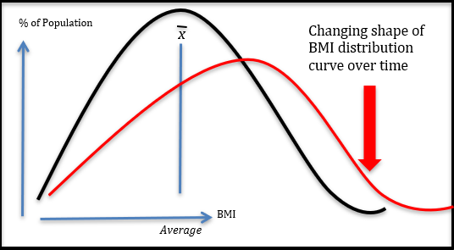

**Figure 1. Changing Shape of BMI Distribution Curve Over Time (2)**

Obesity is defined as a pathologically elevated and defended body fat mass due to dysregulation of the pathways that determine energy balance. The complexity in these pathways, whether through biological, genetic, developmental, epigenetic, environmental, or behavioral factors, lead to substantial variability in the pathophysiological expression of both amount of unwanted weight gain experienced by an individual as well as the number and severity of co-morbid conditions (diabetes, hypertension, etc.) (5, 6, 7, 8, 9).

In addition to the variability in phenotypic presentation of weight gain and fat distribution in obesity (10), individual responses to lifestyle, pharmacological, and surgical treatment are also heterogeneous. Although most patients elicit an average response to a distinct type of treatment, some patients will have an above average response to the intervention, while in others the response may be sub-optimal, or they may not respond at all. A thorough weight history can help identify these targeted responders to specific treatment. Thus, clinically applied and integrated understanding of the disease, its root causes and etiology within a thorough weight history can guide successful treatment.

**THE OVERWEIGHT AND OBESITY-FOCUSED ENCOUNTER**

**History, Physical, and Laboratory Testing of the Patient who is Overweight or Has Obesity**

The evaluation and diagnosis of a patient with obesity follows standard medical history, review of systems with a focus on weight-related complications, a review of potentially weight-promoting medications (11), a medical examination that characterizes the amount and distribution of weight as well as possible signs of secondary causes of unwanted weight gain, as well as relevant clinical laboratory tests. In addition, the history of present illness includes a patient interview and generation of a chronological weight graph using the electronic health record (EHR), lifestyle patterns and preferences, and previous interventions (whether successful or unsuccessful).

The physical exam should note the distribution of weight (especially truncal and abdominal) and areas of conspicuous absence of fat characteristic of lipodystrophies (12), both of which herald increased cardiometabolic risk; documentation of cardiac status looking for evidence of heart failure; abdominal palpation for hepatomegaly; identification of inflammatory or degenerative joint issues that may limit activity; and skin/neurological examinations to look for evidence of hypercortisolism (wide striae, proximal muscle weakness), hypothyroidism, hirsutism/acne in polycystic ovarian syndrome, acanthosis nigricans over extensor surfaces/neck/axilla, lipomas, and lipedema. Laboratory evaluation at the initial visit should include a comprehensive metabolic panel, complete blood count, assessment of thyroid status, and cardiometabolic risk assessment including a lipid panel and A1c (Table 1).

Identification of obesity-related co-morbidities during the patient encounter and lab testing may necessitate referral for further evaluation, such as non-invasive imaging or liver biopsy to establish non-alcoholic steatohepatitis, a sleep study to diagnose obstructive sleep apnea, or X-ray to assess osteoarthritis in weight-bearing joints. Patients reporting low-level dyspnea on exertion or orthopnea should be considered for referral to a cardiologist for the possibility of cardiac ischemia or, an increasingly recognized disorder of severe obesity, heart failure with preserved ejection fraction (HFpEF).

|  |  |
| --- | --- |
| **Table 1. Key Elements of an Obesity-Focused Encounter** | |
| History of Present Illness (HPI) | Weight History and timing to life events, developmental milestones (puberty, pregnancy, menopause), medication use, and injuries, surgeries, or illnesses. |
| Past Medical and Surgical History (PMH, PSH) | In addition to a general review, identification of obesity-associated comorbidities and procedures: gastro-esophageal reflux, hypertension, HFpEF, asthma, OSA, OA, type 2 diabetes, CAD and PVD, menstrual irregularities/infertility/PCOS, bariatric surgery |
| Social History (SH) | Lifestyle, health practices, nutrition, physical activity, sleep, stressors, occupation, marital status |
| Family History | Parental obesity, cultural patterns, family eating patterns |
| Medications/Allergies | Weight-gain promoting medications |
| Physical Examination | BMI, waist circumference. Distribution of body fat |
| Laboratory and Diagnostic Testing | Risk assessment: comprehensive metabolic panel, complete blood count, 25-OH vitamin D, C-reactive protein, TSH, hemoglobin A1c, and lipid panel. When indicated, screening for co-morbid conditions such as obstructive sleep apnea, non-alcoholic steatohepatitis, and PCOS |
| Assessment and Plan | Based on risks, complications, comorbid conditions and barriers to care |

**CLINICAL IMPORTANCE OF A WEIGHT TRAJECTORY**

During the weight-focused portion of the history of present illness, it is important to document changes in the health that led the patient to seek medical attention overtime and establish a clear and chronological description of the sequential events, including weight gain or loss, leading up to the current visit (13, 14) (Table 2).

|  |  |
| --- | --- |
| **Table 2. Key Elements of an Obesity-Focused History of Present Illness (15)** | |
| Onset | Nadir and Maximum Weight (excluding pregnancy)  What was your highest and lowest weight?  What did you weigh in teenage years, college, 20s, 30s, 40s, 50s? |
| Nadir and Maximum Weight (excluding pregnancy) | What were your lowest and highest weights?  How did you achieve your lowest weight? |
| Precipitating Factors | What events in your life triggered weight gain (puberty, pregnancy, menopause, starting or stopping smoking, starting a new medication such as insulin or steroids)? |
| Quality of life | What is hardest to do at your current weight?  When did you feel your best? |
| Weight loss efforts | What did you try that helped you lose weight?  What interventions were successful for you? |
| Setting | In what context were you successful at your previous efforts?  Why do you think those efforts worked? |
| Temporal Pattern | What is the nature of your weight loss and weight gain over time?  Do you ever weight cycle (yo-yo) or is it gradual or rapid over time? |

Multiple studies have demonstrated that an upward weight trajectory can be predictive of future development of obesity, obesity-related comorbid conditions, disability, and mortality (16, 17, 18, 19, 20). Maximum BMI (compared to single baseline BMI measurement) in overweight or obesity categories coupled with 16 or more years of weight history is associated with an increased all-cause and cause-specific mortality including cardiovascular disease and coronary heart disease (21).

As will be discussed below, temporal patterns of weight gain that raise concerns in a weight history might include (a) early adiposity rebound during infancy or early childhood years (22) (b) adolescent weight gain that most correlates with progression to severe adult obesity and related medical conditions (23), and (c) excessive weight gain during pregnancy or menopause. Other temporal associations with weight gain often not appreciated by patients or providers include that which accompanies smoking cessation(24), recovery from hyperthyroidism (25), initiation of now common medications for depression, anxiety, and pain management (e.g., beta-blockers, amitriptyline, gabapentin, others) (11), and the normal age-associated sarcopenia where skeletal muscle mass gradually declines and visceral fat preferentially increases (26).

**Early Growth, Childhood, and Puberty**

Timing of excessive body weight gain during one’s life is also a predictor of future disease severity. Of note, early and rapid weight gain during youth is predictive of co-morbidities later in life and these patients might often experience a more steeply inclined weight trajectory into later stages of adulthood (18). During the ages of 2-6 years, children have a lower adiposity and are usually at their nadir weight (Figure 2). Early adiposity rebound (as denoted by the red dotted line weight trajectory) during this period is a risk factor for childhood obesity and can be visualized on the BMI for-age and gender appropriate growth charts, typically expressed in percentile for age and sex (27). Furthermore, early adiposity rebound in infancy (less than one year of age) should elicit concerns in regards to syndromic or non-syndromic causes of obesity (i.e. genetic or congenital syndromes; Figure 2). Of note, monogenetic obesity syndromes, such as melanocortin-4-receptor gene mutation *MC4R* that has been implicated in 1-6% of early-onset severe obesity, are very rare (22, 28, 29). However, cardinal features such as rapid weight gain from early infancy, development of severe obesity (>97th BMI percentile) at early ages (usually <3 years of age), persistent food-seeking behavior, parental consanguinity, and tall stature/increased growth velocity should prompt screening for genetic obesity.

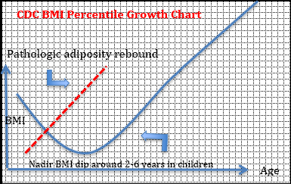

**Figure 2. BMI Percentile Growth Chart**

Weight gain during adolescent development period correlates very highly with progression to severe adult obesity. The adolescent stage is a time of critical pubertal development when body composition and fat distribution changes. Adolescent obesity can affect timing of puberty (early vs. delayed) (30). During normal pubertal development and growth, males acquire greater fat-free and skeletal muscle mass, whereas females attain higher fat mass (31).

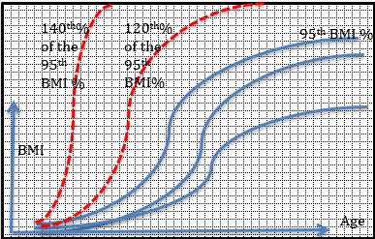

**Figure 3. Schematic Depiction of Abnormal BMI Percentile Growth Curves for Adolescents with Severe Obesity. Greater than or equal to the 95th BMI percentile correspond to cut-offs for pediatric obesity. Other important considerations that determine therapeutic criteria are if the adolescent’s trajectory falls at or above 120th% and 140th% the 95th BMI percentile for age/gender (see Table 3).**

Most patients who experience unwanted excess weight gain in childhood and adolescence develop obesity-related disease pathologies that, when severe, often require pharmacologic intervention and/or bariatric surgery. Early identification, management, and treatment are recommended as there is evidence that chances for weight-loss maintenance long-term are greater at this age than in older patients (see Endotext Chapter on Pediatrics) (32). Currently there are six FDA-approved anti-obesity medications available, of which phentermine and orlistat are approved for age >16 years and >12 years respectively (32). Use of anti-obesity pharmacotherapy in adolescents with severe obesity (>95th BMI percentile plus the presence of obesity-related comorbidity or >120th of 95th BMI percentile) has been recently proposed (32). Furthermore, vertical sleeve gastrectomy and Roux-en-Y metabolic and bariatric surgery procedures are available options for adolescents with severe obesity (>120th of 95th BMI percentile plus obesity-related comorbidity or BMI >140th of 95th BMI percentile) (33).

|  |  |  |  |
| --- | --- | --- | --- |
| **Table 3. Available Therapeutic Options Based on BMI Percentile Cut Offs of Weight Trajectory in Adolescent Patients with Severe Obesity** | | | |
| **BMI percentile as per CDC growth chart** | **>95th BMI percentile** | **>120th of the 95th BMI percentile** | **>140th of the 95th BMI percentile** |
| Intensive lifestyle intervention | ✔ | ✔ | ✔ |
| Anti-obesity medication | With comorbidity  ✔ | ✔ | ✔ |
| Adolescent bariatric metabolic surgery |  | With comorbidity  ✔ | ✔ |

**Pregnancy, Breast Feeding, and Menopausal Transition**

Pregnancy and menopause can be a time when women’s weights and body composition may become permanently altered under the influence of dramatic shifts in sex steroid levels. Excessive weight gain during pregnancy can result in epigenetic changes in the developing fetus leading to adult-onset chronic disease such as diabetes, cardiovascular disease and obesity (22, 23, 24). Furthermore, maternal obesity and excessive gestational weight gain have been linked to maternal-fetal complications such as increased risk of C-sections, preeclampsia, shoulder dystocia, and macrosomia in the infant (25). Data from large population-based epidemiological studies have shown that roughly 50% of women after pregnancy will return to their pre-pregnancy weight, but the other 50% will retain extra weight, with a third of all pregnant women shifting a BMI category (normal to overweight or obesity) (26, 27).

The post-partum period following delivery of the newborn infant is indeed a vulnerable time for weight retention. Moreover, the relationship between breastfeeding practices and postpartum weight changes is largely unclear due to the difficulties examining breastfeeding and weight management in observational research and confounding variables (34, 35). Breastfeeding overall has other notable health benefits to the infant, including atopy, cognitive development, bone health, and maternal-infant attachment (36).

Weight gain during midlife is common, and about two-thirds of women ages 40 to 59 and nearly three-quarters of women older than 60 are overweight (BMI greater than 25 kg/m2). On average, midlife women gain 1.5 pounds (0.7 kg) per year (37). Thus, it is not surprising that menopause is often depicted as a weight-gain trigger on a patient’s life-event graph, especially in older women who gain weight after a period of weight maintenance. Towards midlife, women undergo redistribution of body composition with increase in total body fat and enhanced inclination toward central abdominal visceral adiposity (38). Excess body weight during menopause leads to elevated cardiovascular (39) and metabolic risk, including insulin resistance and Type 2 diabetes mellitus (40, 41). Early or late-onset menopause (with final menstrual cycle age <45 years or age >55 years respectively) compared to age 46-55 years is associated with increased risk of Type 2 diabetes mellitus [HR 1.04, 95% CI 0.99, 1.09 and HR 1.08, 95% CI 1.01, 1.14, respectively](42). Having an underlying hysterectomy or an oophorectomy increases risk of diabetes further (RR 1.17, 95% CI 1.07-1.29) compared to peri-/post-menopausal women (43).

**CASE LESSONS IN PATIENT-GENERATED WEIGHT GRAPHS (44)**

While in the clinic, having a patient submit his/her own drawing of weight graph accomplishes two-fold goals. First, it provides a template on which weight inflections in the patient’s life can be potentially identified with causative or contributory life events, medical conditions, and medications, and secondly, it provides a platform to guide the clinical discussion in regards to appropriate goal setting and best approaches to help him/her achieve as close to a healthy weight range as possible.

**Impact of Medications**

The patient in Figure 4 experienced steroid-induced weight gain that is a very common iatrogenic cause of obesity. Exploring reasons for why this patient was initiated on steroids and communication with other specialists in regards to switch over to another non-steroid dependent medication, if available, might mitigate the weight gain and prove to be a successful weight management strategy. Similar effects prompting discussions of alternative approaches may also be seen by other commonly prescribed medications, including some birth control methods (e.g., Depo-Provera), beta-blockers, amitriptyline, gabapentin, pregabalin, thiazolidinediones, and insulin).

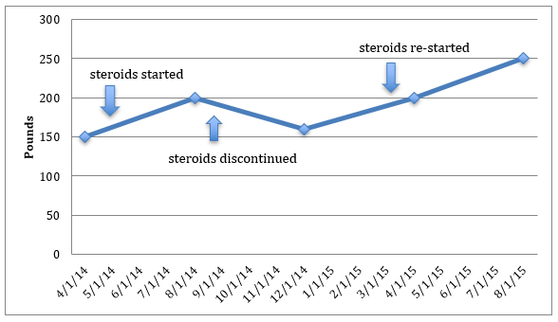

**Figure 4. Life Graph Showing Effects of Repeated Exposures to Steroids on Weight for Chronic Inflammatory Arthritis.**

**Effects of Situational Life Changes That Impact Weight**

In Figure 5, the patient’s weight was at its nadir during college years until graduation. Subsequently, marriage and job change were aforementioned social factors contributing to weight gain. In addition, pregnancy and menopause were identified biological associations with upward weight trajectory overtime. Psychological stressors further augmented weight gain over time. Resilience to major life stressors (marriage, divorce, loss of spouse, unemployment, death of a loved one, major illness or injury, moving/relocation) does not commonly occur and can precipitate psychosocial disorders such as anxiety, depression and alcoholism (45, 46).

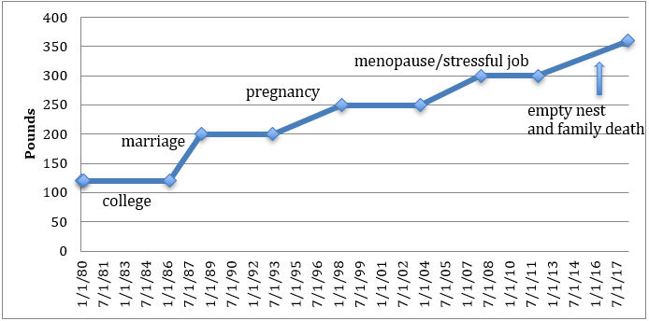

**Figure 5.** **Life Graph Showing Effects of Several Situational Life Changes that Impact Weight.**

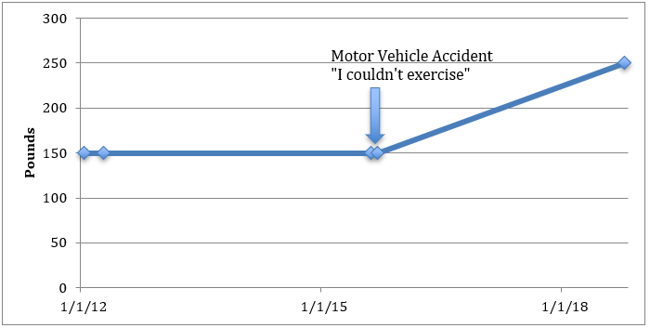

**Figure 6. Life Graph Showing Effect of a Single Traumatic Incident (such as Motor Vehicle Accident in this Case) on Weight**

In Figure 6 above, the patient had a stable weight prior to a traumatic incident that elicited changes in physical function leading to immobility and sedentary behaviors. Identification of this specific event contributing to upward weight trajectory in the patient helped tailor the treatment strategy toward physical therapy, rehabilitation and a customized exercise prescription to mitigate the weight gain.

**Identification of Response to Weight Loss Interventions: Importance of Identifying Lifetime Max**

Below are examples of weight graphs taken from the electronic health record (47, 48).

In Figure 7, the patient gained over 40 pounds through exposure to various antipsychotic medications for the treatment of her bipolar disorder. The downward shift in her weight graph occurred after treatment with metformin 500mg once daily (to mitigate antipsychotic medication induced weight gain (49)) and phentermine to ultimately lose weight. If certain medications are critical and cannot be switched over to a weight-mitigating alternative, as is often the case in patients requiring anti-psychotic medications, anti-obesity medications (48) and in severe obesity, bariatric surgery, can often reverse the weight gain.

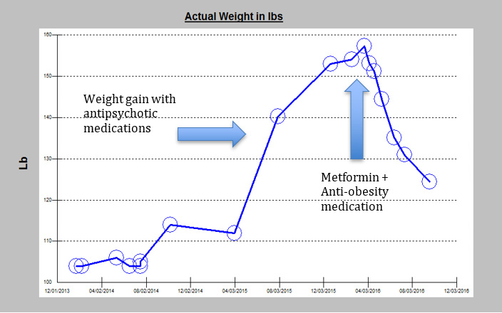

**Figure 7. Life Graph Showing the Effects of Antipsychotic Medications on Weight and Effective Therapeutic Intervention with Anti-Obesity Medications**

In Figure 8, the first blue arrow shows the time of initial visit when the patient had started to gain weight due to multifactorial etiology (strong family history of obesity, maladaptive stress related to work, poor nutritional habits), followed by initiation of anti-obesity medicine therapy and intensive lifestyle intervention (phentermine; 2nd blue arrow). Subsequently, the patient developed side effects and phentermine monotherapy was discontinued (3rd blue arrow). Several other anti-obesity pharmacological options were trialed (4th blue arrow); however, the patient did not respond. Ultimately, the patient underwent bariatric surgery (Roux-en-Y gastric bypass (RYGB)) to achieve successful weight loss response.

Obesity has a multifactorial etiology leading to wide variability in its presentation. Understanding causation and association of weight gain promoting factors in a patient’s life can help elucidate appropriate treatment strategies. Furthermore, initial non-response to anti-obesity medication does not indicate that the medication is ineffective overall; rather it may not be targeting the pathophysiological pathways involved in metabolic dysregulaton in the individual patient and an alternative anti-obesity medication or combination should be trialed for synergistic or additive weight loss effects. In this patient’s case, other anti-obesity medications were prescribed due to initial side effects on phentermine monotherapy.

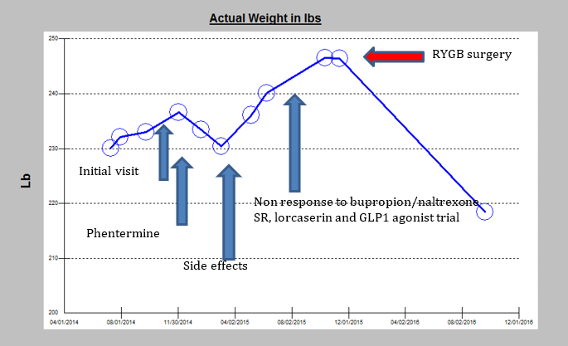

**Figure 8.** **The Life Events Graph Depicts the Response to Treatment and Strategies for Further Intervention.**

**Identification of Weight Regain after Successful Weight Loss: Importance of Prompt Intervention**

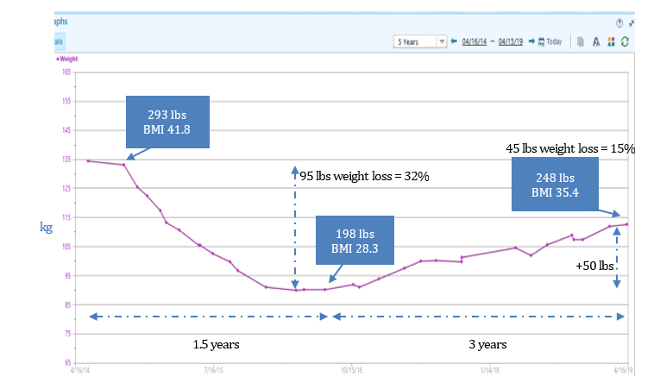

**Figure 9. Life Graph Showing Effect of Weight Loss Program Intervention Overtime with Weight Regain.**

Figure 9 shows the life-events graph of a 55-year-old patient with a history of hypertension, obstructive sleep apnea and severe obesity (BMI 41.8 kg/m2, 293.5 lbs.). The patient lost 95

pounds over a 1.5-year period through self-monitoring using an electronic smart phone tracking application, 1800 kcal/day intake, and an increase in physical activity as tolerated. However, after 1.5 years of successful weight loss, despite continued intensive lifestyle changes in the absence of other potential weight gain triggers, he experienced weight regain over the next 3 years. Weight regain after a period of caloric restriction is physiologic as long-term persistence of metabolic adaptation occurs and hunger and satiety signals resist weight loss (50). It is a prime time to initiate anti-obesity pharmacotherapy at this critical stage after weight maintenance to help sustain the weight loss and prevent weight regain. In this patient, starting an anti-obesity medication after 1.5 years when weight gain had started to occur would be recommended.

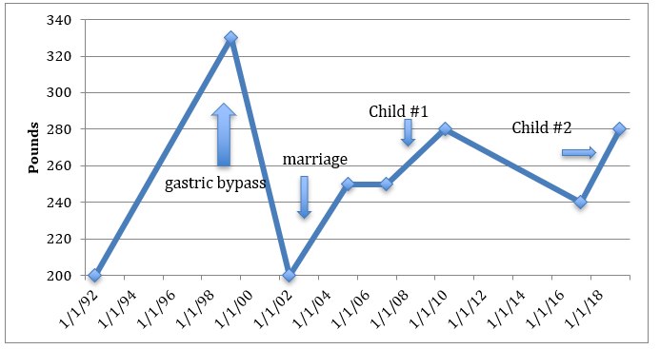

**Figure 10. Life Graph Showing a Patient Status Post Gastric-Bypass Surgery with Weight Regain Following Situational Life Transitions (Marriage, Birth of Child).**

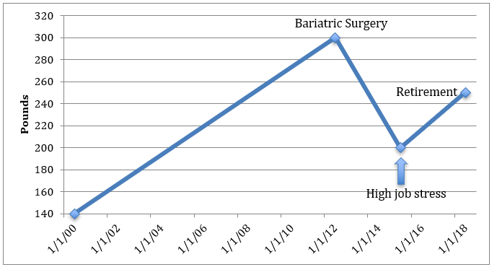

**Figure 11**. **Life Graph Showing Weight Loss in a Patient After Bariatric Surgery Followed by Weight Regain Subsequent to High Job-Related Stress and Retirement.**

Figure 10 and Figure 11 depict life-event graphs of two patients who underwent metabolic and bariatric surgery with successful weight loss following the procedure. However, they both experienced weight regain. Weight regain in the postoperative bariatric patient is often difficult to treat and is usually of multifactorial etiology (recurrence of obesity-related comorbidities, non-compliance and adherence to treatment recommendations and routine bariatric care, physiologic return of hunger signals, introduction of life stressors as examples). Early recognition, evaluation and medical management, provided anatomical causes have been ruled out, with multidisciplinary team support are crucial to removing obstacles to weight maintenance and patient’s continued commitment to lifestyle improvements. Further, it presents an opportunity to intervene early and initiate anti-obesity pharmacotherapy to help arrest weight regain (51).

**CONCLUSIONS**

Eliciting an obesity-focused medical history is important for the care of the patient who is overweight or has obesity. In addition to identifying obesity-related co-morbid conditions by means of a thorough history, physical, and appropriate laboratory work up, we illustrated, through the use of described life-events and electronic health record weight graphs, the clinical relevance of documenting weight trajectories in the management of a patient with obesity. Creating a representation of a patient’s weight trajectory and fluctuations over time can help guide the clinical discussion in regards to potentially modifiable influences on a patient’s weight. These include identifying causative medical conditions or culprit medications that promote weight gain, associating weight gain with known life-transitions that increase a patient’s risk for becoming overweight or obese (e.g., puberty, pregnancy, menopause), help patients to re-commit to improved lifestyle choices, assess an individual’s responsiveness to recommended therapies, and help with timing for when initiating combinations of therapies (either weight loss medications in combination or adding on following weight loss surgery).

**REFERENCES**

1. Flegal KM, Carroll MD, Kit BK, Ogden CL. Prevalence of obesity and trends in the distribution of body mass index among US adults, 1999-2010. *JAMA* 2012;**307:** 491-497.

2. Penman AD, Johnson WD. The changing shape of the body mass index distribution curve in the population: implications for public health policy to reduce the prevalence of adult obesity. *Prev Chronic Dis* 2006;**3:** A74.

3. Fryar CD, Kruszon-Moran D, Gu Q, Ogden CL. Mean Body Weight, Height, Waist Circumference, and Body Mass Index Among Adults: United States, 1999-2000 Through 2015-2016. *Natl Health Stat Report* 2018**:** 1-16.

4. Ritchie SA, Connell JM. The link between abdominal obesity, metabolic syndrome and cardiovascular disease. *Nutr Metab Cardiovasc Dis* 2007;**17:** 319-326.

5. Bessler M, Daud A, DiGiorgi MF, Schrope BA, Inabnet WB, Davis DG. Frequency distribution of weight loss percentage after gastric bypass and adjustable gastric banding. *Surg Obes Relat Dis* 2008;**4:** 486-491.

6. Gardner CD. Tailoring dietary approaches for weight loss. *Int J Obes Suppl* 2012;**2:** S11-S15.

7. Smith SR, Prosser WA, Donahue DJ, Morgan ME, Anderson CM, Shanahan WR*, et al.* Lorcaserin (APD356), a selective 5-HT(2C) agonist, reduces body weight in obese men and women. *Obesity (Silver Spring)* 2009;**17:** 494-503.

8. Hatoum IJ, Greenawalt DM, Cotsapas C, Reitman ML, Daly MJ, Kaplan LM. Heritability of the weight loss response to gastric bypass surgery. *J Clin Endocrinol Metab* 2011;**96:** E1630-1633.

9. Buford TW, Roberts MD, Church TS. Toward exercise as personalized medicine. *Sports Med* 2013;**43:** 157-165.

10. Srivastava G, Apovian CM. Current pharmacotherapy for obesity. *Nat Rev Endocrinol* 2018;**14:** 12-24.

11. Verhaegen AA, Van Gaal LF. Drugs That Affect Body Weight, Body Fat Distribution, and Metabolism. In: Feingold KR, Anawalt, B., Boyce, A., Chrousos, G., Dungan, K., Grossman, A., Hershman, J. M., Kaltsas, G., Koch, C., Kopp, P., Korbonits, M., McLachlan, R., Morley, J. E., New, M., Perreault, L., Purnell, J., Rebar, R., Singer, F., Trence, D. L., Vinik, A., Wilson, D. P. (ed). *Endotext [Internet]*. MDText.com, Inc.; 2000-: South Dartmouth (MA) 2019 Feb 11.

12. Akinci B, Sahinoz, M., and Oral, E. Lipodystrophy Syndromes: Presentation and Treatment. In: Feingold KR, Anawalt, B., Boyce ,A., Chrousos, G., Dungan, K., Grossman, A., Hershman, J. M., Kaltsas, G., Koch, C., Kopp, P., Korbonits, M., McLachlan, R., Morley, J. E., New, M., Perreault, L., Purnell, J., Rebar, R., Singer, F., Trence, D. L., Vinik, A., Wilson, D. (ed). *Endotext [Internet]*. MDText.com, Inc.; 2000-. South Dartmouth (MA), 2018 Apr 24.

13. Adler HM. The history of the present illness as treatment: who's listening, and why does it matter? *J Am Board Fam Pract* 1997;**10:** 28-35.

14. Redelmeier DA, Schull MJ, Hux JE, Tu JV, Ferris LE. Problems for clinical judgement: 1. Eliciting an insightful history of present illness. *CMAJ* 2001;**164:** 647-651.

15. Kushner R, 'Taking a Weight History – Using Mnemonics to Learn a Missing Skill in Medical Education', MedEdPublish, 6, [4], 46, <https://doi.org/10.15694/mep.2017.000215>.

16. Malhotra R, Ostbye T, Riley CM, Finkelstein EA. Young adult weight trajectories through midlife by body mass category. *Obesity (Silver Spring)* 2013;**21:** 1923-1934.

17. Stokes A, Ni Y, Preston SH. Prevalence and Trends in Lifetime Obesity in the U.S., 1988-2014. *Am J Prev Med* 2017;**53:** 567-575.

18. Zheng Y, Manson JE, Yuan C, Liang MH, Grodstein F, Stampfer MJ*, et al.* Associations of Weight Gain From Early to Middle Adulthood With Major Health Outcomes Later in Life. *JAMA* 2017;**318:** 255-269.

19. Zheng Y, Song M, Manson JE, Giovannucci EL, Hu FB. Group-Based Trajectory of Body Shape From Ages 5 to 55 Years and Cardiometabolic Disease Risk in 2 US Cohorts. *Am J Epidemiol* 2017;**186:** 1246-1255.

20. Petrick JL, Kelly SP, Liao LM, Freedman ND, Graubard BI, Cook MB. Body weight trajectories and risk of oesophageal and gastric cardia adenocarcinomas: a pooled analysis of NIH-AARP and PLCO Studies. *Br J Cancer* 2017;**116:** 951-959.

21. Yu E, Ley SH, Manson JE, Willett W, Satija A, Hu FB*, et al.* Weight History and All-Cause and Cause-Specific Mortality in Three Prospective Cohort Studies. *Ann Intern Med* 2017;**166:** 613-620.

22. Farooqi IS, O'Rahilly S. The Genetics of Obesity in Humans. In: Feingold KR, Anawalt, B., Boyce A3, Chrousos, G., Dungan, K., Grossman, A., Hershman, J. M., Kaltsas, G., Koch, C., Kopp, P., Korbonits, M., McLachlan, R., Morley, J. E., New, M., Perreault, L., Purnell, J., Rebar, R., Singer, F., Trence, D. L., Vinik, A., Wilson, D. P. (ed). *Endotext [Internet]*. MDText.com, Inc.; 2000-: South Dartmouth (MA), 2017 Dec 23.

23. Twig G, Yaniv G, Levine H, Leiba A, Goldberger N, Derazne E*, et al.* Body-Mass Index in 2.3 Million Adolescents and Cardiovascular Death in Adulthood. *N Engl J Med* 2016;**374:** 2430-2440.

24. Bush T, Lovejoy JC, Deprey M, Carpenter KM. The effect of tobacco cessation on weight gain, obesity, and diabetes risk. *Obesity (Silver Spring)* 2016;**24:** 1834-1841.

25. Schneider DF, Nookala R, Jaraczewski TJ, Chen H, Solorzano CC, Sippel RS. Thyroidectomy as primary treatment optimizes body mass index in patients with hyperthyroidism. *Ann Surg Oncol* 2014;**21:** 2303-2309.

26. Choi KM. Sarcopenia and sarcopenic obesity. *Korean J Intern Med* 2016;**31:** 1054-1060.

27. Rolland-Cachera MF, Peneau S. Growth trajectories associated with adult obesity. *World Rev Nutr Diet* 2013;**106:** 127-134.

28. Oswal A, Yeo GS. The leptin melanocortin pathway and the control of body weight: lessons from human and murine genetics. *Obes Rev* 2007;**8:** 293-306.

29. Doulla M, McIntyre AD, Hegele RA, Gallego PH. A novel MC4R mutation associated with childhood-onset obesity: A case report. *Paediatr Child Health* 2014;**19:** 515-518.

30. Lee JM, Wasserman R, Kaciroti N, Gebremariam A, Steffes J, Dowshen S*, et al.* Timing of Puberty in Overweight Versus Obese Boys. *Pediatrics* 2016;**137:** e20150164.

31. Loomba-Albrecht LA, Styne DM. Effect of puberty on body composition. *Curr Opin Endocrinol Diabetes Obes* 2009;**16:** 10-15.

32. Srivastava G, Fox CK, Kelly AS, Jastreboff AM, Browne AF, Browne NT*, et al.* Clinical Considerations Regarding the Use of Obesity Pharmacotherapy in Adolescents with Obesity. *Obesity (Silver Spring)* 2019;**27:** 190-204.

33. Pratt JSA, Browne A, Browne NT, Bruzoni M, Cohen M, Desai A*, et al.* ASMBS pediatric metabolic and bariatric surgery guidelines, 2018. *Surg Obes Relat Dis* 2018;**14:** 882-901.

34. Neville CE, McKinley MC, Holmes VA, Spence D, Woodside JV. The effectiveness of weight management interventions in breastfeeding women--a systematic review and critical evaluation. *Birth* 2014;**41:** 223-236.

35. Neville CE, McKinley MC, Holmes VA, Spence D, Woodside JV. The relationship between breastfeeding and postpartum weight change--a systematic review and critical evaluation. *Int J Obes (Lond)* 2014;**38:** 577-590.

36. Lucas A. Scientific Evidence for Breastfeeding. *Nestle Nutr Inst Workshop Ser* 2019;**90:** 1-12.

37. Kapoor E, Collazo-Clavell ML, Faubion SS. Weight Gain in Women at Midlife: A Concise Review of the Pathophysiology and Strategies for Management. *Mayo Clin Proc* 2017;**92:** 1552-1558.

38. Kozakowski J, Gietka-Czernel M, Leszczynska D, Majos A. Obesity in menopause - our negligence or an unfortunate inevitability? *Prz Menopauzalny* 2017;**16:** 61-65.

39. Ramezani Tehrani F, Behboudi-Gandevani S, Ghanbarian A, Azizi F. Effect of menopause on cardiovascular disease and its risk factors: a 9-year follow-up study. *Climacteric* 2014;**17:** 164-172.

40. Davis SR, Castelo-Branco C, Chedraui P, Lumsden MA, Nappi RE, Shah D*, et al.* Understanding weight gain at menopause. *Climacteric* 2012;**15:** 419-429.

41. Senechal M, Arguin H, Bouchard DR, Carpentier AC, Ardilouze JL, Dionne IJ*, et al.* Weight gain since menopause and its associations with weight loss maintenance in obese postmenopausal women. *Clin Interv Aging* 2011;**6:** 221-225.

42. LeBlanc ES, Kapphahn K, Hedlin H, Desai M, Parikh NI, Liu S*, et al.* Reproductive history and risk of type 2 diabetes mellitus in postmenopausal women: findings from the Women's Health Initiative. *Menopause* 2017;**24:** 64-72.

43. Pandeya N, Huxley RR, Chung HF, Dobson AJ, Kuh D, Hardy R*, et al.* Female reproductive history and risk of type 2 diabetes: A prospective analysis of 126 721 women. *Diabetes Obes Metab* 2018;**20:** 2103-2112.

44. Kushner RF, Ryan DH. Assessment and lifestyle management of patients with obesity: clinical recommendations from systematic reviews. *JAMA* 2014;**312:** 943-952.

45. Infurna FJ, Luthar SS. Resilience to Major Life Stressors Is Not as Common as Thought. *Perspect Psychol Sci* 2016;**11:** 175-194.

46. Just-Ostergaard E, Mortensen EL, Flensborg-Madsen T. Major life events and risk of alcohol use disorders: a prospective cohort study. *Addiction* 2018;**113:** 25-33.

47. Jensen MD, Ryan DH, Apovian CM, Ard JD, Comuzzie AG, Donato KA*, et al.* 2013 AHA/ACC/TOS guideline for the management of overweight and obesity in adults: a report of the American College of Cardiology/American Heart Association Task Force on Practice Guidelines and The Obesity Society. *J Am Coll Cardiol* 2014;**63:** 2985-3023.

48. Apovian CM, Aronne LJ, Bessesen DH, McDonnell ME, Murad MH, Pagotto U*, et al.* Pharmacological management of obesity: an endocrine Society clinical practice guideline. *J Clin Endocrinol Metab* 2015;**100:** 342-362.

49. Hendrick V, Dasher R, Gitlin M, Parsi M. Minimizing weight gain for patients taking antipsychotic medications: The potential role for early use of metformin. *Ann Clin Psychiatry* 2017;**29:** 120-124.

50. Sumithran P, Prendergast LA, Delbridge E, Purcell K, Shulkes A, Kriketos A*, et al.* Long-term persistence of hormonal adaptations to weight loss. *N Engl J Med* 2011;**365:** 1597-1604.

51. Srivastava G, Buffington C. A Specialized Medical Management Program to Address Post-operative Weight Regain in Bariatric Patients. *Obes Surg* 2018.